PAYROLL
PAYROLL
PAYROLL
PAYROLL
PAYROLL
PAYROLL
PAYROLL
PAYROLL
PAYROLL
PAYROLL
PAYROLL
PAYROLL
PAYROLL
PAYROLL

Reference manual
including the System Specification manual

This manual is for the 1.0C version written in Cobol using the Free GnuCobol compiler - it is in development mode at this time

Applewood Computers (United Kingdom)

Payroll
Reference and Specification Manual

11 November 2025
(c) 2025 and onwards

Rewritten using LibreOffice Writer, 9 October 2025
with sources taken from the original v1.0B (CBasic) version
with updates occurring during the development of the Cobol version

Copyright (c) 2025-26 Vincent B. Coen (Hatfield, UK) and Applewood Computers

Vincent B Coen and
Applewood Computers
17 Stag Green Avenue
Hatfield
Hertfordshire
AL9 5EB

vbcoen@gmail.com

Table of Contents
Introduction 4
1. Using the Documentation 4
2. Features and Facilities 6
3. System Overview 8
4. Practice Run 12
5. Gathering your Materials 17
Reference Section 25
6. Background Information 25
7. System Set Up 26
8. Setting System Parameters 29
9. The Account File and G L Interface 36
10. System-Wide Earnings and Deductions 38
11. Putting Employees on the System 42
12. The Payroll Processing Cycle 47
13. Entering Pay Transactions 50
14. Payroll Application 54
15. Printing Pay Checks and the Pay Check Register 56
16. End of Period Processing 59
17. Optional Reports 61
Operation Section 77
18. Interacting with the System 77
19. Setting Up 81
20. Setting System Parameters 85
21. The Account File and GL Interface 87
22. System wide Earnings and Deductions 89
23. Entering and changing Employee Information 92
24. Entering and Changing Pay Rate Information 96
25. The Payroll Processing Cycle 99
26. Entering Employee Pay Transactions 101
27. Payroll Application 105
28. Printing Pay Checks and the Pay Check Register 106
29. Ending the Quarter 107
30. Ending the Year 109
31. Producing the Optional Reports 111
Appendixes 112
32. DMS Screen Formats 112
33. DMS Setup for non standard CRT's 124
34. Error Messages 130
35. Error Recovery 153
36. COMMAND SUMMARY 156
37. Payroll Specifications Manual 158

Introduction

1. Using the Documentation
Before you operate the Payroll System, read this manual thoroughly and do the Practice Run outlined in Chapter 4 page 12.

This manual is being rewritten to support the Cobol version at v1.0.

The ACAS Payroll System documentation includes two manuals in one. This manual starts as a Reference Manual which provides all the background information and instructions necessary for successful operation. At the end of the reference manual is the Specifications Manual which contains technical information on file accessing and file descriptions, etc.

Note Both are subject to detailed changes during the development and programming of the Payroll product using the Cobol programming language and that utilises the GnuCobol Cobol compiler which is a free to own and use product - Yes, like Payroll itself, as well as all the other systems within the ACAS Accounting System, all are free to own and use for your business but they are not free to resell, hire or rent out, etc., without a commercial business arrangement with Vincent Coen - the lead programmer and developer.

The User and Reference Manual contains an Introduction, a Reference Section, an Operations Section, and Appendixes. The Reference section deals with general concepts and procedures. The Operations section gives additional specifics on running the programs. After you get a good understanding of the system from the Reference section, you should rarely have to refer to it. From then on, most questions can be answered by referring to the Operations section.

The original developers S.S.G. has closed down during the 80's. and Vincent Coen is the sole remaining vendor/developer. As the original is written in CBASIC for the CPM operating system there is a need to redevelop the Payroll package so that it will run on any operating system such as Linux, Windows, OSX and other *nix systems. Using the Cobol programming language will allow that to happen with minimal changes.

While Applewood Computers is glad to provide support to registered owners of its products, please read the documentation carefully and check for hardware problems before giving us a call.
See https://sourceforge.net/p/acas/code-v3.3/HEAD/tree/payroll where later versions might be present for Payroll and for the rest of the source tree for ACAS.

Starting October 2025, I am attempting to rewrite Payroll using Cobol so it will integrate into ACAS. This will not happen any time soon but watch out for the ACAS folder payroll.

I have created a program that takes input of the CBASIC code and inserts all of the include sources into each program source as the CBasic compiler is not available, let alone a working CPM environment that works under Linux or Windows.

This Payroll product, will be supplied as source code written in Cobol. Therefore some elements of this manual will be redundant and will be replaced such as discussions regarding the use of CPM and the CBASIC runtime systems. Note as written, the Payroll system is only of use in the USA and possibly Canada but that at the moment is unlikely as information of the Canadian payroll requirements are not known.

Note that I am based in the UK (United Kingdom) and the UK Payroll system is different from the one used in the USA, therefore the amount of testing I can do is limited. As is, I do not have access to the employer tax tables for Federal and the 50 odd states and so I have very limited access to what has changed over the last 40 years in new taxation requirements. If you are based in the USA I invite you to supply samples of these tax tables as a pdf or text file for the state you can access as well as the federal one.

These tax tables are of the form -
Rate Amount
% rate limit for example :
------ -----------
00.00 10,000
10.00 17,500
14.60 23,500
22.50 31,000
40.00 50,000
55.00 0

The last one indicates 55% on all amounts at and above $50,000. So you get the idea. Caution, some tables are based on amount in say 500 increments etc and these are not the one's to use, only the type as shown above. These table types are available for both Federal and state via the tax websites of each. The above sample table does not reflect any tax table - it is shown as an example of the type of table only.

Some of the coding taking place now, will be possibly missing some processing that will appear a requirement as I go through the basic modules in more detail especially for the payment apply processes. My intention to complete in order, all data entry programs including system parameters, followed by the printed reporting modules then the pay apply ones followed by end of period processing for both quarterly and end of year.
Initially some of the program names are the same as the basic one's and this is to help avoid missing any programs or processes but will be changed to be in the same format as the rest of ACAS once programming has completed.

As I think of it etc, I will do some updates to this manual with the most obvious differences from the Basic version running under CPM to the modern Linux and Windows processes.

2. Features and Facilities
The ACAS Payroll System is a sophisticated payroll processing program for small and medium businesses based in the USA.

The Payroll System calculates deductions from employee wages for Federal income tax withholding, Social Security tax (FICA), State Disability Insurance (SDI), and state and local income tax withholding for many state and local governments. The Payroll System also calculates the employer's FICA, FUTA (Federal Unemployment Tax), and SUI (State Unemployment Insurance) contributions. Advance Earned Income Credit (EIC) payments and reduction in payments for earnings over the EIC limit are also handled by the system.

In addition to the standard deductions listed above, you can define up to five system-wide earnings or deductions and up to three employee specific earnings or deductions. Of course any employee can be exempted from the standard and system-wide earnings and deductions categories. User defined earnings and deductions can be a flat amount each pay period, or a percentage of the employee's gross taxable pay. You can limit the amount that can be earned or deducted in one year, or the amount earned or deducted can be without limit. The user-defined earnings categories can be marked as subject to all taxes and percentage based deductions, subject to all except FICA, subject to all except Federal, state, and local taxes, or not subject to any taxes or percentage based deductions.

Provision has been made for entering an employee's head of household status and special withholding allowances for California tax purposes.

The Payroll System supports additional Federal, state, local, and FICA withholding if requested or required by an employee.

The system handles tips collected by the employer, and tips reported to but not collected by the employer. The Payroll System exempts the employer from FICA tax on tips, and taxes the employee correctly for them.

The Payroll System permits three fully taxable pay rates, plus one rate with a tax status that may be defined differently for different employees. These normally correspond to regular pay, overtime pay, special overtime, and commission, piecework pay, or other pay, though the descriptive name that may be anything you desire.

The system can generate recurring pay amounts automatically (with a simple override procedure), and calculate overtime pay automatically. The Payroll System calculates vacation and sick leave earned, and provides for comp time entry.

The Payroll System handles employee bonuses, expense reimbursement, salary advances and repayments, sick pay, and vacation pay.

It supports weekly, bi-weekly, monthly, and semi-monthly pay schedules for employees classified as active, on leave, or terminated.

It will print pay checks automatically, and if the option is requested, void checks over a stated maximum amount. Support for payment via bank to bank in place of using checks will also be supported. As an added safety feature, the Payroll System gives an error message when an employee receives payment in excess of the maximum you set for him or her.

You can distribute an employee's total cost to the company to up to five ledger accounts. The system is completely audit-able, and interfaces with the ACAS IRS or General Ledger.

The Payroll System prints 941 government reporting forms every quarter, and 940 & W-2 forms at the end of every year. These forms can be printed on plain paper or reprinted ones as well as using cut paper i.e., USA Letter format (or A4) or continuous paper as used on a matrix or line printer depending on usage or other requirements.

It produces payroll transaction working and audit proof reports, a Payroll Journal that details earnings and deduction information by employee (with a company wide and ledger account summary), and a pay check register from which checks or bank to bank payments may be prepared manually if desired. The system prints out the master employee file in a full or short form for some or all employees, and also prints an employee history report which presents summarized quarter and year-to-date pay information. You can order a report of vacation, sick leave, and comp time accumulated and used, as well as a printout of the accounts currently used by the Payroll System.

Payroll provides full screen formatting to make data entry a simple matter of filling in the blanks. Default values for all requests speed data entry and ensure successful processing. The Payroll System incorporates extensive processing safeguards and error checking routines, and employs advanced defensive programming techniques.

THE NEW Cobol SOURCE CODE Does not use DMS screen code and so references to such should be ignored in this manual as changes will be taking place. Ditto the removal of all references to CPM and file drives etc., as these are for old computers using floppy disks - long gone. Details of the procedures and usage with Linux or any other *nix system will be generally excluded as the other manuals in the ACAS system provide such information.

Using ACAS Payroll, it is assumed that the ACAS system has been set up using the parameter entry procedure at the start as well as the payroll parameter procedure as outlined in this document.

3. System Overview
The ACAS Payroll System is "menu driven", which means you run the programs by choosing them from a "menu" list. The Payroll System employs a full-screen display formatting utility that enables you to view a number of requests and their current values at once. To enter a new value or change an old one, you move the cursor to the desired field and type in the new response. The Payroll System edits your responses to its requests and checks them carefully for reasonableness and validity, issuing descriptive error messages when necessary.

The Payroll System breaks logically into three parts: System Set up, the Payroll Processing Cycle, and End of Period Processing. Once installation of your Payroll System is complete, you will rarely need to take the System Set up steps again. The Payroll Processing Cycle is repeated once for every pay period, and End of Period Processing once at the end of each quarter and year.

3.1 System Set Up
Step One of System Set up is to install the free to obtain and use Cobol compiler and build it if you only have access to the source code, otherwise install the binaries for it for use on Linux using your package manager, search for cobol and version greater than v3 with v3.2 or later the best choice. Failing that, then obtain the compiler from its location at sourceforge.net/p/gnucobol and download the v3.2 or any later released versions as sources etc., then build it according to the supplied instructions - it will take five to ten minutes to do so. Further detailed instructions on these process can be found in the ACAS - Building the ACAS System manual.

Step Two of System Set up is to build the payroll system along with the other elements of ACAS on to your system using the Cobol compiler.

Step Three of System Set up involves downloading your federal, state and local governments tax tables as files where provided or the document detailing them and entering the details into the Payroll system using the parameter entry option via the Payroll menu options.

Step Four of System Set up is called Parameter Entry. During this step you tell the system what options you want to use, as well as other information to make processing more efficient. At first time start up the Payroll System lets you choose between using a simpler "default" version of the system (Quick Parameter Entry), and doing further customisation.
If you choose the default Payroll System, the parameter requests you answer during system start up are limited in number. If you choose further customisation at first time start up, the system presents you with the full range of parameter requests, and allows you to change account and deduction information. If all employees are paid on the same schedule, and if no additional accounts or special earnings or deduction categories are needed, the default system will be the simplest set up procedure. Of course, you can always choose to do further customisation later. The Cobol version does not offer the simplified option as it is felt to be too simple for use these days (subject to final decision after coding is completed.
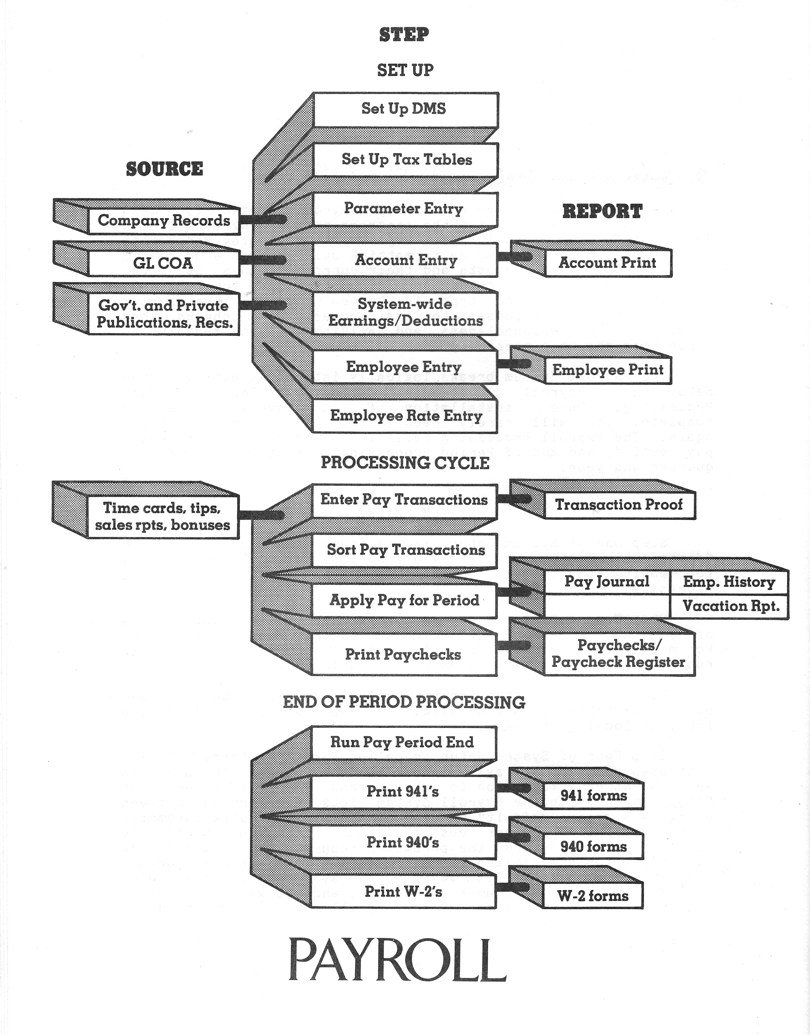
Step Five of System Set up is Account Entry. If you choose the default Payroll System option at first time start up, no requests are issued and the program creates a default account file containing a cash, accrued liability, salary expense, and accrued payroll cost liability account.
If you choose further customization, you can add additional accounts, or change the existing default accounts using IRS or GL (General Ledger). Use of IRS would be the normal process unless you require the extra facilities of branch or profit centre accounting, in which case use GL. Note that IRS can deal with branch or profit centres by the controlled use of the nominal and sub nominal account numbers. More of use, is that a sample CoA (Chart of Accounts) file is supplied that can be the basis for your CoA for input directly into IRS.

Step Six of System Set up is called System-wide Earnings and Deduction Entry.
During this step you tell the system which of the standard deduction categories you wish to use (such as Federal, state, and local income tax, FICA, SDI, FUTA, EIC, etc.), and enter current rate and limit information. During this step you can define up to five system-wide earnings or deductions to suit the specific needs of your company. Individuals may of course be exempted. If you choose the default Payroll System option, at first time start up the program creates a default Earnings and Deductions file and allows no entries or changes. You can, however, make changes to the default file at a later time through the Deduction/Earning Entry program.

Step Seven of System Set up is called Employee Entry. There are two programs to be run for this step. The first is Employee Entry, which creates a record on the Employee Master and History files for each employee, and assigns him or her a number. The second is the Employee Deduction/Earnings and Cost Distribution program, which you can use to exempt specific employees from system-wide earnings or deductions, establish up to three earrings or deductions categories for a particular employee, and distribute an employee's cost to the company to up to five ledger accounts. For the new version, these are handled in the one program.

Step Eight of System Set up is Employee Pay Rate Entry. During this step you enter an employee's pay frequency, set the four pay rates (usually regular, overtime, special overtime, and commission, although you can give them any description), and set the number of Normal Units (used for automatic computation of overtime), and set the number of Autogen Units (used for automatic generation of recurring pay amounts). During this step you also enter the rate at which vacation and sick leave are accumulated, and the vacation, sick leave, and comp time accumulated and used so far in the current year.

When you set up your Payroll System in mid-year, a ninth set up step is required. After the first eight steps are complete, you run the History Entry program to bring the earnings, deduction, and tax information up to date for each employee and for the company as a whole. It will not run after the first payroll application has taken place. See Chapter 7 and Chapter 19 for instructions. A special program may well be created to allow you on receipt of the new employee's historic record being available for the current year to Add the entries on it to existing employee history data.. In the UK this is provided by forms called P45 and P60 - I do not what the name of these are in the USA at this time.

Processing Cycle
When set up is complete, you can begin the processing cycle you repeat for each pay interval to calculate employee earnings and deductions, produce pay checks, and update historical information. The Payroll System permits four pay intervals: weekly, bi-weekly, monthly, and semi-monthly. The weekly and bi-weekly schedules are called week-based intervals, and the monthly and semi-monthly schedules are called month-based intervals. Although pay transactions for all four intervals can be entered into the same pay transaction batch, the central program of the processing cycle, Apply Payroll, never processes week-based and month-based employees together. When weekly and bi-weekly employees are on the system, the Apply Payroll program processes them together every two weeks. When monthly and semi-monthly employees are on the system, the Apply Payroll program processes them together at the end of each month.

The second step in the cycle is to Apply Payroll for the period. The Apply Payroll program is the main processing program of the system. It separates transactions for week-based employees from those for month-based, and if both intervals for the interval base are not to be processed by this application (e.g., semi-monthly, but not monthly), it separates those that are to be processed from those that are not. The Apply Payroll program produces a check file from which the pay checks and the Pay check Register are produced, updates the Company History and Employee History files, and creates a General Ledger batch file if that option has been requested. Before you can run the application program again, you must print a Payroll Journal report that presents detailed and summarized transaction information for each employee, a company payroll summary, and a ledger account summary.

The third step in the cycle is to actually print the pay checks or bank to bank schedule and the Pay check Register. If you do not choose the automatic check printing option, you can use the Pay check Register to manually prepare the pay checks or bank to bank report.

End of Period Processing

After the last payroll application of each quarter, and before the first payroll application of the next quarter, you must print the Federal 941 report (Employer's Quarterly Federal Tax Return), and run the Close for Quarter program to reset quarter to date statistical registers to zero.

After Closing for the fourth quarter, and before the first payroll application of the next year, you must print the Federal 940 report, print W-2 forms for all employees, and run the Close for the Year program to reset year to date statistical registers to zero.

The last step is to update all of the tax tables you use for the new year.

4. Practice Run

Before you begin this practice run, follow the procedure outlined in Chapter 19 for making copies of the Payroll sources into a new folder say cobolsrc/ACAS-3.3/ (or a later one if now available), install the GnuCobol compiler and build the ACAS system then setting up the tax tables for your state and local government. It is assumed you are using state tax tables. If you are not you must run the Deduction/Earning Entry program and set State Withholding Used to No before running the Apply Payroll program. Follow the Practice Run instructions carefully, making the entries exactly as directed. When you are done, you may want to work with the practice run data for several processing cycles more before starting for real.

Note: Ignore any and all references to changing drives throughout this document.

Make sure you have the programs, tax files, etc., on your chosen folder for running the system for the practice sessions

payroll

After you press RETURN, the ACAS copyright message, the Payroll System version number, and the serial number of your package appears.

CHANGES HERE ::::
When the Payroll System menu appears select number Y, Parameter Entry but the system will automatically go into this step. Be sure to hit RETURN after each response. If you key in the wrong character, use the key backspace.

When the Parameter Entry screen appears, hit RETURN until the cursor is at the Company Name field. If you go by, you can back up by giving the command CTRL-B. Type in the information below, hitting RETURN after each entry:

NAME: Universal Practice Company
ADDRESS 1: 2120 Main Street
ADDRESS 2: [hit RETURN]
ADDRESS 3: [hit RETURN]
ADDRESS 4: [hit RETURN]
STATE: [enter the 2 character abbreviation of your state]
ZIP: 60609 or 60609-12345
PHONE: (408)222-3322
GOVT ID NUMBERS:
FEDERAL: 01-0092688
STATE: 72-7228809
LOCAL: [hit RETURN to skip the local ID number]

Make no other entries or changes. Hit ESCAPE to end Parameter Entry. Answer the date request with 01/16/2025. After RETURN, the system creates an account file, a deduction file, and the menu returns. Choose number L - Employee Entry.

When the Employee Entry screen appears, type "RUN" to create the Employee Master and History files. When the cursor is waiting at the Employee Number field, give the command:

CTRL-A

The program will display the first available employee number and move the cursor to the NAME field. Type in the following information for the first employee:

NAME: Brian Boisterous
ADDRESS 1: 747 Airport Way
ADDRESS 2: Apartment 3B
ADDRESS 3: Anytown
STATE: [your state]
ZIP: 60715 or 60715-12345 etc
PHONE: (408)635-2929
SOCIAL SECURITY NUMBER: 167-82-4906
BANK ACCOUNT NUMBER: 8705-05654
BIRTH DATE: 11/21/1946
SEX: M
PENSION: N
JOB CODE: [hit RETURN]
START DATE: 7/4/1975
EMPLOYMENT STATUS: [hit RETURN]
TERM. DATE: [hit RETURN]

Now press ESCAPE to begin the next employee. Remember to press RETURN after each response. You can go back one field by CTRL-B, forward one field by RETURN, and erase an erroneous character by CTRL-H. Enter the information below for the second employee.

NAME: Margaret Mellow
ADDRESS 1: 23 Lovely Lane
ADDRESS 2: [hit RETURN]
ADDRESS 3: Anytown
STATE: [your state]
ZIP: 60715-23456
PHONE: (408)635-3030
SOCIAL SECURITY NUMBER: 916-22-1066
BANK ACCOUNT NUMBER: 893-25619
BIRTH DATE: 4/1/1951
SEX: F
PENSION: Y
JOB CODE: [hit RETURN]
START DATE: 12/15/1974
EMPLOYMENT STATUS: [hit RETURN]
TERM. DATE: [hit RETURN]

Press ESCAPE when the entries are correct. Hit ESCAPE again to leave the add-records mode, and then a third time to end the Employee Entry program. When the menu returns select number 26, Employee Pay Rate Entry (we will skip the Employee Ded/Earn and Cost Dist. program since the default values are fine for now). When the Employee Pay Rate Entry screen appears with the cursor waiting at the Employee Number field, give the command:
CTRL-N

to bring up the employee record for the first employee you entered. Press RETURN to begin entering information for the employee. Leave the Pay Type set to Salaried (S) and the Pay Interval set to Semi-Monthly (S) by hitting RETURN at those requests. Enter the following rate information (do not enter commas, do enter the decimal):

REGULAR: 1150.75
OVERTIME: [hit RETURN]
SPEC. OVERTIME: [hit RETURN]
COMMISSION: 1

Answer the remaining requests with the following information:

RATE4 TAX EXCLUS. TYPE: [hit RETURN]
AUTOGEN UNITS: 1
NORMAL UNITS: [hit RETURN]
MAXIMUM PAY: 5000
MARITAL STATUS: [hit RETURN]
FEDERAL WH ALLOWANCES: 1
STATE WH ALLOWANCES: 1
LOCAL WH ALLOWANCES: [hit RETURN]
EIC USED (Y OR N): [hit RETURN]

Leave the remaining values unchanged and hit ESCAPE to begin the next employee. When the cursor is at the Employee Number field, give the CTRL-N command to get the next employee record. After the name and social security number appear, press RETURN to begin entering the information below

PAY TYPE: H
PAY INTERVAL: [hit RETURN]
REGULAR: 5
OVERTIME: 7.50
SPECIAL OVERTIME: 10.00
COMMISSION: [hit RETURN]
RATE4 TAX EXCLUS. TYPE: [hit RETURN]
AUTOGEN UNITS: [hit RETURN]
NORMAL UNITS: 80
MAXIMUM PAY: [hit RETURN]
MARITAL STATUS: M
FEDERAL WH ALLOWANCES: 3
STATE WH ALLOWANCES: 3
LOCAL WH ALLOWANCES: [hit RETURN]
EIC USED (Y OR N): [hit RETURN]

Make no more entries and press ESCAPE to end the employee. Press ESCAPE once more to end the Employee Rate Entry program. The set up steps are now complete.

Assume that the first working period (January 1 to January 15) is now over. Today is January 16. Today you will enter pay transactions, generate an audit proof report of the transactions, sort the batch of pay transactions, apply payroll for the period, print pay checks (on plain paper), and print the Pay check Register. To begin, select menu item number 1, Pay Transaction Entry.
When the Pay Transaction Entry screen appears, hit RETURN at the Display Employee Names request. When the cursor is waiting at the Record Number field, give the command:
i
CTRL-A

to begin adding transactions to the file. Type in the transaction information below, hitting ESCAPE to begin the next transaction. Do not enter the Record Number, it is presented for reference only.

Record Employee Transaction Effective
Number Number Code Units Date

1 00014 8 8 [RETURN] [ESCAPE]
2 [RETURN] 10 43.55 [RETURN] [ESCAPE]
3 [RETURN] 11 200 [RETURN] [ESCAPE]
4 [RETURN] 4 124.75 [RETURN] [ESCAPE]
5 00028 0 88 [RETURN] [ESCAPE]
6 [RETURN] 9 50.00 [RETURN] [ESCAPE]
7 [RETURN] 15 13.12 [RETURN] [ESCAPE]
8 [RETURN] 18 22.12 [RETURN] [ESCAPE]
9 [RETURN] 28 25.12 [RETURN] [ESCAPE]

After entering in the last transaction, press ESCAPE to leave the add-records mode, and ESCAPE again to end the Pay Transaction Entry program and return to the menu.

Align the paper in your printer (132 column matrix printer is assumed), choose menu item number 2, Pay Transaction Proof. If the paper should jam, hitting any key on the keyboard will end the printout.

When the printout is finished and the menu returns, choose menu item number 3, Pay Transaction Sort. When the sort is complete the menu will return.

Choose menu item number 4, Apply Payroll, and when asked, type "YES"to confirm that the interval to be processed is correct. Give the Check Date as 1/16/2020. When asked, type "YES" to create the Company History file. The menu returns when processing is over.

Make sure the paper in your printer is aligned correctly, then print the Payroll Journal by choosing menu item number 5, Print Payroll Journal.

Now select the Print Pay checks program, menu item number 6. Use plain paper. Answer N (NO) to the test form request. Give the starting check number as 1 and then press RETURN.

When the menu returns, choose item number 7, Print Check Register.

When the menu returns after the Check Register is printed, select number 20, Print Employee Master List. When the printing option menu appears, select number 1, ALL EMPLOYEES. Enter F at the request for the Full or Single line option. When the printout ends and the print option menu returns, press ESCAPE to return to the main system menu.

Press ESCAPE at the system menu to end the Payroll System. Continue practising with this data, or erase all data files that end in .dat*. When the prompt appears, copy the automatic back up file and store it safely away.

5. Gathering your Materials

Having the information you need right at hand makes system set up an easy task. After you read the documentation thoroughly, decide what Payroll System options you want to use and gather the data you'll need for each employee and for the company as a whole.

Many of the requests in the Parameter Entry program are for "default" values. Defaults are items of information used in the absence of other instructions (i.e., "in default"). The default values you set in Parameter Entry appear as the current values in the corresponding Employee Entry requests. In certain situations they can save a great deal of time. For example, if many employees accumulate vacation at the same rate, you would enter that rate at the request for the default vacation rate, and thus avoid having to key in the same answer for many employees. If you think carefully about the default values you
enter, you might be able to save yourself a substantial amount of time and effort. Specifically, the Parameter Entry program lets you set default values for:

1. Vacation Rate
2. Sick Leave Rate
3. Pay Rates 1 through 4
4. Rate4 Tax Exclusion Type
5. Employee Pay Interval (e.g., weekly, monthly, etc.)
6. Pay Type (hourly or salaried)
7. Maximum Pay Factor (see Chapter 8)
8. Normal Units (see Chapter 8)

The Payroll System account file created automatically by the system contains four default accounts: cash, accrued liabilities, salary expense, and accrued payroll costs liability. If you plan to add or change accounts, or if you've chosen the GL interface option, it will save time to have your chart of accounts handy also.

By far the best thing you can do to speed system set up along is to have the personnel information you need gathered in one place before you sit down to the machine. In addition to having the information you need for setting up the system-wide earnings and deductions (such as FICA rate and limit, EIC rates, etc.), you'll want to have information on earnings and deductions that apply to specific employees (such as insurance or savings account deductions).

An Employee Data Collection Form is provided (Figure 5.1) to help you gather personnel data in a form that requires little or no adaptation to be entered into the Payroll System. We suggest you make as many copies of this form as you need (plus a few extra), and fill one out for each employee. If you're unsure how to answer any request, re-read the documentation for a full explanation.
Next is a blank page so for double sided printing the needed information is only one sheet of paper for each form / set.

Deliberately Blank page

ACAS PAYROLL SYSTEM
EMPLOYEE ENTRY DATA COLLECTION FORM

Name:______________________________________________________________

Address:___________________________________________________________

______________________________________________________________

______________________________________________________________

City:____________________ State:_____ Zipcode:________________

Phone: ( ) ________-______________

Social Security No.: ______-____-________

Bank Account No. (optional) _______________________________________

Birth Date: ____/____/_______ Sex: ______

Pension Plan: Y or N (circle one)

Job Code (3 characters, optional): __________

Starting Date: ____/____/______

Employment Status: Active On Leave Terminated (circle one)

Termination Date (if applicable): ____/____/______

Distribution of Employee Cost to Company:

Account No. Percentage

__________ __________

__________ __________

__________ __________

__________ __________

__________ __________
Total: 100 %

Exempt From Withholding?
Federal Y or N (circle one)
FICA Y or N (circle one)
State Y or N (circle one)
SDI Y or N (circle one)
Local Y or N (circle one)
FUTA Y or N (circle one)
SUI Y or N (circle one)
Medicare Y or N (circle one)
(Figure 5.1)
Pay Type: Hourly Salaried (circle one)

Pay Interval: Semi-Monthly Monthly Weekly Bi-Weekly (circle one)

Rate1 Pay Rate: _______________

Rate2 Pay Rate: _______________

Rate3 Pay Rate: _______________

Rate4 Pay Rate: _______________ Rate4 Tax Exclusion Type: ______

Automatic Pay Units (see Chapter 11): ____________

Normal Pay Units (see Chapter 11): ____________

Maximum Pay (see Chapter 11): ____________

Marital Status: Married Single (circle one)

Withholding Allowances:
Federal __________

State __________

Local __________

Advance Earned Income Credit Option Used? Y or N (circle one)

State of California Special Information:
Head of Household: Y or N (circle one)

Special Withholding Allowances: __________

Vacation Rate: _______________

Vacation Accumulated This Year: _______________

Vacation Used This Year: _______________

Sick Leave Rate: _______________

Sick Leave Accumulated This Year: _______________

Sick Leave Used This Year: _______________

Comp Time Accumulated This Year: _______________

Comp Time Used This Year: _______________

(Figure 5.1)

Mid-Year Set up

To bring the Payroll System up to date when starting in mid-year, you run the History Update program (see Chapters 7 and 19). This program requests quarter and year to date earnings and deduction information for each employee, and for the company as a whole. You also enter quarter and year to date information on company FICA, FUTA, and SUI costs, and quarter to date vacation earned and taken. Finally, the program asks you to enter the amount and date of Federal tax deposits for the current quarter, and the amount of Federal, FICA, and FUTA tax payments for previous quarters. See Chapter 32 for reproductions of the entry screens. An Employee History Update Data Collection Form is provided for your convenience. Make as many copies of this form as needed and fill one out for each employee (Active, On Leave, and Terminated).

Deliberate Blank Page
ACAS PAYROLL SYSTEM
EMPLOYEE HISTORY UPDATE DATA COLLECTION FORM

QUARTER TO DATE INFORMATION

Employee Name: ______________________________ Number: ____________

QUARTER TO DATE EARNINGS BY TAX CATEGORIES

1. Income (subject to all taxes) ________________

2. Other (subject to all but FWT, SWT, and LWT) ________________

3. No Taxes (income not subject to taxation) ________________

4. FICA (income subject to FICA tax; not ________________
including tips)
5. EIC CREDIT (advance EIC payment received) ________________

6. TIPS (collected and reported) ________________

7. NET (sum of checks written) ________________

QUARTER TO DATE TAXES WITHHELD

FEDERAL __________ STATE __________ LOCAL __________

FICA __________ SDI ____________ Other __________

QUARTER TO DATE EARNINGS AND DEDUCTIONS

SYS1 ________ SYS2 ________ SYS3 ________ SYS4 ________ SYS5 ________

EMP1 ___________ EMP2 ____________ EMP3 ____________

OTHER DEDUCTIONS: _______________

UNITS BY PAY TYPE: 1 _________ 2 _________ 3 _________ 4 _________

(Figure 5.2)

ACAS PAYROLL SYSTEM
EMPLOYEE HISTORY UPDATE DATA COLLECTION FORM
YEAR TO DATE INFORMATION

Employee Name: ______________________________ Number: ____________

YEAR TO DATE EARNINGS BY TAX CATEGORIES

1. Income (subject to all taxes) ________________

2. Other (subject to all but FWT, SWT, and LWT) ________________

3. No Taxes (income not subject to taxation) ________________

4. FICA (income subject to FICA tax; not ________________
including tips)
5. EIC CREDIT (advance EIC payment received) ________________

6. TIPS (collected and reported) ________________

7. NET (sum of checks written) ________________

YEAR TO DATE TAXES WITHHELD

FEDERAL __________ STATE __________ LOCAL __________

FICA __________ SDI __________ Other __________

YEAR TO DATE EARNINGS AND DEDUCTIONS

SYS1 ________ SYS2 ________ SYS3 ________ SYS4 ________ SYS5 ________

EMP1 ___________ EMP2 ____________ EMP3 ____________

OTHER DEDUCTIONS: _______________

UNITS BY PAY TYPE: 1 _________ 2 _________ 3 _________ 4 _________

(Figure 5.2)

Reference Section

6. Background Information
(Original) Hardware and Software Requirements

The ACAS Payroll System will run on any micro computer under the control of the Linux. *nix or Windows operating system. Your system must have the following minimum hardware and software components:

1. 1 GB of Random Access Memory (RAM)

2. Hard drive or SSD having over 1 GB of free space, although additional disk capacity is highly recommended.

3. A 132 column wide printer capable of skipping to the top of the next form in response to the ASCII form-feed character or a laser or ink jet type printers but first option is best.

4. A monitor with a minimum dimensions of 24 lines by 80 columns.

All micro computer based system will exceed these requirements with room to spare. If not your local dealer / computer supplier can give you specific information about the hardware and software currently available.

MORE CHANGES NEXT for v1.0C or later.

7. System Set Up
This chapter covers the initial steps in setting up your Payroll System: Copying the distribution disks, setting up the Display Management System, and setting up the tax tables for your state and locality. It also explains the sequence of events that occurs when the Payroll System is run for the first time, and the mid-year start up procedure. Chapter 8 deals with setting the Payroll System parameters. Chapter 9 covers setting up the Payroll System accounts Chapter 10 covers establishing the earnings or deductions that are to apply to all employees (unless exempted), and changing the Federal Withholding Tax Table. Chapter 11 treats the final set up steps, putting employees on the system, and entering their pay rate information.

The Payroll System is distributed on archive containing all documentation (manuals) source code and any additional notes. You will need the tax tables as outlined earlier to input into the various computer tax files by federal, state and if needed local.

Normally when you call up the Payroll System a menu appears from which you choose the programs to run. However, the first time the system is run you are automatically taken through a sequence of start up steps before the full range of menu options is made available to you. After you give the command to call up the Payroll System (payroll), the the copyright message, the Payroll System version number. The system menu then appears with a message prompting you to choose one of the two parameter entry programs (Quick Parameter Entry or Parameter Entry), depending on whether you want to use the default parameter values, accounts, and system wide deductions, or customize the system further by answering additional parameter requests and entering other account and deduction information. Read the chapter on Setting System Parameters (Chapter 8) and note the default values presented beside each request to decide which start up option to choose. Read also the chapters on the Account File (Chapter 9) and System-wide Earnings and Deductions (Chapter 10), noting the defaults created by the programs described in those chapters.

If you choose the default Payroll System (Quick Parameter Entry), after you answer the limited number of parameter requests, the system goes on to create the default account file, the default system-wide deduction and earnings file, and the sort parameter file. Later, if you need to, you can change the default values in these files by choosing the appropriate program from the menu and making the entries in the normal way. (Default values are values used in the absence of other instructions, i.e., "in default".)

If you do not use the default Payroll System, after you answer all the parameter requests, the system goes on to the Account Entry program, and then the System Deduction Entry program where you can make entries or changes. After these steps, it presents you with the system menu, from which you can run the final set up programs.

Mid Year Set up Procedure

The accuracy of many of the Payroll System reports (especially the government reporting forms), and the correctness of certain earning and deduction calculations (for example FICA, which applies only to a limited part of an employee's earnings), depend on historical information you enter through the History Entry program distributed with the Payroll System.

The History Entry program should be run after the Employee Pay Rate Entry set up step is complete. It can be run as many times as necessary before the first run of the Apply Payroll program. After that point, the program is automatically disabled to protect the audit trail. The program is run from the menu.

Quarter to date and year to date earnings, withholding, and deduction information must be entered for each employee, active, on leave, and terminated. The Employee History Update Data Collection Form in Chapter 5 is provided for your convenience. Reproductions of the entry screens can be found in Chapter 32. The program requests the following information for each employee, totals it, and then presents the company wide totals for modification. The year to date requests have been omitted since they are identical to the quarter to date requests.

Quarter To Date Earnings By Tax Categories:

INCOME: This request is for income subject to all taxes earned in the current quarter
(FWT, SWT, LWT, FICA, FUTA, SUI, SDI).

OTHER: This request is for income subject to all except Federal, state, and local income taxes earned in the current quarter (FICA, SDI, FUTA, SUI).

NO TAXES: This request is for income not subject to taxation received in the current quarter.

FICA: This request is for income subject to FICA tax earned in the current quarter. Do not include tips since they are handled separately.

EIC CREDIT: This request is for the amount of advance Earned Income Credit payments received so far in the current quarter.

TIPS: This request is for the amount of tips collected (by the employer) and reported (by the employee to the employer) so far in the current quarter.

NET: This request is for the net pay received so far in the current quarter. This is normally the sum of checks written to the employee.

Quarter To Date Taxes Withheld

FEDERAL: Enter the amount of Federal Taxes withheld from the employee so far in the current quarter.

STATE: Enter the amount of state taxes withheld from the employee so far in the current quarter.

LOCAL: Enter the amount of local taxes withheld from the employee so far in the current quarter.
Quarter To Date Earnings And Deductions

SYS1 THROUGH SYS5: If you have established system wide earnings or deduction categories through the Deduction/Earning Entry program, these requests let you enter the amounts paid or withheld so far in the current quarter for each employee.

EMP1 THROUGH EMP3: If you have established employee specific earnings or deduction categories through the Ded/Earn and Cost Distribution program, these requests allow you to enter the amounts paid or withheld so far in the current quarter for each employee.

OTHER DEDUCTIONS: If you have made any other deductions from an employee's wages enter the amount deducted so far in the current quarter.

UNITS BY PAY TYPE 1 THROUGH 4: Enter the number of pay units each employee has accumulated so far in the current quarter. For example, if an employee has worked 120 regular hours and 20 overtime hours, you would enter 120 for Rate (Type) 1, and 20 for Rate2. The information you enter has no effect on calculations or government reports. It is for informational purposes only.

After you answer the requests described above for quarter and year to date information for each employee, the program updates each record on the Employee History file. It then totals the information to arrive at a company-wide total, which it presents for modification when you choose Update Employee History Totals from the "mini" menu that appears when you are finished entering information for each employee.

A second menu choice, Update Company Liabilities, Vacation, Etc., lets you enter the amount of the FICA, FUTA, and SUI liabilities incurred by the company (NOT withheld from wages) in the current quarter and year. Since the vacation, sick leave, and comp time information you entered through the Employee Rate Entry program is for the year to date, this entry screen lets you enter company-wide quarter to date information if desired. The year to date vacation, sick leave, and comp time information is totalled from each employee record and presented also. You can modify this information if necessary.

A third menu choice, Update Payments History, lets you enter the amount and date of the Federal tax payments you have made so far in the current quarter. The total Federal, FICA, and FUTA tax payments you have made in each of the quarters so far during the year are also requested.

8. Setting System Parameters
Parameters are items of information that tell the Payroll System what options you want to exercise, where it can find certain files it needs during processing, and certain other things it needs to know to operate efficiently. Because not all users have the same needs, you can adapt the Payroll System to your requirements by changing the parameter values, rather than by expensive and complex reprogramming.

Payroll System users fall into one of two classes. Some can use the default parameter values that come with the Payroll System, and will only need to answer a few parameter requests (for their company name, ID numbers, etc.). Others may want to customize the system further by answering additional parameter requests and by changing account and deduction information. To decide which class you belong to, read the description of each parameter request presented in this chapter and note whether the default value is adequate for your needs. If you choose the default Payroll system at start up (Quick Parameter Entry), you need only answer the first set of requests presented below (Parameter Requests that must be answered in any case). Whether you use the "default" Payroll System, or choose to customize it further, the first set of parameter requests shown below must be answered in any case. Of course, if your needs change you can change the parameter values later through the regular Parameter Entry program.

Parameter Requests That Must Be Answered In Any Case

PAY INTERVAL USED [S]: You must use at least one of the four possible pay schedules: weekly (W), bi-weekly (B), monthly (M), or semi-monthly (S). The default Payroll System allows only one pay interval. If you need more, you should choose the option to do further customization.

DATE FORM: [MM/DD/CCYY]: State whether you want to enter dates in the American (MM/DD/CCYY) or international date format (DD/MM/CCYY).

ENDING DAY OF LAST PERIOD [12/31/2025]: If only one pay interval is used, you would enter the last day of the last working period. The Payroll System adds one day to arrive at the first day of the new period, and the appropriate number of days to arrive at the last day. The ending day for the monthly interval must be the last day of the month. The ending day for the semi-monthly interval must be the 15th of the month, or the last day of the month. The last day of the last period for weekly or bi-weekly intervals can be any you desire.

LAST QUARTER ENDED [4]: State which quarter was the last quarter ended.

CURRENT YEAR [2025]: Enter the current year.

FEDERAL ID NUMBER:
STATE ID NUMBER:
LOCAL ID NUMBER:

LINES PER PAGE [ 66]: Enter the length in lines. The print programs assume 132 column wide paper. - - Changes for Cobol and ink jets etc. as uses portrait mode for A4 or Letter

DEBUGGING AID [ No]: Leave set to No.

COMPANY NAME: This field allows 60 characters, but since the W-2 forms permit only 30 characters and the 941 form accepts only 43 characters, an abbreviated version may be preferable. If the company name exceeds these limits, the excess is truncated.

ADDRESS: Four lines are provided for the street address.
STATE:
ZIP:
PHONE:

Additional requests you answer, if you do not use the default payroll system

PAY INTERVAL USAGE

SEMI-MONTHLY [Y] END OF LAST SEMI-MONTHLY PAY PERIOD [12/31/2025]: If any employees are paid on a semi-monthly schedule, you would state that the semi-monthly interval is to be used, and enter the last day of the previous semi-monthly pay period, either the 15th of the month or the last day of the month.

MONTHLY [N] END OF LAST MONTHLY PAY PERIOD [12/31/2025]: If any employees are paid once a month, you would state that the monthly interval is to be used, and enter the last day of the previous month.

BI-WEEKLY [N] END OF LAST BI-WEEKLY PAY PERIOD [12/31/2025]: If any employees are paid every two weeks, you would state that the biweekly interval is to be used, and enter the last day of the previous biweekly pay period. This can be any day you want, although if both the bi-weekly and the weekly intervals are used, the last day of the last period should be entered so they are the same every two weeks.

WEEKLY [N] END OF LAST WEEKLY PAY PERIOD [12/31/2025]: If any employees are paid weekly, you would state that the weekly interval is to be used, and enter the last day of the previous weekly pay period.

DEFAULT EMPLOYEE VALUES: Default values are values used in the absence of other instructions or information. The Default Employee Values are the values that will appear as the current answers to the requests issued by the three employee entry programs (see Chapter 11). They are intended to speed system set up by making it unnecessary to type in the same answers over and over for many employees. If, for example, most employees accumulate vacation at the same rate each pay period, you would enter that rate as the default. It is faster to change the vacation rate for the few exceptions than to enter the same value for the many who accumulate vacation at the same rate.

VACATION RATE [ 0.42]: This is the default rate in days or hours (use one or the other consistently to avoid confusion) an employee accumulates vacation each pay period. For example, if an employee paid semi-monthly receives 10 days per year, he or she would accumulate vacation at a rate of .42 days per period (10 days/24 pay periods = .42 days per month).

SICK LEAVE RATE [ 0.21]: This is the default rate in days or hours at which an employee accumulates sick leave each pay period. For example, if an employee paid on a semi-monthly schedule receives 5 days per year, he or she would accumulate sick leave at a rate of .21 days per pay period (5 days/24 pay periods = .21 days per period).

RATE1 DESCRIPTIVE NAME [REGULAR ] AND DEFAULT VALUE [ 1.00]: This is the first of four user-definable pay rate types. The four rates usually take the descriptive names shown below (these are the default descriptive names), but you can change them to meet your particular needs.

RATE1 -- Regular Pay
RATE2 -- Overtime Pay
RATE3 -- Special Overtime
RATE4 -- Commission Pay

Although the RATE1 through RATE4 pay rates can be set for each employee individually, the RATE2 and RATE3 default values are multiples of the default RATE1 amount. For example, default RATE2 can be established as 1.5 times RATE1, which would correspond to the usual practice of paying employees one and one-half times their regular rate for overtime or other special working conditions.

RATE2 DESCRIPTIVE NAME [OVERTIME ] AND FACTOR [ 1.50]: The RATE2 default value is the result of multiplying the RATE1 default amount times the RATE2 FACTOR. For example, if the RATE1 default value is 5.00 per hour, and the RATE2 FACTOR is 1.5, the RATE2 default value would be 7.50 per hour. Of course, you can change the RATE2 value for any employee.

RATE3 DESCRIPTIVE NAME [SPEC. OVERTIME ] AND FACTOR [ 2.00]: The RATE3 default value is the result of multiplying the RATE1 default amount times the RATE3 FACTOR. For example, if the RATE1 default value is 5.00 per hour, and the RATE3 FACTOR is 2.0, the RATE3 default value would be 10.00 per hour. Of course, you can change the RATE3 value for any employee.

RATE4 DESCRIPTIVE NAME [COMMISSION ] AND EXCLUSION TYPE [1]: RATE1, RATE2, and RATE3 pay transactions are subject to all taxes and deductions that apply to the employee for whom they are entered. The tax status of RATE4 transactions, however, can be defined by the user for each employee according to a tax exclusion code (see Chapter 20). The Exclusion Type you enter here is a default value that can be changed for any employee. Exclusion type 1 means Rate4 earnings are subject to all taxes and deductions.

DEFAULT PAY INTERVAL [S]: Enter the pay schedule by which most employees are paid. This default value is intended to speed the Employee Rate Entry set up step. If most employees are paid on a semi-monthly schedule you would give that as the Default Pay Interval. The pay interval for employees not paid semi-monthly would have to be changed to the appropriate interval individually.

DEFAULT PAY TYPE (HOURLY OR SALARIED) [S]: If most employees are salaried, you would set the default pay type to Salaried. Again, this is intended as a convenience. The Pay Type you enter for an employee only affects certain report printing procedures. Don't worry if an employee does not fit neatly into one or the other classification.

MAX PAY FACTOR [ 3.00]: The number you enter at this request, multiplied by the RATE1 amount produces the maximum amount of pay an employee can receive without an error message being issued when the Apply Payroll and Print Payroll Journal programs are run. It serves as a check to make sure no employee is paid an inordinate amount (due to any kind of error) in a given pay period. For example, entering 2.0 as the MAX PAY FACTOR would ensure that any employee paid over twice the normal amount would be brought to the attention of the operator. The maximum amount a particular employee can receive appears in the MAX PAY field in the Employee Rate Entry program, and of course can be changed for any employee.

NORMAL UNITS [ 0.00]: This is the default value for the normal number of pay units an employee accumulates in one pay period. Most hourly employees who are paid weekly work 40 hours a week, and thus would have 40 normal units. The same workers, if paid every two weeks would have 80 normal units. The normal number of pay units for salaried employees is usually 1 (one) per period. This parameter value is only a default and is intended to speed up the entry of employee pay rate information in the Employee Pay Rate Entry program. It can be changed for any employee.

A special RATE0 transaction can be entered through the Pay Transaction Entry program that causes the Payroll System to calculate any pay units over the Normal Units figure at RATE2. Units up to the Normal Units amount are paid at RATE1. Thus, if an hourly employee normally works a 40 hour week, and is paid at RATE2 for hours worked over the normal 40 hours, a RATE0 transaction for 48 units would cause the employee to be paid at RATE1 for the first 40 hours, and RATE2 (the overtime rate) for the last 8 hours.

TAX TABLES : These files contain the state or local tax tables. Each tax file consists of one record and is thus very small.

Note: Here file names are shown as upper case for clarity, but are in fact lower case.
SYSTEM DED/EARN (PYDED.DAT): This is a very small file containing system-wide earnings and deduction information and the Federal tax table. It is created by the Deduction/Earning Entry program.

COMPANY HISTORY (PYCOH.DAT): This is a small file created and updated by the Apply Payroll program. It holds quarter and year to date gross pay, direct payroll expenses, and tax withholding statistics.

PAYROLL ACCOUNTS (PYACT.DAT): This file holds the account names and numbers that correspond to the Payroll System Account Reference Numbers. If you select the General Ledger interface option, it cross-references the Payroll System Account Reference Numbers with the ACAS IRS or General Ledger account numbers. It is a small file, with one record for each account.

EMPLOYEE MASTER (PYEMP.DAT): This file holds information for calculating employee earnings and deductions, as well as descriptive information used by the various Payroll System printing programs. There is one very larger record (over 700 bytes) for each employee. The file may be large if many employees are on the system.

EMPLOYEE HISTORY (PYHIS.DAT): This file contains summarized quarter and year to
date information on employee earnings and deductions. It is created and added to by the Employee Entry and Employee Deduction/Earnings and Cost Distribution programs. The Apply Payroll program updates the information on the file. There is one record for each employee. The file may be large with many employees on the system. The Employee History and Employee Master file always exist at the same time and contain the same number of records under normal circumstances.

TRANSACTION BATCH (PYHRS.DAT): This temporary file holds the batch of pay transactions to be processed by the next run of the Apply Payroll program. After sorting, a sorted version (PYHRS.101) and an unsorted version (PYHRS.BAK) of the file exist on the same disk. The Payroll Application program completely consumes the sorted version, and erases the unsorted version at the end of processing. The file may be large or small, depending on the number of employees and the number of transactions per pay period.

PAY CHECK (PYCHK.DAT: The Pay Check file is created by the Apply Payroll program. Each record contains only the information needed to produce a pay check for each employee to be paid for the period. The Apply Payroll program creates a backup version of the Pay Check file (PYCHK.BAK) before creating a new one.

PAY DETAIL (PYPAY.DAT): The Pay Detail file contains detailed pay transaction information for employees who are to be paid on the next run of the Apply Payroll program for their pay interval, and employees who were paid on the last payroll application. Once created the Pay Detail file is permanent. The Apply Payroll program creates a backup version of the old Pay Detail file before it creates the new one, and erases it when the program ends. The file may be large or small depending on the number of employees and the number of transactions per employee per pay period.

GENERAL LEDGER

GL INTERFACE USED (Y OR N) [N]: This request tells the Payroll System if it should create a file of General Ledger transactions, and require the GL data disk with the chart of accounts file to be "on-line" (in one of the disk drives) when you run the Account Entry program.

USER DEFINED PROGRAM - Not for the Cobol version (at this time)

These three are defined but not used.

PROGRAM USED [N]: The Payroll System menu provides room for one program created by the user. To take advantage of this feature you would answer Yes to this request.

PROGRAM [________]: Give the eight character file name of the program you created.

DESC. [______________________________]: Space is provided for a brief description of the program. The description you enter here appears on the Payroll System menu.

CHECK WRITING

COMPUTER CHECK PRINT (Y OR N) [Y]: To tell the Payroll system you want to use the automatic check printing feature, you would answer Yes to this request.

VOID CHECKS OVER MAX (Y OR N) [N]: As an added safety feature, you can order any checks written over a specified maximum amount to be voided.

MAXIMUM AMOUNT [xxxx5,000.00]: This is the most a check can be written for without being voided if you answer the previous request affirmatively.

Note: When the Payroll package is migrated over to Cobol the use of drive letters has been dropped and the GL interface likewise unless configured to use the ACAS IRS (or GL) products. The ACAS accounting system currently comprises of IRS (Nominal / (General) Ledger, Sales (Receivables), Purchase (Payables) Ledgers, Stock Control (Inventory) and General Ledger (IRS is normally used over the ACAS General product as that is geared only for use with branch accounting or profit Centres and this can be undertaken using IRS and the usage of nominal and sub nominal account numbers).

PAYROLL SYSTEM ACCOUNTS

OFFSET CASH ACCOUNT [xx1]: This is the Payroll System account reference number to be credited with the amount of the payroll checks written. You cannot change this account reference number unless the account to which it is to be changed already exists on the account file. If you do not choose to use the automatic check writing feature, you might want to change this to an accounts payable account.

DEFAULT DIST ACCOUNT [xx3]: This is the Payroll System account reference number debited for 100% of an employee's total cost to the company (gross pay plus company payroll expenses) in the absence of other accounts distribution information for the employee. You cannot change this account number unless the account to which it is to be changed already exists on the account file.

DISTRIBUTE EMPLOYEE COST TO 1-5 GL ACCOUNTS (Y OR N) [N]: If you want to be able to distribute the total cost of an employee to more than one account, answer Yes.

SORT PARAMETERS

None all sorting is handled within the programs as required.

9. The Account File and G L Interface
At first time start up the Payroll System moves directly to the Account Entry program after Parameter Entry is complete. If you have chosen to use the default Payroll System (as explained in Chapter 7), no requests are issued and the default account file is created automatically. If you have chosen to do further customization, the Account Entry screen appears so you can add or change account information. Once the start up sequence is complete and the account file created, you enter or change account information by choosing the Account Entry program from the system menu.

The default Payroll Account File contains four accounts (Figure 5.1).

Payroll System (General Ledger)
Account Ref. Account Name Account Number
Number
1 CASH 011100
2 ACCRUED LIABILITY 121100
3 SALARY EXPENSE 411100
4 ACCRUED PAYROLL COSTS LIAB. 131100

(Figure 5.1: The Default Account File)

These accounts are the bare minimum required for payroll processing. Account number 1 is the cash account credited when checks are written. If you do not select the automatic check writing feature you may want to change this to an accounts payable account. Account number 2 is the liability account credited when you incur a liability by withholding money from an employee's wages for taxes or other deductions. Account number 3 is the salary expense account debited for the total cost of the employee to the company (employee gross plus employer payroll costs). If you choose the option to distribute employee cost to more than one account, additional accounts (e.g., Admin. Salaries, Programming Costs, Collins Project--Salaries, etc.) would be used for distributing the cost of the employee to the employer. The fourth account, Accrued Payroll Costs Liability, is debited for the employers payroll expenses, such as Company FICA and Company FUTA.

Whether you choose GL interface or not, all account numbers must conform to the following numbering scheme: [ No they don't, see IRS or GL manuals ]

1. The first digit of a CASH account must be 0 (zero), e.g. 011100.

2. The first digit of a LIABILITY account must be 1 (one), e.g., 121100.

3. The first digit of an EXPENSE account must be 4 (four), e.g., 411100.

The four default accounts, plus additional accounts you may enter should always be referred to by their Payroll System account reference numbers. The Payroll System account reference number is the relative position of the account record on the Account file. For example, the first account on the account file has account reference number 1, the second account has account reference number 2, and so on.

If you select the General Ledger interface option you must enter a valid four or six digit General Ledger account number for each account. The fourth digit from the left may never be zero, since that would mean it was a title account and not a balance holding account (see the GL Reference Manual). The General Ledger data disk with the chart of accounts file must be mounted on one of the disk drives when you enter the GL account numbers so the Account Entry program can verify the accuracy of the account information you key in. The Account Entry program prompts you to insert the GL data disk at the proper time.

If you do not selected the General Ledger interface option you may enter any number of up to six digits, subject to the first digit numbering restrictions explained above. A printout showing the account numbers and names currently in use can be generated from the system menu at any time.

System wide and employee specific deductions, and company payroll costs such as CO FUTA and CO SUI should be liability accounts (begin with 1). The accounts used to distribute the employees cost to the company should be expense accounts (begin with 4). If the accounts are numbered improperly an imbalance will show on the Payroll Journal Ledger Account Summary. The GL batch will also be incorrect.

Before you can respond to any Payroll System request for an account number with an account number other than one already on the account file, the new account name and number must first have been entered onto the file through the Account Entry program. This is because the Payroll System checks the account information you enter against the account file before it accepts the entry to make sure you do not enter an invalid or non-existent account.

10. System-Wide Earnings and Deductions

At first time start up, after Parameter Entry and Account Entry, the Payroll System moves directly to the program used to enter system-wide earnings and deduction information. If you have chosen to use the default Payroll System (as explained in Chapter 7), the System Deduction Entry program issues no requests and creates the default System Deduction and Earnings file automatically (see Figures 10.1, 10.2, and 10.3 for the values in the default file). Once the start up sequence is complete and the System Deduction and Earnings file created, you call this program directly from the menu. The System Deduction Entry Program is used for entering standard withholding and deduction information, changing the Federal tax table, and creating up to five system-wide earnings or deductions of your choice.

Standard Deduction Rates

The System Deduction Entry program requests the following information:

FWT: Whether Federal income tax is to be withheld from employee pay checks, and if so, what account should be credited with the accrued liability.

SWT: Whether state income tax is to be withheld from employee pay checks, and if so, what account should be credited with the accrued liability.

LWT: Whether local income tax is to be withheld from employee pay checks, and if so, what account should be credited with the accrued liability.

FICA: Whether Social Security tax is to be deducted from an employee's earnings, the account to be credited with the accrued liability, the rate at which it is to be deducted, and the highest total salary subject to the deduction.

CO FICA: Whether the company must pay into the Social Security fund for an employee, the account to be credited with the accrued liability, the rate of the employer's contribution, and the highest total salary subject to the tax.

SDI: Whether a deduction should be made from an employee's gross pay for State Disability Insurance, the account to be credited with the accrued liability, the rate at which the deduction is to be made, and the highest total salary subject to the deduction.

CO FUTA: Whether the company must pay into the Federal Unemployment Tax fund, the account number to be credited with the accrued liability, the rate at which the tax is calculated, and the highest total salary subject to the tax.

FUTA MAX STATE CREDIT: The highest rate that can be credited against the CO FUTA rate if the employer makes a contribution to a state unemployment insurance fund. For example, if the CO FUTA rate is 3.4, the CO SUI rate 3.0, and the largest rate that can be credited against the FUTA liability is 2.7 (FUTA MAX STATE CREDIT), the effective FUTA rate will be 0.4 percent (3.4 - 2.7). If the CO FUTA rate is 3.4, the CO SUI rate 2.0, and the FUTA MAX STATE CREDIT is 2.7, the effective FUTA rate will be 1.4 percent (3.4 - 2.0).

CO SUI: Whether the company must pay into a state unemployment tax fund, the account to be credited with the accrued liability, the rate at which the contribution is calculated, and the highest total salary subject to the tax.

EIC: Whether the company must make an advance payment for the earned income credit to employees who request it, the liability account to be offset by the advance payment, the rate at which the payment is calculated, and the highest annual equivalent wage to which
that rate applies.

EIC EXCESS: Provision has been made for entering the rate and limit used for calculating the reduction in the earned income credit payment that results when an employee's annual equivalent wage exceeds the EIC EXCESS limit.

Standard Deduction Rates

ACCT
USED? NO RATE LIMIT

FWT: [Y] [ 2]
SWT: [Y] [ 2]
LWT: [N] [ 2]
FICA: [Y] [ 2] [ 6.13] [ 22,900.00]
CO FICA: [Y] [ 4] [ 6.13] [ 22,900.00]
SDI: [N] [ 2] [ 1.00] [ 6,000.00]
CO FUTA: [Y] [ 4] [ 3.40] [ 6,000.00]
FUTA MAX STATE CREDIT: [ 2.70]
CO SUI: [Y] [ 4] [ 0.00] [ 6,000.00]
EIC: [N] [ 2] [ 10.00] [ 5,000.00]
EIC EXCESS: [ 12.50] [ 6,000.00]

(Figure 10.1: Default Standard Deduction Rates)

Federal Withholding Tax Table Entry

Structured Systems Group distributes the Payroll System with the current Federal withholding tax table. Income tax withholding is based on the percentage method (see IRS circular E, Employer's Tax Guide), using the ANNUAL payroll period table. The System Deduction Entry program lets you to change this table when necessary. See Chapter 22 for details.

FEDERAL WITHHOLDING TAX TABLE ENTRY
ALLOWANCE AMOUNT: [ 1,000.00]
M A R R I E D S I N G L E
CUTOFF PERCENT CUTOFF PERCENT
1. [ 2,400.00] [ 15.00] [ 1,420.00] [ 15.00]
2. [ 6,600.00] [ 18.00] [ 3,300.00] [ 18.00]
3. [ 10,900.00] [ 21.00] [ 6,800.00] [ 21.00]
4. [ 15,000.00] [ 24.00] [ 10.200.00] [ 26.00]
5. [ 19,200.00] [ 28.00] [ 14,200.00] [ 30.00]
6. [ 23,600.00] [ 32.00] [ 17,200.00] [ 34.00]
7. [ 28,900.00] [ 37.00] [ 22,500.00] [ 39.00]
(Figure 10.2: Default Federal Tax Table)

System Earning And Deduction Information

The Payroll System lets you define up to five system-wide earnings or deductions categories of your choice. You enter a description, state whether it is an earning or deduction, and state in which box on the pay check stub it is to be printed. If a deduction, you also enter the account number to be credited with the liability. You state whether the earning or deduction is a percentage of the employee's salary or a flat amount each pay period. You can also state whether there is a limit to the amount that can be earned or deducted in one year, and if so, enter that amount. If the entry is an earning, you can assign a tax exclusion code to it that indicates one of the following:

1. Subject to all taxes and percentage based deductions.

2. Subject to all taxes and percentage based deductions except FICA.

3. Subject to all taxes and percentage based deductions except Federal, state, and local income taxes.

4. Not subject to taxation or percentage based deductions.

System Earning And Deduction Information

USED? DESC E/D ACCT A/P FACTOR LIMITED LIMIT XLCD CAT

1. [N] [ ] [E] [ ] [A] [ 0.00] [Y] [ 0.00] [1] [2]
2. [N] [ ] [E] [ ] [A] [ 0.00] [Y] [ 0.00] [1] [2]
3. [N] [ ] [E] [ ] [A] [ 0.00] [Y] [ 0.00] [1] [2]
4. [N] [ ] [E] [ ] [A] [ 0.00] [Y] [ 0.00] [1] [2]
5. [N] [ ] [E] [ ] [A] [ 0.00] [Y] [ 0.00] [1] [2]

(Figure 10.3: Default System Earning and Deduction Information)

11. Putting Employees on the System

Putting employees on the Payroll System is a three step procedure:

- Enter the employee's name, address, social security number, and other information through the Employee Entry Program.
- Enter earnings, deduction, exemption, and costing information for the employee through the Employee Ded/Earn and Cost program.
- Enter pay interval, pay rate, withholding allowance, vacation, sick leave, and comp time information for the employee through the Employee Rate Entry program.

Step one must be completed for an employee before step two or step three can be taken for that employee. This is simply to say that before pay rate or deduction information for an employee can be entered, a record for the employee must be created by the Employee Entry program.

Employee Entry

When you select the Employee Entry program from the system menu, an entry screen appears with the cursor waiting at the Employee Number field. From there you can give commands to add new employees to the file, or to change or examine information for employees already on the file.

The Employee Entry program requests the following information:

EMPLOYEE NUMBER: Unless you are entering information for an employee for the first time, in which case the program assigns the next available number to the employee automatically, you may enter the five digit number of an employee whose record you wish to examine or change. To examine or change information for an employee, instead of accessing the employee's record by the employee number, you can issue a series of Next Record or Previous Record commands to "thumb" through the file.

NAME:
ADDRESS: four lines are available for the street address.
STATE:
ZIP:
PHONE:
SOCIAL SECURITY NUMBER:
BANK ACCOUNT NUMBER: This is an optional entry for informational purposes only.
BIRTH DATE:
SEX:

TERM. DATE: If an employee left or was terminated, enter the date s/he left the company's employ.

EMPLOYMENT STATUS: You can designate an employee as Active, On Leave, or Terminated. Automatic pay generation is suppressed for employees on leave. The year end closing program deletes terminated employees from the file after a W-2 form has been printed, and makes the number available for reassignment. You can print W-2 forms for terminated employees at any time.

Employee Deduction/Earnings And Cost Distribution

When you select the Employee Deductions/Earnings and Cost Dist. program from the system menu, an entry screen appears with the cursor waiting at the Employee Number field. You can then enter an employee number, or issue a Next-Record or Previous-Record command until you find the desired employee record. After the program displays the employee's name and social security number, you can make entries or changes to the following requests:

GL COST DISTRIBUTION OF EMPLOYEE GROSS AND EMPLOYER COST: The sum of all employee pay (including tips collected but excluding tips reported and EIC payments) and additional payroll expenses paid by the employer for the employee can be distributed to up to five accounts if the option is requested in Parameter Entry. If you do not want a particular pay type to be so distributed, you may have to make an adjusting entry to your General Ledger. To set up the distribution accounts you enter the Payroll System Account Reference number (see Chapter 9) and the percentage of the total cost of the employee to the employer that is to be allocated to that account. Thus, if a particular employee works part of the time in one department and part in another, the cost of that employee can be distributed to the appropriate department or project for accounting purposes.

EXEMPTIONS FROM TAX WITHHOLDING: A series of YES or NO requests lets you exempt a specific employee from Federal, state, local, FICA, or SDI withholding.

EXEMPTIONS FROM SYSTEM DEDUCTIONS: Five YES or NO requests permit you to exempt specific employees from any of the five system-wide earnings or deductions you can create through the System Deduction Entry program (see Chapter 10).

EMPLOYEE SPECIFIC DEDUCTIONS: These Payroll System requests let you define up to three earnings or deductions for a specific employee. You enter a description, state whether it is an earning or deduction, and state in which box on the pay check stub it is to be printed. If a deduction, you enter the account number to be credited with the liability. If an earning, the expense is debited to the account or accounts specified for distributing the employee's cost to the company. You can state whether the earning or deduction is a percentage of the employee's salary, or a flat amount each pay period. You can also state if there is a limit to the amount that may be earned or deducted in one year, and if so, enter the amount. If the entry is an earning, you can state whether the amount is:

- Subject to all taxes and percentage based deductions.
- Subject to all taxes and percentage based deductions except FICA.
- Subject to all taxes and percentage based deductions except Federal, state, and local income taxes.
- Not subject to taxation or percentage based deductions.

Employee Rate Entry

When you select the Employee Rate Entry program from the system menu, an entry screen appears with the cursor waiting at the Employee Number field. You can then enter an employee number, or issue Next-Record and Previous-Record commands until you find the desired record. After the program displays the employee's name and Social Security number, you can enter or change the following information:

Pay Intervals And Pay Rates:

PAY TYPE: State whether the employee is paid by the hour or is a salaried employee. This information affects only certain report printing procedures.

PAY INTERVAL: State whether the employee is paid weekly, bi-weekly, monthly, or semi-monthly.

PAY RATE (1-4): The Payroll System allows four types of pay rates. The descriptive name given to each pay rate in Parameter Entry appears beside the current rate amount. Usually these are "Regular Pay", "Overtime", "Special Overtime", and "Other Pay", "Commission Pay", or "Piecework Pay", but they can take any description.

Unless you enter an overriding Rate1 transaction through the Pay Transaction Entry program, an employee is paid the Rate1 amount times the number of Autogen Units established for that employee (for example, 5.50 x 40 hrs, or 1,500 x 1 pay unit). If no Autogen Units have been established for an employee, you must enter a RATE1 transaction through the Pay Transaction Entry program for the number of units the employee worked if the employee is to receive any Regular (Rate1) pay.

A special RATE0 (Rate Zero) transaction can be made through the Pay Transaction Entry program, so that any pay units over the number of Normal Units established for that employee are paid at Rate2 and all Normal Units are paid at RATE1. The Rate2 and Rate3 default values are Rate1 times the Rate2 and Rate3 Factors (entered through Parameter Entry), respectively. Of course, RATE2 and RATE3 can be changed to any value you desire for an employee.

RATE4 TAX EXCLUSION TYPE: You can set the tax exclusion status for individual employees according to the table below:

- Subject to all taxes and percentage based deductions.
- Subject to all taxes and percentage based deductions except FICA.
- Subject to all taxes and percentage based deductions except FWT. SWT, LWT.
- Not subject to taxes or percent deductions.

AUTOGEN UNITS: Many employees, especially those on a salary, receive the same pay amount each pay period. Instead of entering a Rate1 transaction each time for these employees, you can set the number of Rate1 units for which pay will be automatically generated. Of course, other types of transactions can be entered for the employee (a bonus, advance on wages, vacation taken, etc.), but if a Rate1 transaction is entered, automatic pay generation will be suppressed and the employee paid for the number of Rate1 units entered. You would normally set the number of Autogen Units for a salaried employee to 1 (with the Rate1 rate set to the amount the employee earns each pay period, such as 1,200.00).

NORMAL UNITS: This is the number of units an employee normally works in one pay period. If you enter a RATE0 transaction through the Pay Transaction Entry program, the employee is paid at RATE2 for units over the Normal Units figure. Normal Units are usually expressed in hours for hourly employees, pay periods for salaried employees, pieces for piecework employees, etc.

MAXIMUM PAY: This is the most gross pay an employee may receive in one pay period without an warning message being issued when the employee is processed by the Apply Payroll and the Print Payroll Journal program. The default value for this field comes from multiplying the Rate1 amount times the Maximum Pay Factor entered in Parameter Entry.

Tax Withholding Allowances:

MARITAL STATUS: Married or Single. Needed for figuring tax withholding.

FEDERAL WH ALLOWANCES:
STATE WH ALLOWANCES:
LOCAL WH ALLOWANCES: Enter the number of withholding allowances for Federal,
state, and local income tax.

STATE OF CALIFORNIA SPECIAL INFORMATION:

HEAD OF HOUSEHOLD: State whether the employee is considered a head of household for California tax purposes. This and the following request are asked only if California (CA) is the state given in the company address in Parameter Entry.

SPECIAL WITHHOLDING ALLOWANCES: Enter the number of special withholding allowances to which the employee is entitled under California's tax laws.

VACATION RATE: Enter the number of days or hours of vacation the employee accumulates each pay period. To avoid confusion, enter this, as well as sick leave and compensatory time off information, consistently in terms of days or hours for all employees on the system. If both hours or days are used on the same payroll system, an employee might occidentally accumulate vacation time in hours, but use it up in days or vice versa.

VACATION ACCUMULATED: When first setting up your Payroll System, enter the amount of vacation time the employee has accumulated so far in the year, or has remaining from the year before. Once set, this figure increases by the Vacation Rate each pay period. Although it should not be necessary, you can change the value in this field at any time.

VACATION USED: This field keeps track of vacation used during the current year. Although you normally record Vacation Used through the Pay Transaction Entry program, you can make changes to this field directly if needed. At the end of the year Vacation Used is subtracted from Vacation Accumulated. The difference, if any, is placed in the Vacation Accumulated field and the Vacation Used field is set to zero.

SICK LEAVE RATE: Works the same as Vacation Rate.

SICK LEAVE ACCUMULATED: Works the same as Vacation Accumulated.

SICK LEAVE USED: Works the same as Vacation Used.

COMP TIME ACCUMULATED: If an employee has earned compensatory time off during the current year, this field tells how much. Comp time earned is recorded by a special transaction in the Pay Transaction Entry program. At first time start up the amount of comp time accumulated should be entered directly to this field. Note that Comp Time Accumulated is not the same as comp time available (remaining). That figure results from subtracting Comp Time Used from Comp Time Accumulated.

COMP TIME USED: This field tells how much compensatory time off an employee has taken so far this year. When an employee uses up comp time, a comp time taken transaction should be entered through the Pay Transaction Entry program, although the Employee Rate Entry program does permit direct access to this field. At the end of the year Comp Time Used is subtracted from Comp Time Accumulated. The difference, if any, is placed in the Comp Time Accumulated field, and the Comp Time Used field set to zero.

12. The Payroll Processing Cycle
Once the Payroll System set up steps are complete, you can begin the regular payroll processing cycle. The payroll processing cycle is the sequence of steps you repeat for every working period to compute earnings and deductions, generate pay checks, and update historical information. For the purpose of explanation, the quarter and year end processing steps are not considered part of the payroll processing cycle, although they too are repeated on a regular basis. This chapter explains the payroll processing cycle in general terms. The following chapters cover steps in the cycle more fully.

In the simplest case (when all employees on the system are paid on the same pay interval) the steps in the payroll processing cycle are repeated once for every pay period. Thus, if all employees are paid weekly, you would repeat the following steps once a week:

- Enter Pay Transactions.
- Print a Pay Transaction Audit Proof.
- Back up all files. [ Occurs when existing the ACAS system ]
- Sort the Pay Transaction batch file. - [ Discontinued ]
- Run the Apply Payroll program.
- Print the Payroll Journal.
- Print pay checks and/or the Pay check Register.

When weekly and bi-weekly employees are on the system, every other week
both are processed by the same cycle. Similarly, when semi-monthly and monthly employees are on the system, both are processed by the same cycle at the end of each month. Note, however, that although you may enter transactions for all four types into the same transaction batch, the Apply Payroll program does not process week-based and month-based employees in the same run. Thus, the Payroll Journal, pay checks, and Paycheck Register are always printed separately for month-based and week-based employees, even if they are to be paid on the same day.

When you run the Apply Payroll program, it asks whether you want to process week-based (weekly and bi-weekly) or month-based employees (monthly and semi-monthly). If you answer that you want to process week-based employees, the Payroll Application program separates out the month-based employee transactions and stores them on the Pay Detail file. Later, when you process the month-based employees, the Payroll Application program will use the transaction information stored on the Pay Detail file, as well as any additional transactions for month-based employees on the current transaction file.

If weekly and bi-weekly employees are on the system, when you instruct the Payroll Application program to process week-based employees, it will know whether to process only weekly employees, or both weekly and bi-weekly employees by checking the week-base "application number" to see which were processed last time. If only weekly employees were processed during the last week-based application, it knows to process weekly and bi-weekly employees next. The same is true for month-based employees.

When end of period processing should occur is determined not by how many times you've repeated the cycle, but by the check date you enter at the beginning of the Apply Payroll program. This is the date that is printed on each pay check, and thus the date that determines which quarter is to be charged for the payroll costs. The date you enter is checked against the Payroll System's internal calendar, and if end of period processing is required, you are not allowed to run the Payroll Application program until the end of period processing steps are completed.

Enter Pay Transactions

During this step you may enter any of a number of possible pay transactions for an employee. Among those possible are transactions for Rate1 pay (Regular), Rate2 pay (Overtime), Rate3 pay (Special Overtime), Rate4 pay (commission), vacation taken, sick leave taken, comp time taken or earned, bonus pay, tips collected, tips reported, advance pay, advance repayment, sick pay, vacation pay, expense reimbursement, or additional withholding. Unless you enter a Rate1 pay transaction, an employee automatically receives the Rate1 amount times the Autogen Units figure set for that employee. If no automatic pay units have been established, the employee receives no Rate1 pay.

Transactions may be entered for any employee, whether week-based or month-based. A transaction takes effect the next time the employee is processed by the Apply Payroll program. Any transactions not used by the Apply Payroll program are stored on the Pay Detail file until the next application for that interval.

Print a pay transaction audit proof

Once the batch of pay transactions is complete and accurate, you must generate a hard copy transaction proof report as part of the accounting audit trail. Although a batch proof may be obtained as a working proof any time during the development of the batch, only the final proof is considered the audit proof. The audit proof must be taken before the file is sorted, and if it is to retain it status as the audit proof, additional pay transactions may not be entered.

Back up all Files

In order to process as many employees as possible, the Apply Payroll program does not automatically create backup versions of all the files it processes. If the program is run at the wrong time, or if some difficulty arises during or after processing, it may be very difficult to get back to where you where before the application took place. For this reason, we strongly recommend that you make backup copies of all your disks before going to the next processing step. Use the full-disk single density copy program SDCOPY (see Chapter 35) provided with the Payroll system if you are operating in single density, use the full-disk copy program the manufacturer of your disk drives should have provided with your equipment, or if that is not available, use the CP/M PIP program. Label the disks as backup disks and use them over and over. It is always wise to keep your files backed up at least one generation. That way, should any problems arise the recovery procedure is quick and relatively easy. (Be sure to make copies of your backup files before you use them for recovery.) Do not minimize the importance of this step; adequate backups are crucial to successful error recovery. The information on your disks represents a substantial investment in time and effort.

Sort The Pay Transaction Batch File

This will be discontinued.
The Pay Transaction file is the only Payroll System file that must be sorted for payroll application processing. To sort it you simply choose the sort program from the menu (or if your CP/M compatible operating system does not have the SUBMIT command, you run the sort outside the Payroll System; see Chapter 26). You must have room for the sorted output and temporary work files on the same disk as the input file. The QSORT sorting program requires a sort parameter file which the Payroll System creates automatically at first time start up after the Parameter Entry, Account Entry, and System Deduction Entry steps are complete. Whenever you change the location of the Pay Transaction file through the Parameter Entry program, you must run the Create Sort Parameters program to generate a new sort parameter file. The Create Sort Parameter File program issues no requests. Be sure to print the audit proof before you sort the batch.

Run The Apply Payroll Program

The Apply Payroll program separates transactions for employees to be paid this application from those to be paid later, creates a check file with the earnings and deduction information needed for each check, updates the company history and employee history files, and creates a General Ledger batch file (if GL interface is requested). The Apply Payroll program consumes all the records in the Pay Transaction file and creates a new Pay Detail file that contains detailed transaction information both for employees paid on this application (so the Payroll Journal can be printed) and employees to be paid on the next application.

Print The Payroll Journal

Before you can run the Apply Payroll program again, you must print at least one copy of the Payroll Journal. This report is part of the official audit trail. It is a detailed record of the pay transactions for the employees paid this application. It also summarizes company wide earning and deduction information, and presents a ledger account summary.

Print Pay Checks and/or The Paycheck Register

After you complete the previous steps, you print the pay checks and the Pay Check Register. If you have not requested computer check printing, print the check register and take the information you need from it to prepare the pay checks manually. The pay checks produced by the Payroll System check writing program are designed to use Moore Business Form pay checks.

13. Entering Pay Transactions

The Pay Transaction Entry program is used to enter employee time, commissions, tips, bonuses, sick pay, vacation pay, advances, and other types of pay. It is also used to enter vacation, sick leave, and comp time taken, reimbursement for expenses, repayment of advances, and additional withholding when requested. Detailed instructions on how to enter the various transactions can be found in Chapter 26. This chapter presents a general overview of the Pay Transaction Entry program's facilities.

You may enter any number of transactions, in any order, for any active employee. For example, if some of your employees are paid by the hour once a week on Tuesday for the week before, and some are paid a salary once a month on the first Tuesday of the following month, transactions may be entered into the same batch for both groups.

| month 1 | month 2
|week1|week2|week3|week4|week1|week2|
|mtwtf|mtwtf|mtwtf|mtwtf|mtwtf|mtwtf| etc...
-------------------------------------
PAYDAY (weekly) t t t t t
PAYDAY (monthly) t

Figure 13.1: Weekly employees paid every Tuesday.
Monthly employees paid first Tuesday.

The hours worked by the hourly employees can be entered at the end of each day, or at the end of the week, as long as you enter them some time before the payroll application and pay check printing scheduled for Tuesday. Special transactions for hourly employees, such as reimbursement for expenses, comp time earned, advances, etc., can be entered at any time until the Tuesday deadline. Transactions for monthly employees can be entered any time during or after the month, as long as you enter them before the first Tuesday of the next month, which is when the payroll application program is scheduled to be run and pay checks printed.

Since salaried employees normally receive a regular amount each pay period, a Rate1 pay transaction is usually not required, although special transactions may be needed. When no Rate1 transaction has been entered for an active employee, the Apply Payroll program automatically generates a transaction for the Rate1 amount times the number of Autogen Units established for the employee (usually 1 unit for monthly employees, 40 for an hourly employee paid weekly, etc.).

In the example above, each Tuesday the Apply Payroll program is run once for the weekly employees. On the first Tuesday of the second month you would run it twice, once for the week-based employees, and once for the month-based employees. The pay check, check register, and payroll journal print programs are also run once for week-based and once for month-based employees.

The Pay Transaction Entry program requests four items of information for each transaction: 1). the number of the employee who is affected, 2). the transaction type or code, 3). the number of units (in hours, days, dollars, pieces, etc.), and 4). a date, either the date the work was done, vacation taken, bonus given, etc., or the date the transaction is entered onto the file. The date you give is your decision, although if none is entered, the run date given at start up is used in default. This date is for reference only. The date used as the General Ledger transaction reference is the check date entered when you begin the Apply Payroll program.

Below is a complete list of the transactions you may enter through the Pay Transaction Entry program. Beside each is the transaction (or rate) code you would enter to indicate the transaction type.

(0) AUTOMATIC CALCULATION OF REGULAR AND OVERTIME PAY: When you enter a Rate0 transaction and the number of units, the Payroll System automatically calculates pay at Rate2 for units over the normal number of units, and Rate1 for the normal units. For example, if Normal Units is set to 40 for an hourly employee, a Rate0 transaction of 48 units causes pay for the first 40 units to be calculated at Rate1, and pay for the next 8 units to be calculated at Rate2. This transaction type is intended as a convenience. The same thing could be accomplished by two transactions, a Rate1 transaction for 40 hours, and a Rate2 transaction for 8 hours.

(1) RATE1 PAY: When you enter a Rate1 transaction, the employee is paid at Rate1 for the given number of units. Rate1 is normally Regular Pay, but can be given any description through the Parameter Entry program. Entering a Rate1 transaction always overrides (suppresses) automatically generated pay. If a Rate1 transaction is not entered, the Rate1 pay amount is calculated according to the number of Autogen Units set for the employee through the Employee Rate Entry program. Rate1 pay is subject to all taxes and percentage-based deductions that apply to the employee.

(2) RATE2 PAY: When you enter a Rate2 transaction, the employee is paid at Rate2 for the number of units entered. Rate2 is normally overtime pay, but can be given any description through the Parameter Entry program. Rate2 pay is subject to all taxes and percentage-based deductions that apply to the employee.

(3) RATE3 PAY: When you enter a Rate3 transaction, the employee is paid at Rate3 for the number of units entered. Rate3 is normally special overtime pay, but can be given any description through the Parameter Entry program. Rate3 pay is subject to all taxes and percentage-based deductions that apply to that employee.

(4) RATE4 PAY: When you enter a Rate4 transaction, the employee is paid at Rate4 for the number of units entered. Rate4 is normally used to enter commission pay, piecework pay, or "other" pay, but can be given any description through the Parameter Entry program. If a labourer who receives 65 cents per box (Rate4) for picking fruit picks 50 boxes, you would answer 4 at the request for the transaction code, and 50 for the number of units. If a salesperson who is paid once a month for 1 unit at Rate1 (for example, 1 unit at $1,500 per unit) is to receive in addition to his or her regular pay a commission of $500 for closing a large sale, you would set Rate4 for the employee to one dollar ($1.00) and enter a Rate4 transaction at 500 units, in addition to entering the normal Rate1 transaction. Rate4 pay is taxed according to the exclusion code set for Rate4 pay in Parameter Entry.

(5) VACATION TAKEN: To record the fact that an employee has used some of his or her accumulated vacation time, you would enter a transaction with a transaction code of 5. The number of units would be the number of days or hours the employee took for vacation.

(6) SICK LEAVE TAKEN: To record the fact that an employee has used some of his or her accumulated sick leave, you would enter a transaction for that employee with the transaction code of 6. The number of units would be the number of days or hours the employee took in sick leave.

(7) COMP TIME TAKEN: To record the fact that an employee has used some of his or her accumulated comp time, you would enter a transaction for that employee with the transaction code of 7. The number of units would be the number of days or hours the employee took in compensatory time off.

(8) COMP TIME EARNED: To record the fact that an employee has earned compensatory time off, you would enter a transaction for that employee with the transaction code of 8. The number of units would be the number of hours or days the employee has earned.

(9) BONUS: To give an employee a bonus, you would would enter a transaction for that employee with the transaction code of 9. The number of units would be the dollar amount of the bonus. If all or most employees are to receive the bonus, if the bonus is to be distributed over several pay periods, or if the amount is a percentage of an employee's salary, you will probably want to use the System Deduction Entry program or the Employee Deduction/Earnings and Cost program to order the bonus. Bonus transactions entered through the Pay Transaction Entry program are subject to all taxes and percentage-based deductions that apply to the employee.

(10) TIPS COLLECTED: To pay an employee for tips collected by the employer you would enter a transaction with the transaction code of 10. The number of units would be the dollar amount of the tips owed by the employer to the employee. Tips are added to the employee's other earnings, and are subject to all taxes and percentage-based deductions that apply to the employee, including FICA. Since the employer is not required to pay FICA tax on employee tips, tips are excluded from the employee's earnings for the purpose of calculating the employer's FICA tax contribution.

(11) ADVANCE: To pay an employee an advance on his or her salary, you would enter a transaction with a transaction code of 11. The number of units would be the dollar amount of the advance. An advance is not subject to any taxes or percentage-based deductions. It is distributed to the cost accounts set for the employee. An adjusting General Ledger entry may be required.

(12) SICK PAY: To mark employee pay as sick pay, you would enter a transaction with a transaction code of 12. The number of units would be the dollar amount of the sick pay. Sick pay is subject to all taxes and percentage-based deductions that apply to the employee.

(13) VACATION PAY: To mark employee pay as vacation pay, you would enter a transaction with a transaction code of 13. The number of units would be the dollar amount of the vacation pay. Vacation pay is subject to all taxes and percentage-based deductions that apply to the employee.

(14) OTHER EXCLUDED PAY: Pay transactions with a transaction code of 14 are excluded from all taxes and percentage-based deductions that apply to the employee.

(15) EXPENSE REIMBURSEMENT: To reimburse an employee for expenses, you would enter a transaction with a transaction code of 15. The number of units would be the dollar amount of the reimbursement. The amount is added to the employee's net earnings and is not subject to any taxes or percentage-based deductions that apply to the employee. It is, however, distributed to the ledger accounts set for the employee. An adjusting General Ledger entry may be required.

(17) OTHER PAY: Pay transactions with a transaction code of 17 are subject to all taxes and percentage-based deductions that apply to the employee.

(18) TIPS REPORTED: Tips reported are tips pocketed by the employee when earned and later reported to the employer. Because Tips Reported are tips that have already been collected by the employee, the employer does not pay the employee for them. However, these tips must be added to the employee's earnings for tax purposes. Tips Reported are included in the employee's gross taxable earnings, but are also deducted from earnings since the employee has already collected them. The employer is exempt from paying FICA tax on employee tips. Tips reported are not distributed to the cost accounts set for an employee.

(27) ADVANCE REPAY: To deduct money from an employee's net pay for the repayment of an advance on his or her salary, you would enter a transaction with a transaction code of 27. The number of units would be the dollar amount of the repayment.

(28) FWT ADD-ON: If an employee requests additional Federal income tax withholding, you would enter a transaction with a transaction code of 28. The number of units would be the dollar amount of the additional withholding.

(29) SWT ADD-ON: If an employee requests additional state income tax withholding, you would enter a transaction with a transaction code of 29. The number of units would be the dollar amount of the additional withholding.

(30) LWT ADD-ON: If an employee requests additional local income tax withholding, you would enter a transaction with a transaction code of 30. The number of units would be the dollar amount of the additional withholding.

(31) FICA ADD-ON: If an employee requests additional FICA tax withholding, you would enter a transaction with a transaction code of 31. The number of units would be the dollar amount of the additional withholding.

14. Payroll Application

The Apply Payroll program is the main processing program of the Payroll System. It calculates employee gross earnings by multiplying the number of pay units times the rate information stored on the Employee Master file, and adding bonuses, tips, and other pay transactions. If no Rate1 units have been entered for an Active employee, the program generates pay for that employee automatically, according to the number of Autogen Units set for the employee (unless set to zero units). The Payroll Application program calculates income tax withholding, and deductions for FICA, SDI, and user-defined deductions. The program updates registers of historical information, such as quarter and year to date withholding for employees, company liabilities, vacation used, etc. It creates a Check File that contains the information needed to produce checks and print the Paycheck Register. If the option has been selected, the Apply Payroll program creates a General Ledger batch file for entry into your General Ledger. Finally, as a matter of housekeeping, the program increase the apply number for the interval base (i.e., if the application was for week-based employees, it increases its counter of the number of times the application program has been run for week-based employees by one), and resets the Last Day of Last Period for the intervals (pay periods) processed by the application.

Before you run the Payroll Application make certain that:

1. Transactions for employees to be paid by this run of the Apply Payroll program have been entered into the Pay Transaction batch file, and checked carefully for accuracy and completeness. If you forget someone, you must re-run the application using your backup files since there is no provision for processing individual employees separately. You cannot just run another application since this would throw off the Payroll System's internal count of the applications run and distort the historical statistics accumulated so far.

2. You have backup copies of all of your processing disks. Do not neglect this step.

3. A final, audit proof of the Pay Transaction batch has been printed to protect the audit trail. If this has not been done, the application program will not let you continue.

4. The Pay Transaction file has been sorted into employee number order.

The Payroll System allows you to pay employees on any combination of four pay schedules: weekly, bi-weekly, monthly, and semi-monthly. The weekly and bi-weekly schedules (or "intervals") are called week-based intervals, and the semi-monthly and monthly schedules are called month-based intervals. Week-based employees and month-based employees are never processed by the same run of the Apply Payroll program, although transactions for both kinds of employees can exist on the Pay Transaction file. The weekly and semi-monthly pay intervals are referred to as the "fast" intervals because payroll application occurs twice as often for them as for the so-called "slow"intervals, bi-weekly and monthly (there may be 52 or 53 weekly applications in one year, and only 26 or 27 bi-weekly applications; payroll application occurs 24 times a year for semi-monthly employees, while application takes place only 12 time a year for the "slow" monthly employees).

The Payroll System maintains two counters of the number of applications that have been run. One counter keeps track of week-based applications, the other of month-based applications. When "fast" interval employees are on the system, each run of the application program increases the counter for that interval base by one. When "slow" interval employees are on the system, each run of the application program increases the counter for that interval base by two. When both fast and slow intervals of the interval base are used (i.e., semi-monthly and monthly, weekly and bi-weekly), every other application processes both fast and slow employees, which should occur only when the application number is even. When you add new intervals to the system, they should be timed to coincide with the the proper odd or even number.

In general, only fast interval employees are processed on odd applications. An even application processes both fast and slow interval employees (or just slow interval employees if the fast interval is not used). The payroll application for month-based employees that takes place at the end of the month for work done during the month (the whole month for monthly employees, the last half for semi-monthly) should always be even. The application number for week-based applications will, of course, be even every two weeks.

When you run the Payroll Application program, before beginning it asks you for a Check Date. This is the date that will print on the checks, and thus the date you legally incur liabilities for such things as Federal, state, local and FICA withholding. This is also the date on the General Ledger transactions. The Apply Payroll program checks this date carefully to make sure end of period processing is not required. If it is, you are not permitted to run the application until you have completed end of period processing.

15. Printing Pay Checks and the Pay Check Register

The Payroll System pay checks are designed to print on Moore Business Form payroll checks; contact your local representative. Earning and Deduction information prints in 16 boxes on the check stub. Box 1 holds the Gross Pay amount, boxes 2 through 7 hold other earnings categories, box 8 contains the Net Pay amount, and boxes 9 through 16 are reserved for deductions. A complete list of which values are assigned to which boxes appears below in Figure 15.1.

When you create a employee specific or system wide earning or deduction category, you are asked to enter the check category where the amount should be printed. Boxes (check categories) 2 through 7 are set aside for earnings, while boxes 9 through 16 are set aside for deductions. You cannot assign a deduction to an earnings box or vice versa. When more than one item is assigned to a box, they are added together.

Earning or deduction amounts generated by payroll transactions are assigned to stub boxes automatically by the system and cannot be changed, though that does not prevent you from assigning other items to those boxes.

STUB BOX ITEM

EARNINGS 1 Gross Earnings
2 Rate1 Pay (Regular)
3 Rate2 Pay (Overtime)
4 Rate3 Pay (Special Overtime)
5 Rate4 Pay (Commission)
6 Other Pay transaction
Other Excluded Pay transaction
Bonus transaction
Vacation Pay transaction
Sick Pay transaction
EIC Payment
Expense Reimbursement transaction
7 Tips Collected
8 Net Pay

DEDUCTIONS 9 Federal Withholding
FWT Add On transaction
10 State Withholding
SWT Add On transaction
11 Local Withholding
LWT Add On transaction
12 FICA Withholding
FICA Add On transaction
13 SDI Withholding
14 Tips Reported transaction
Advance Repayment
15 [no system assigned significance]
16 [no system assigned significance]

To print the checks after the Apply Payroll program has been run and a Check file created, you call the Print Pay Checks program from the menu. It will tell you what the number of the last check printed was, and ask you to enter the Starting Check Number for this run (it can be any number you desire). The program lets you print a test form to check your form alignment.

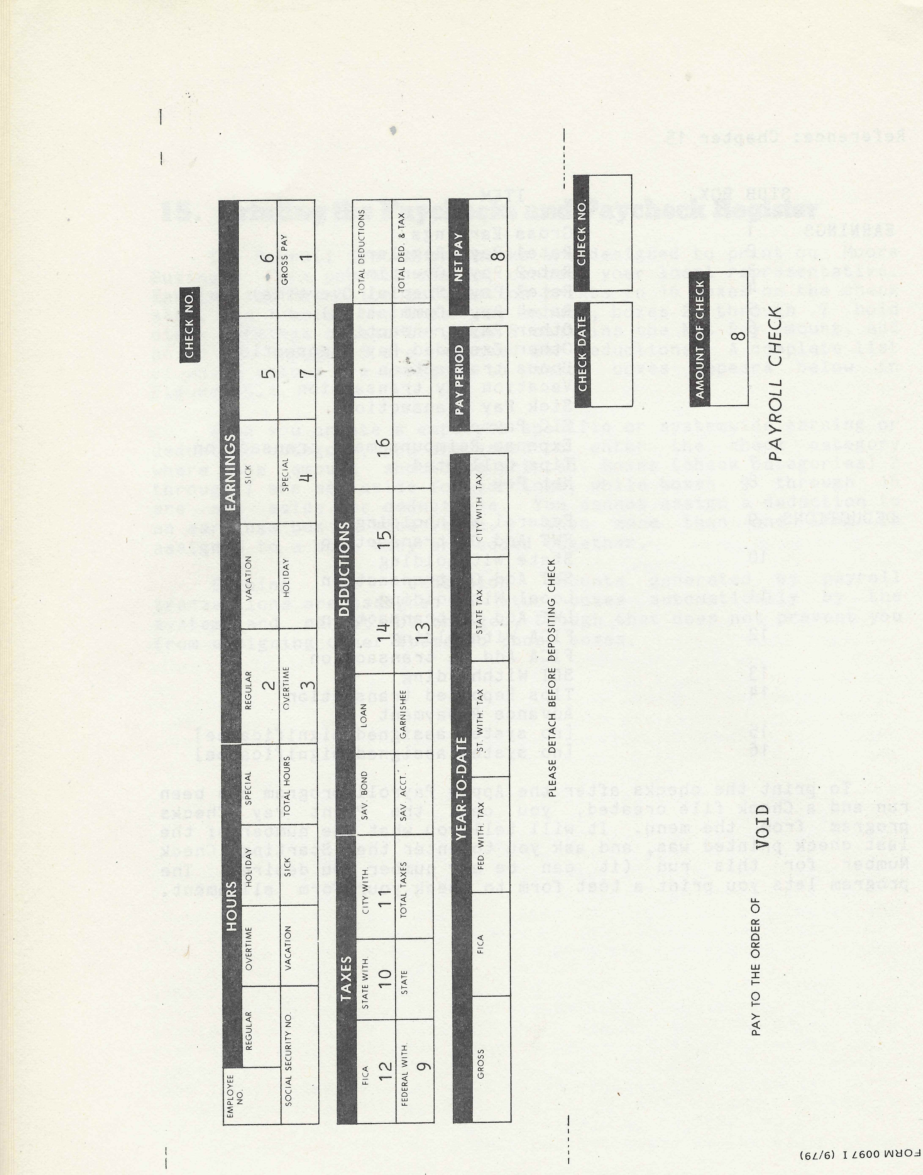

16. End of Period Processing

At the end of each quarter you must print the Federal 941 Report, the Employer's Quarterly Federal Tax Return and run the Close for the Quarter program. At the end of each year you must print the Federal 940 Report, W-2 forms for all employees, and run the Close for the Year program.

Ending The Quarter

The quarter end processing steps must be undertaken sometime after the last application of the last quarter, and before the first payroll application of the next quarter. The Apply Payroll program does not let you continue if the Check Date you enter is past the last day of the quarter (Figure 16.1), and the Print 941 Report and Close for Quarter programs have not been run. You are also prevented from continuing if not enough applications have been run for the quarter to end (3 monthly, 6 semi-monthly, at least 13 weekly, and at least 6 bi-weekly). New intervals may only be added after quarter end processing and before the first application of the next quarter.

QUARTER LAST DAY OF QUARTER

1 March 31
2 June 30
3 September 30
4 December 31

(Figure 16.1)

The 941 Report may be printed directly onto the government form, or you can print it on plain paper and transfer the information by hand. You can suppress the automatic printing of your company name and address if you wish to use the printed label provided by the government. The Print 941 Report program displays a facsimile reproduction of the 941 report with the current figures, and allows you to change several of the items displayed. You can enter an adjustment of withheld income tax from previous quarters, an adjustment of FICA taxes, or change the payment dates and amounts if necessary to correspond to the actual dates and payment amounts. The report may be printed as many times as you desire.

The Close for Quarter program resets various registers of historical information to zero in preparation for beginning the next quarter. This program issues no requests. You must print the 941 report before you are permitted to run the Close for the Quarter program.

Ending the Year

The year end processing steps must be undertaken sometime after the Close for the Quarter program has been run for the fourth quarter, and before the first run of the Apply Payroll program for the new year. The Apply Payroll program does not let you continue if the Check Date you enter is past the first of the year and the Close for the Year program has not been run. The Close for the Year program may not be run until the Federal 940 Report and the W-2 forms have been printed. And the Federal 940 Report and the W-2 forms may not be printed until the Close for the Quarter program has been run for the fourth quarter.

YEAR END PROCESSING STEPS

1. Close for the fourth quarter.
2. Print Federal 940 Report.
3. Print W-2 forms for all employees.
4. Run Close for the Year program.

(Figure 16.2: Ending the Year)

Print the 940 report on plain paper and transfer the information to the government form. There are no requests issued by this program.

The W-2 forms print in the standard W-2 format. The Print W-2 Report program lets you specify the number of forms to print for each employee. This option makes it possible to print W-2's on multiple copy carbon forms, or print the required number of W-2 forms on carbon less forms. You can suppress printing of local and state withholding amounts for the run, or print Federal, state, and local withholding information together. The program also lets you set the starting print column if you wish.

You can produce W-2 forms for all employees, a range of employees, terminated employees only, or for a single employee. The Print W-2 Report program may be run as many times as needed before you run the Close for the Year program.

The Close for the Year program resets various registers of historical information in preparation for the new year. It issues no requests. It does not run until the 940 Report has been printed and W-2 forms have been printed for all employees.

17. Optional Reports

The reports below (Figure 17.1) are optional in that their production is not a prerequisite to further processing steps. They can be produced at any time.

1. Account Print
2. Employee Master List
3. Employee History Report
4. Vacation Report

The Account Print is a short report that lists the currently valid Payroll System accounts. To produce the Account Print you align the paper in your printer, and choose the Print Accounts program from the menu.

The Employee Master List can be produced in two versions. One is a short version that gives an employee's name, number, social security number, pay interval, status (active, terminated, on leave), pay type (hourly, salaried), phone number, start date, birth date, Rate1 rate, and job code. It prints one line for each employee.

The full version of the Employee Master List does a simple report as above to act as a quick reference followed by one that devotes one page to each employee. It lists all of the above, plus information on pay rates, vacation, sick leave, comp time, withholding allowances, tax exemptions, employee specific earnings and deductions, and cost distribution.

When you select the Print Employee Master List program from the system menu, another menu appears from which you can select the desired printing option. This menu is reproduced below (Figure 17.2).

Y O U R C O M P A N Y N A M E
ACAS Payroll SYSTEM
00/00/00 EMPLOYEE MASTER LIST PRINT MENU

1. ALL EMPLOYEES 8. ALL HOURLY EMPLOYEES
2. ALL WEEKLY EMPLOYEES 9. ALL SALARIED EMPLOYEES
3. ALL BI-WEEKLY EMPLOYEES 10. ALL ACTIVE EMPLOYEES
4. ALL SEMI-MONTHLY EMPLOYEES 11. ALL ON-LEAVE EMPLOYEES
5. ALL MONTHLY EMPLOYEES 12. ALL TERMINATED EMPLOYEES
6. ALL WEEK BASED EMPLOYEES 13. ALL DELETED EMPLOYEES
7. ALL MONTH BASED EMPLOYEES 14. A RANGE OF EMPLOYEES

ENTER YOUR SELECTION NUMBER: [ ]

RANGE FROM [ ] TO [ ]

FULL INFORMATION OR SINGLE LINE (F OR S) [ ]

(Figure 17.1)

The Employee History Report presents summarized quarter to date and year to date earnings and deduction information. To print this report you choose the Print History Report from the system menu.

The Vacation Report includes information on sick pay and comp time. To print this report you select it from the system menu.

Next pages faint images for Employee Master Print out - 73 - 86 -- 14 pages landscape on continuous stationary - dated 1/16/80-

Needs to be revised for the new versions.

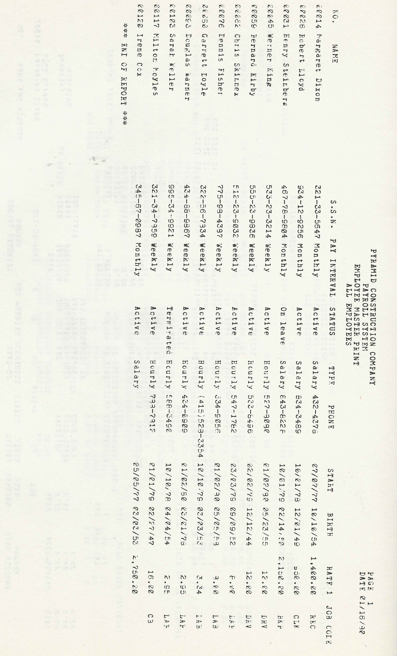
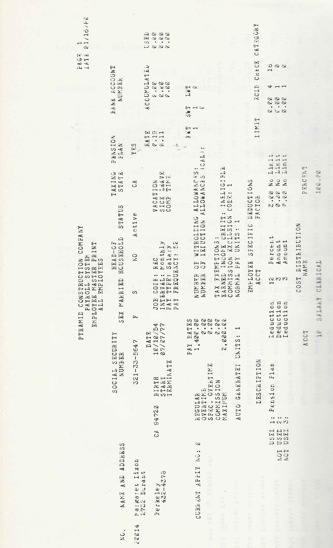
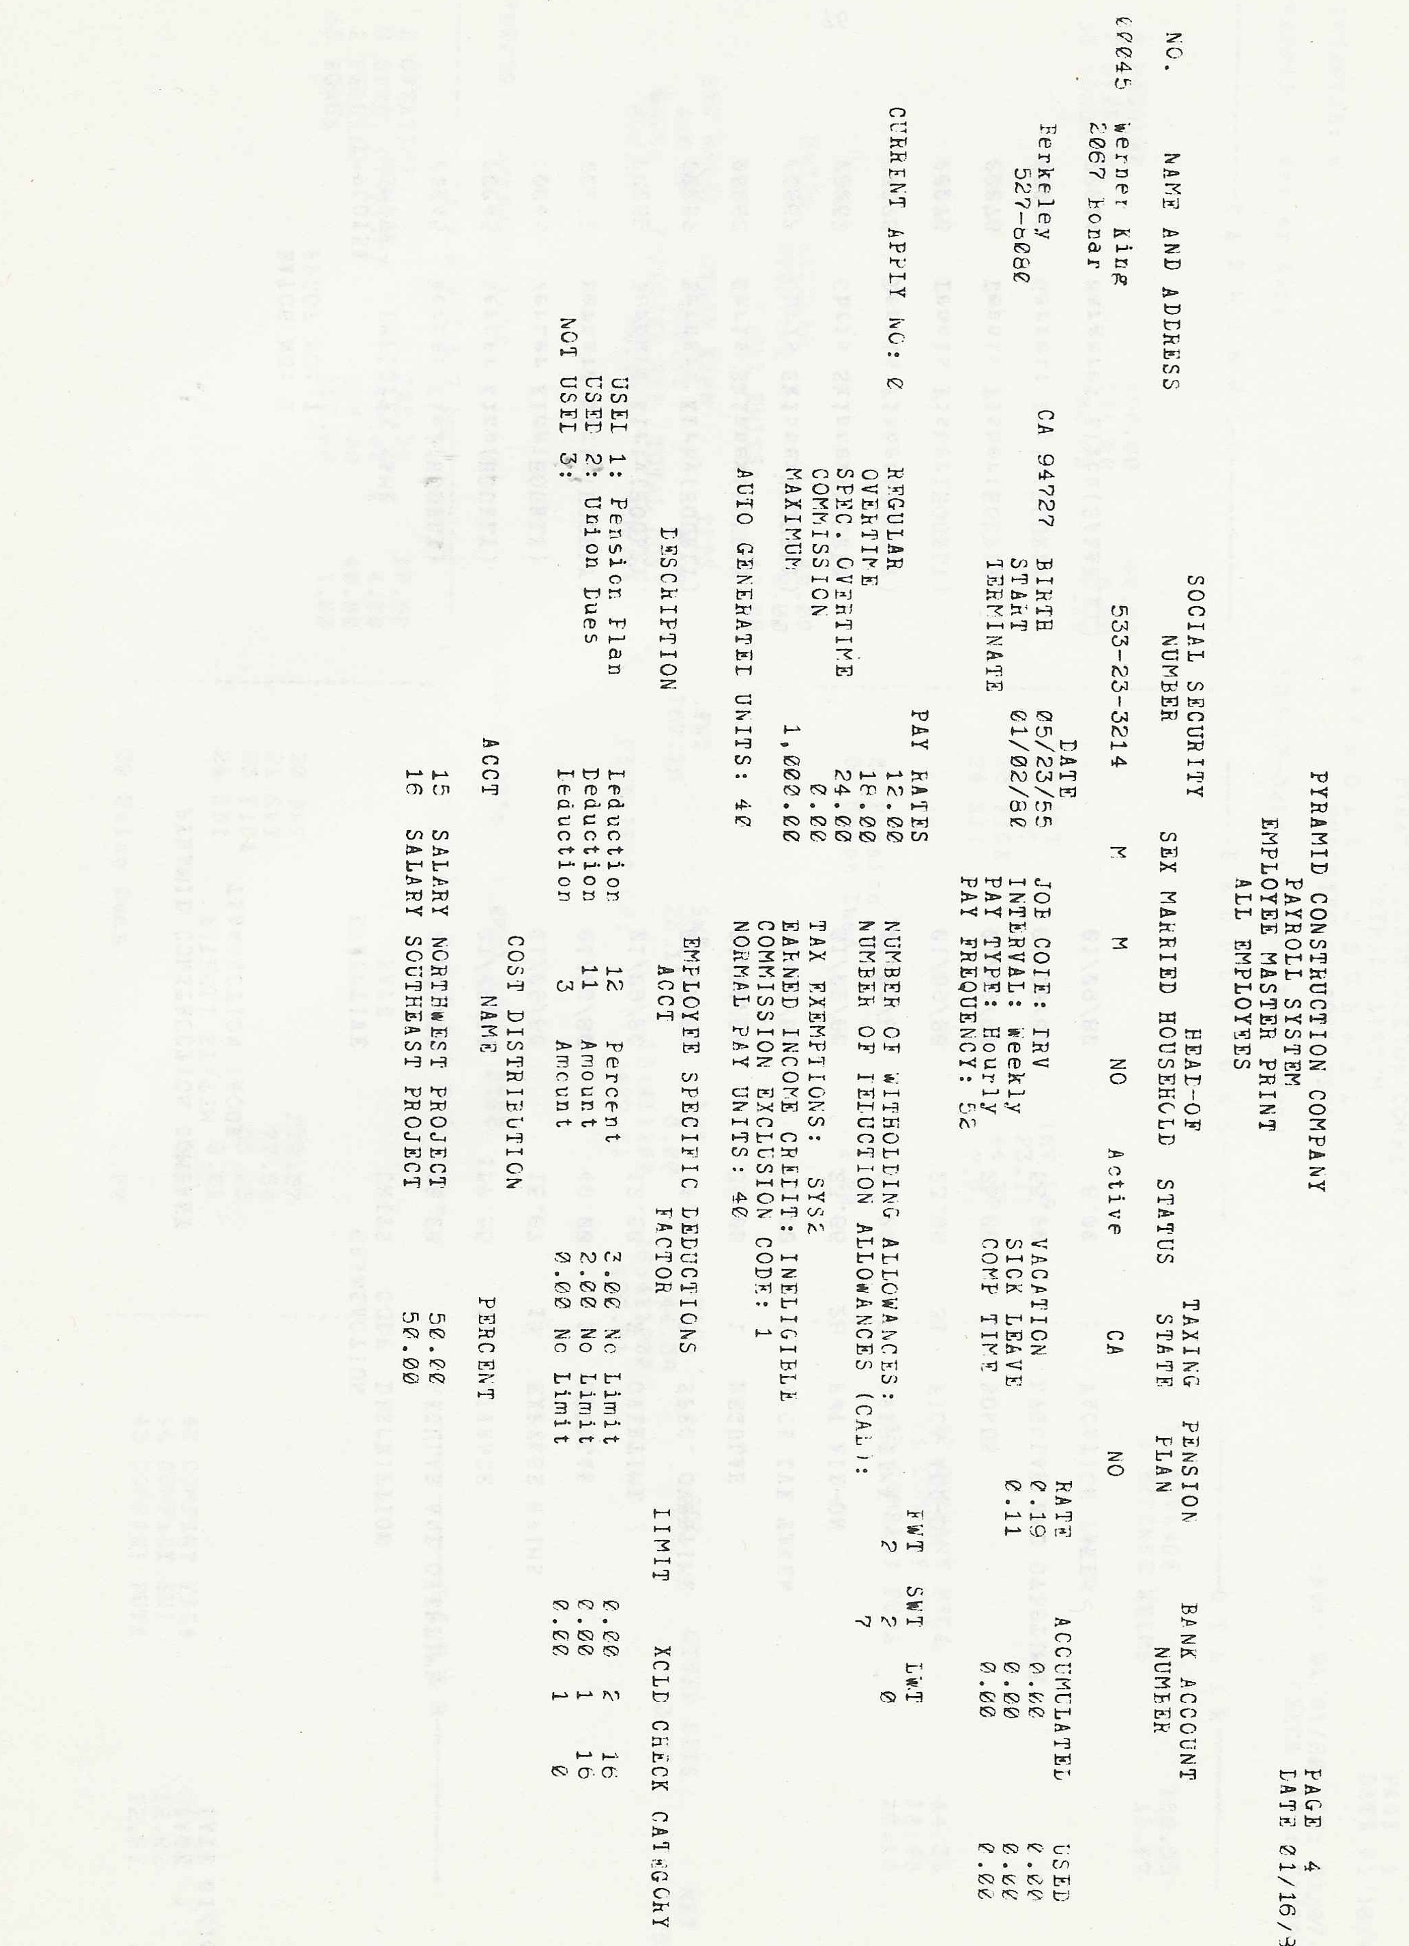
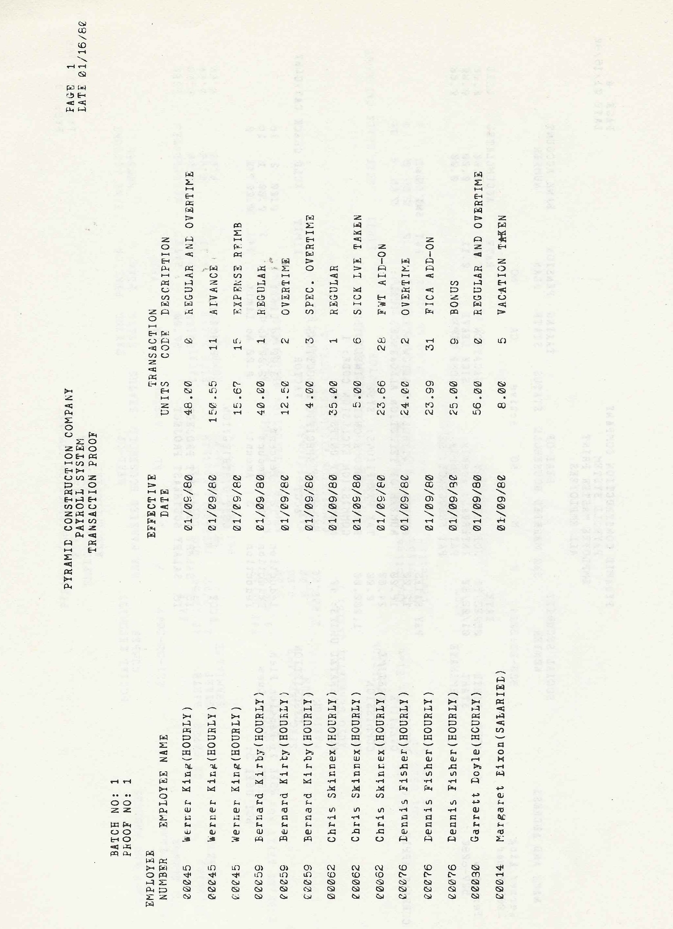
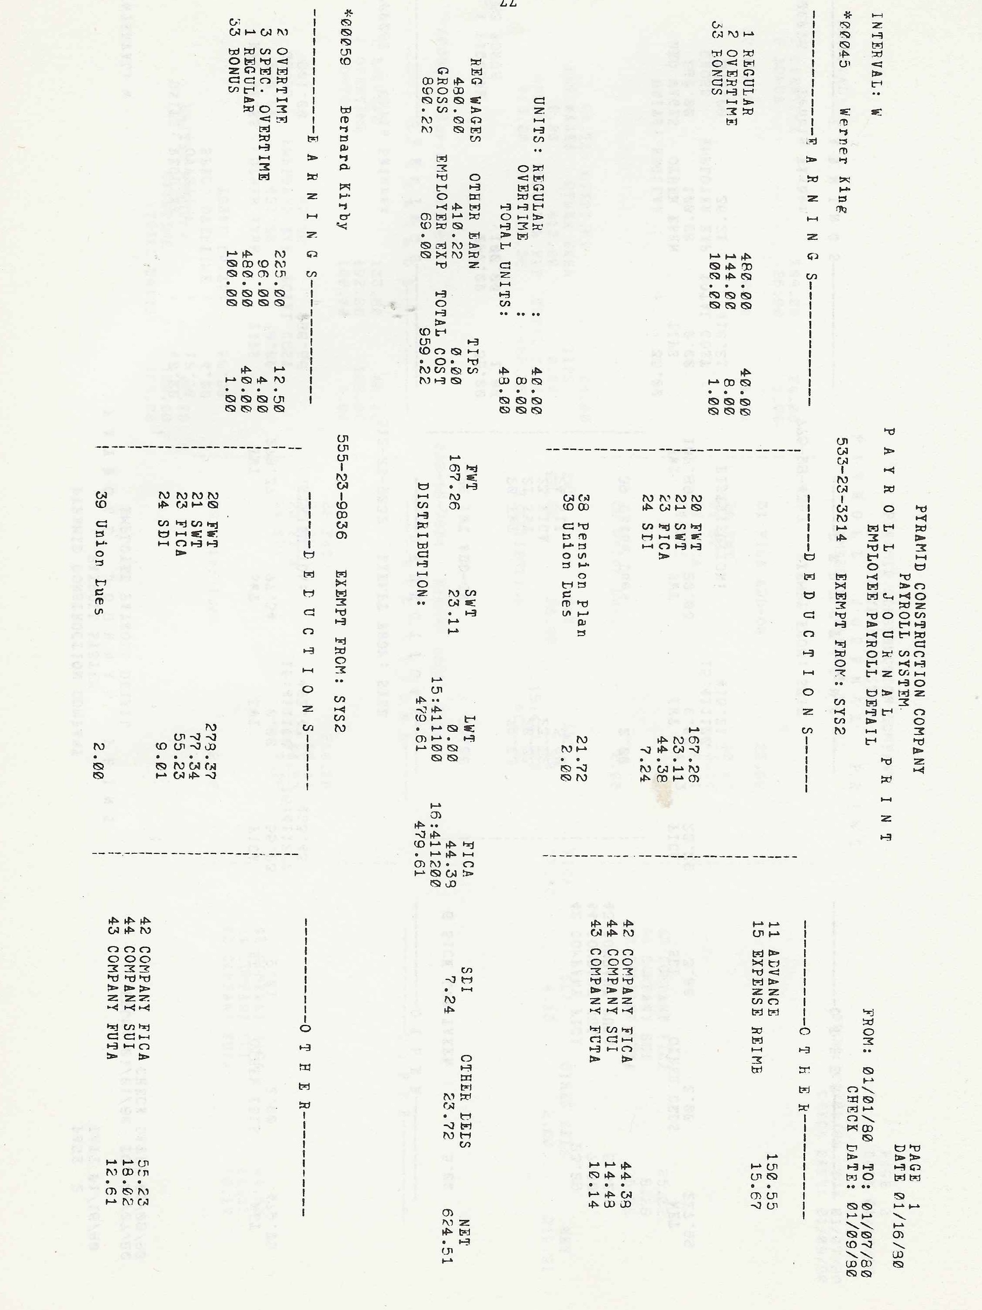
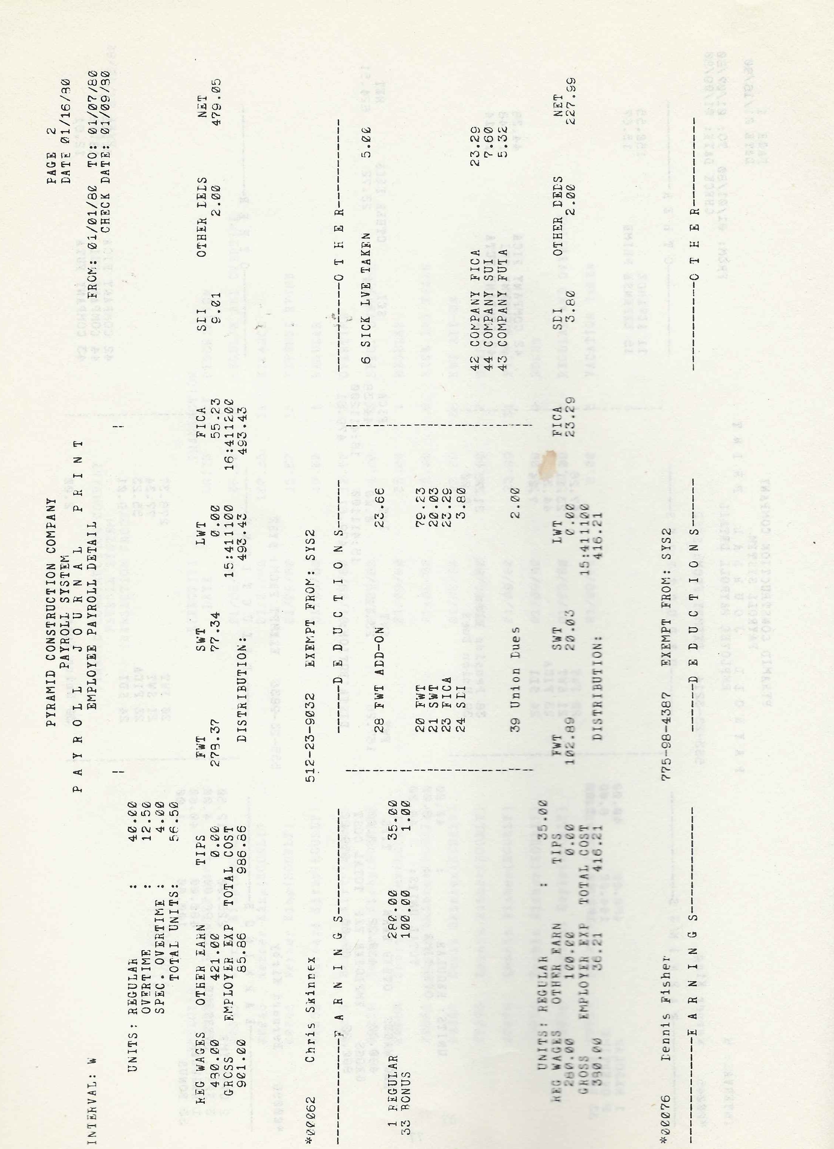
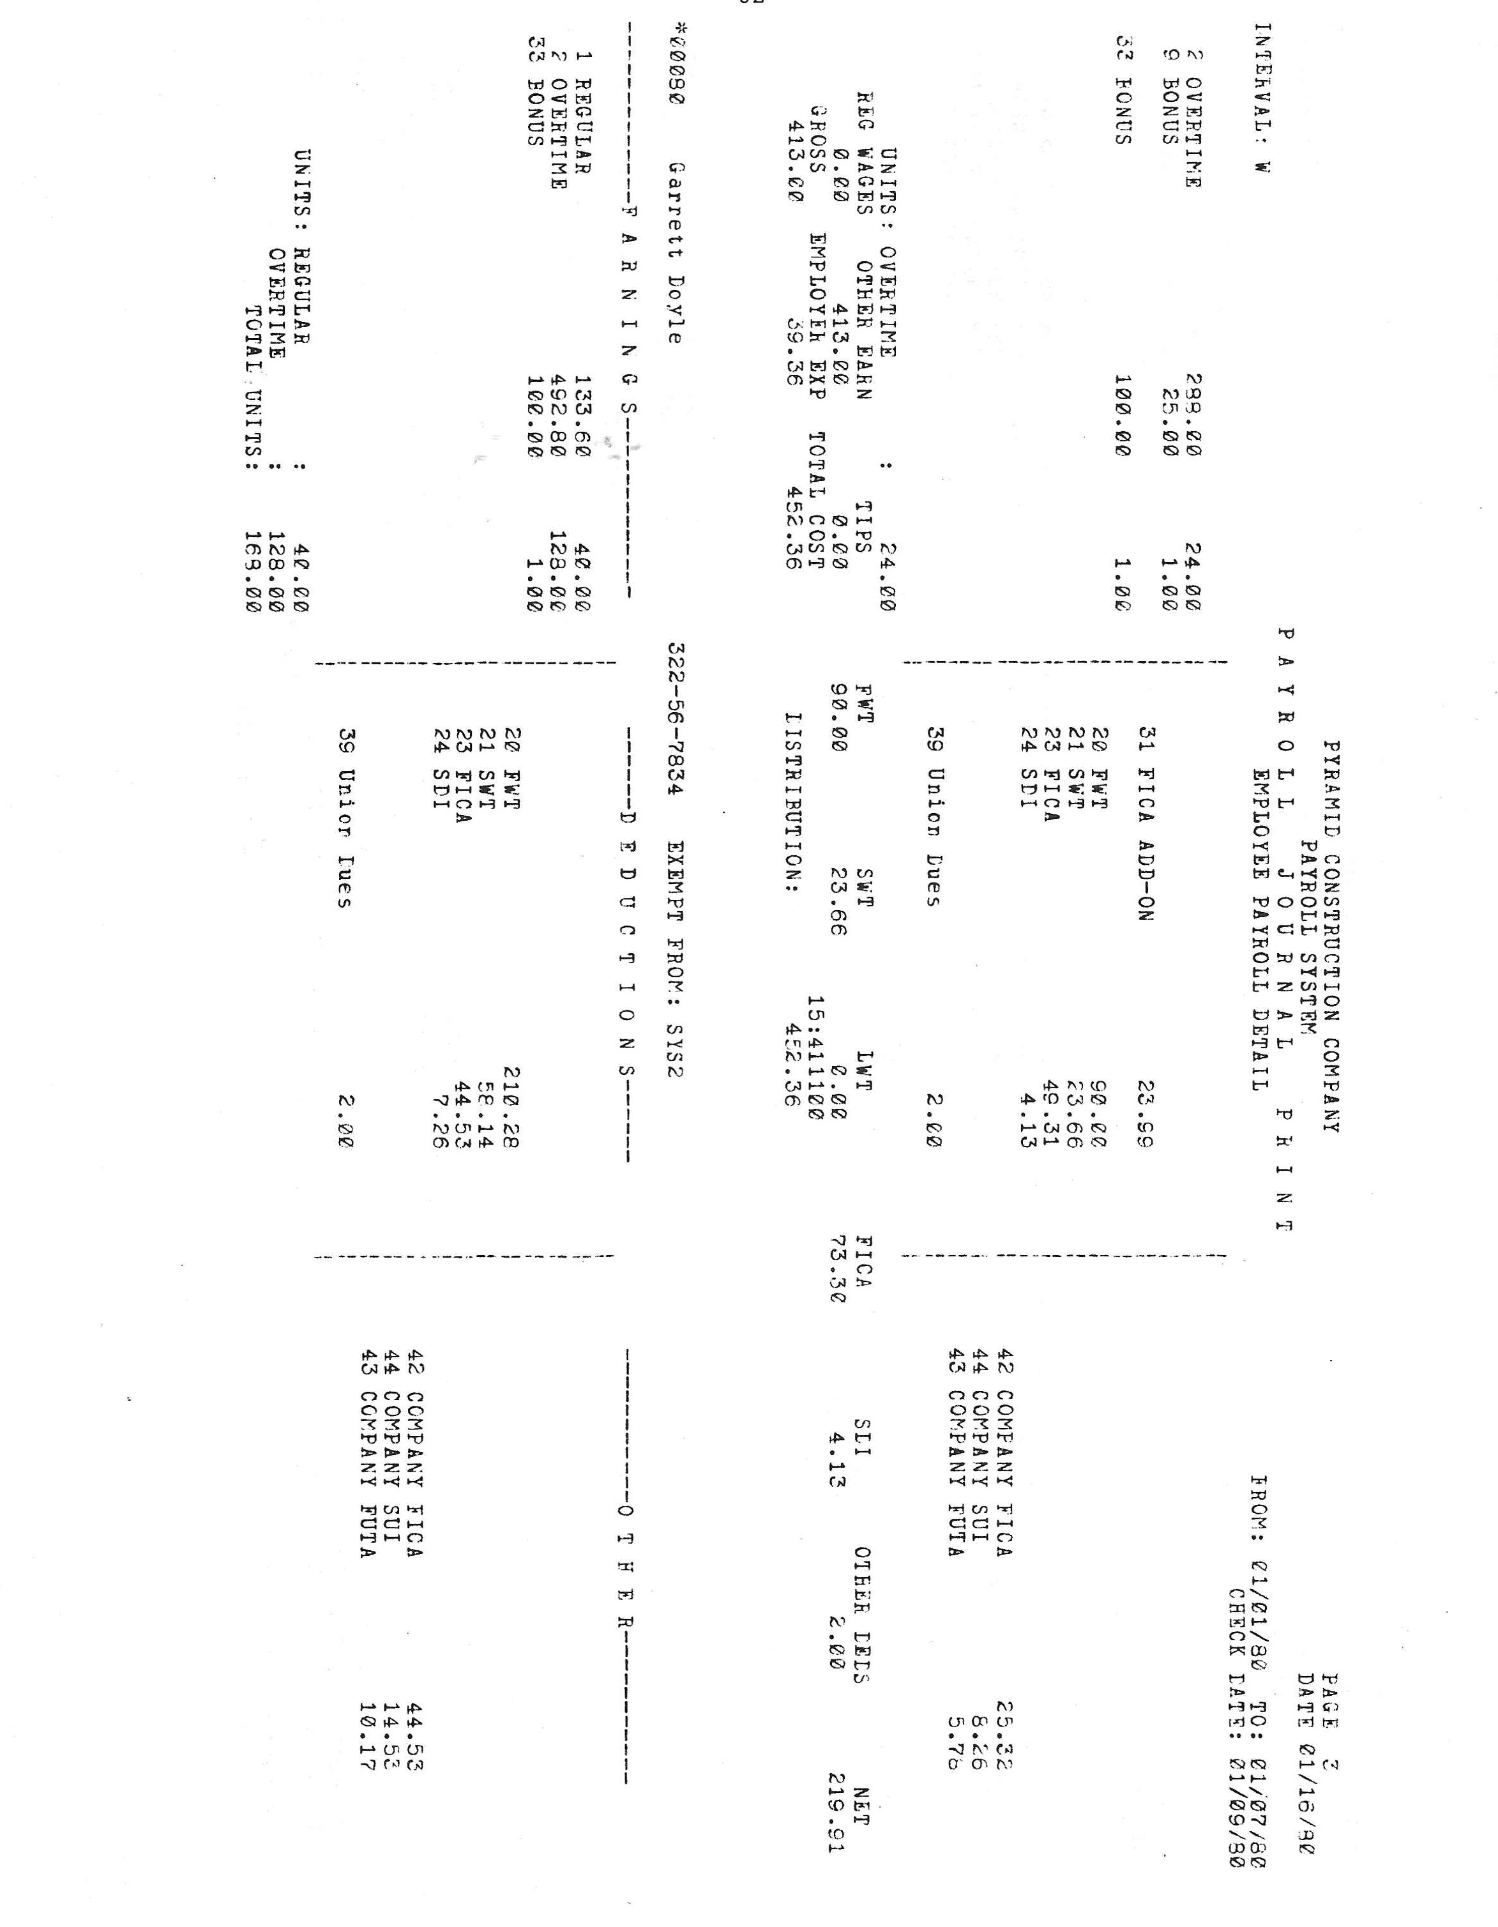
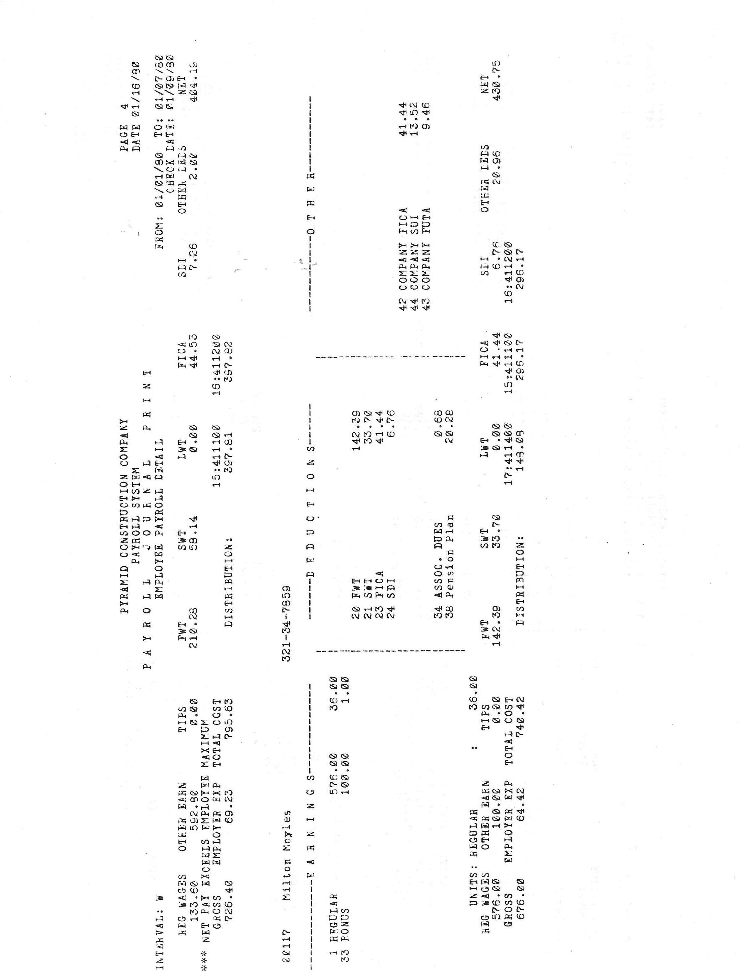
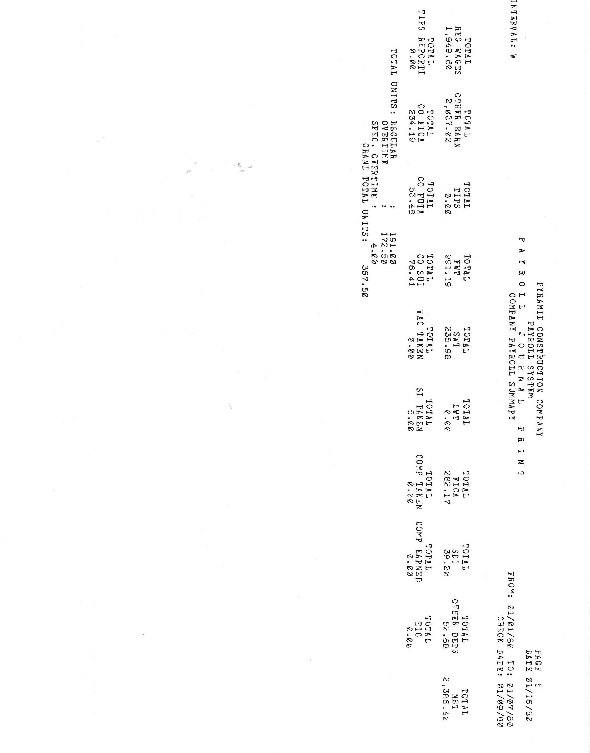
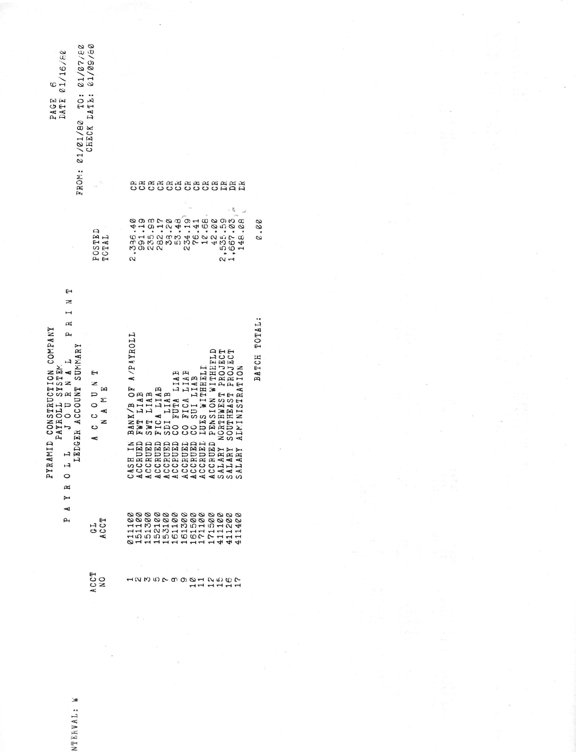
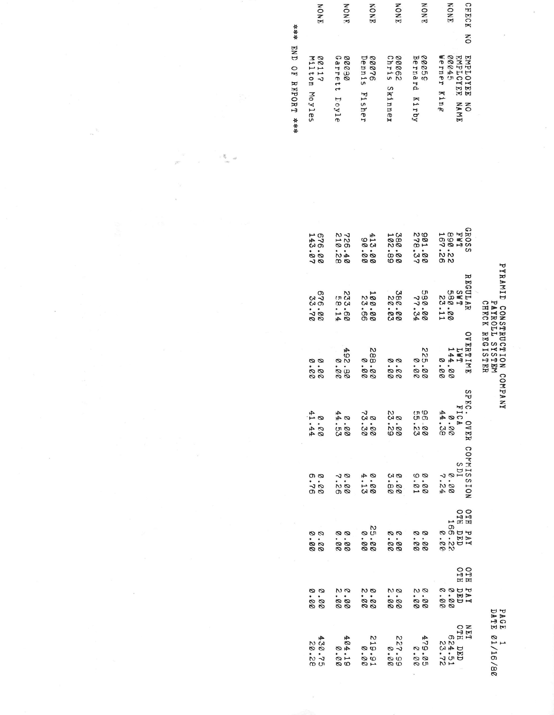
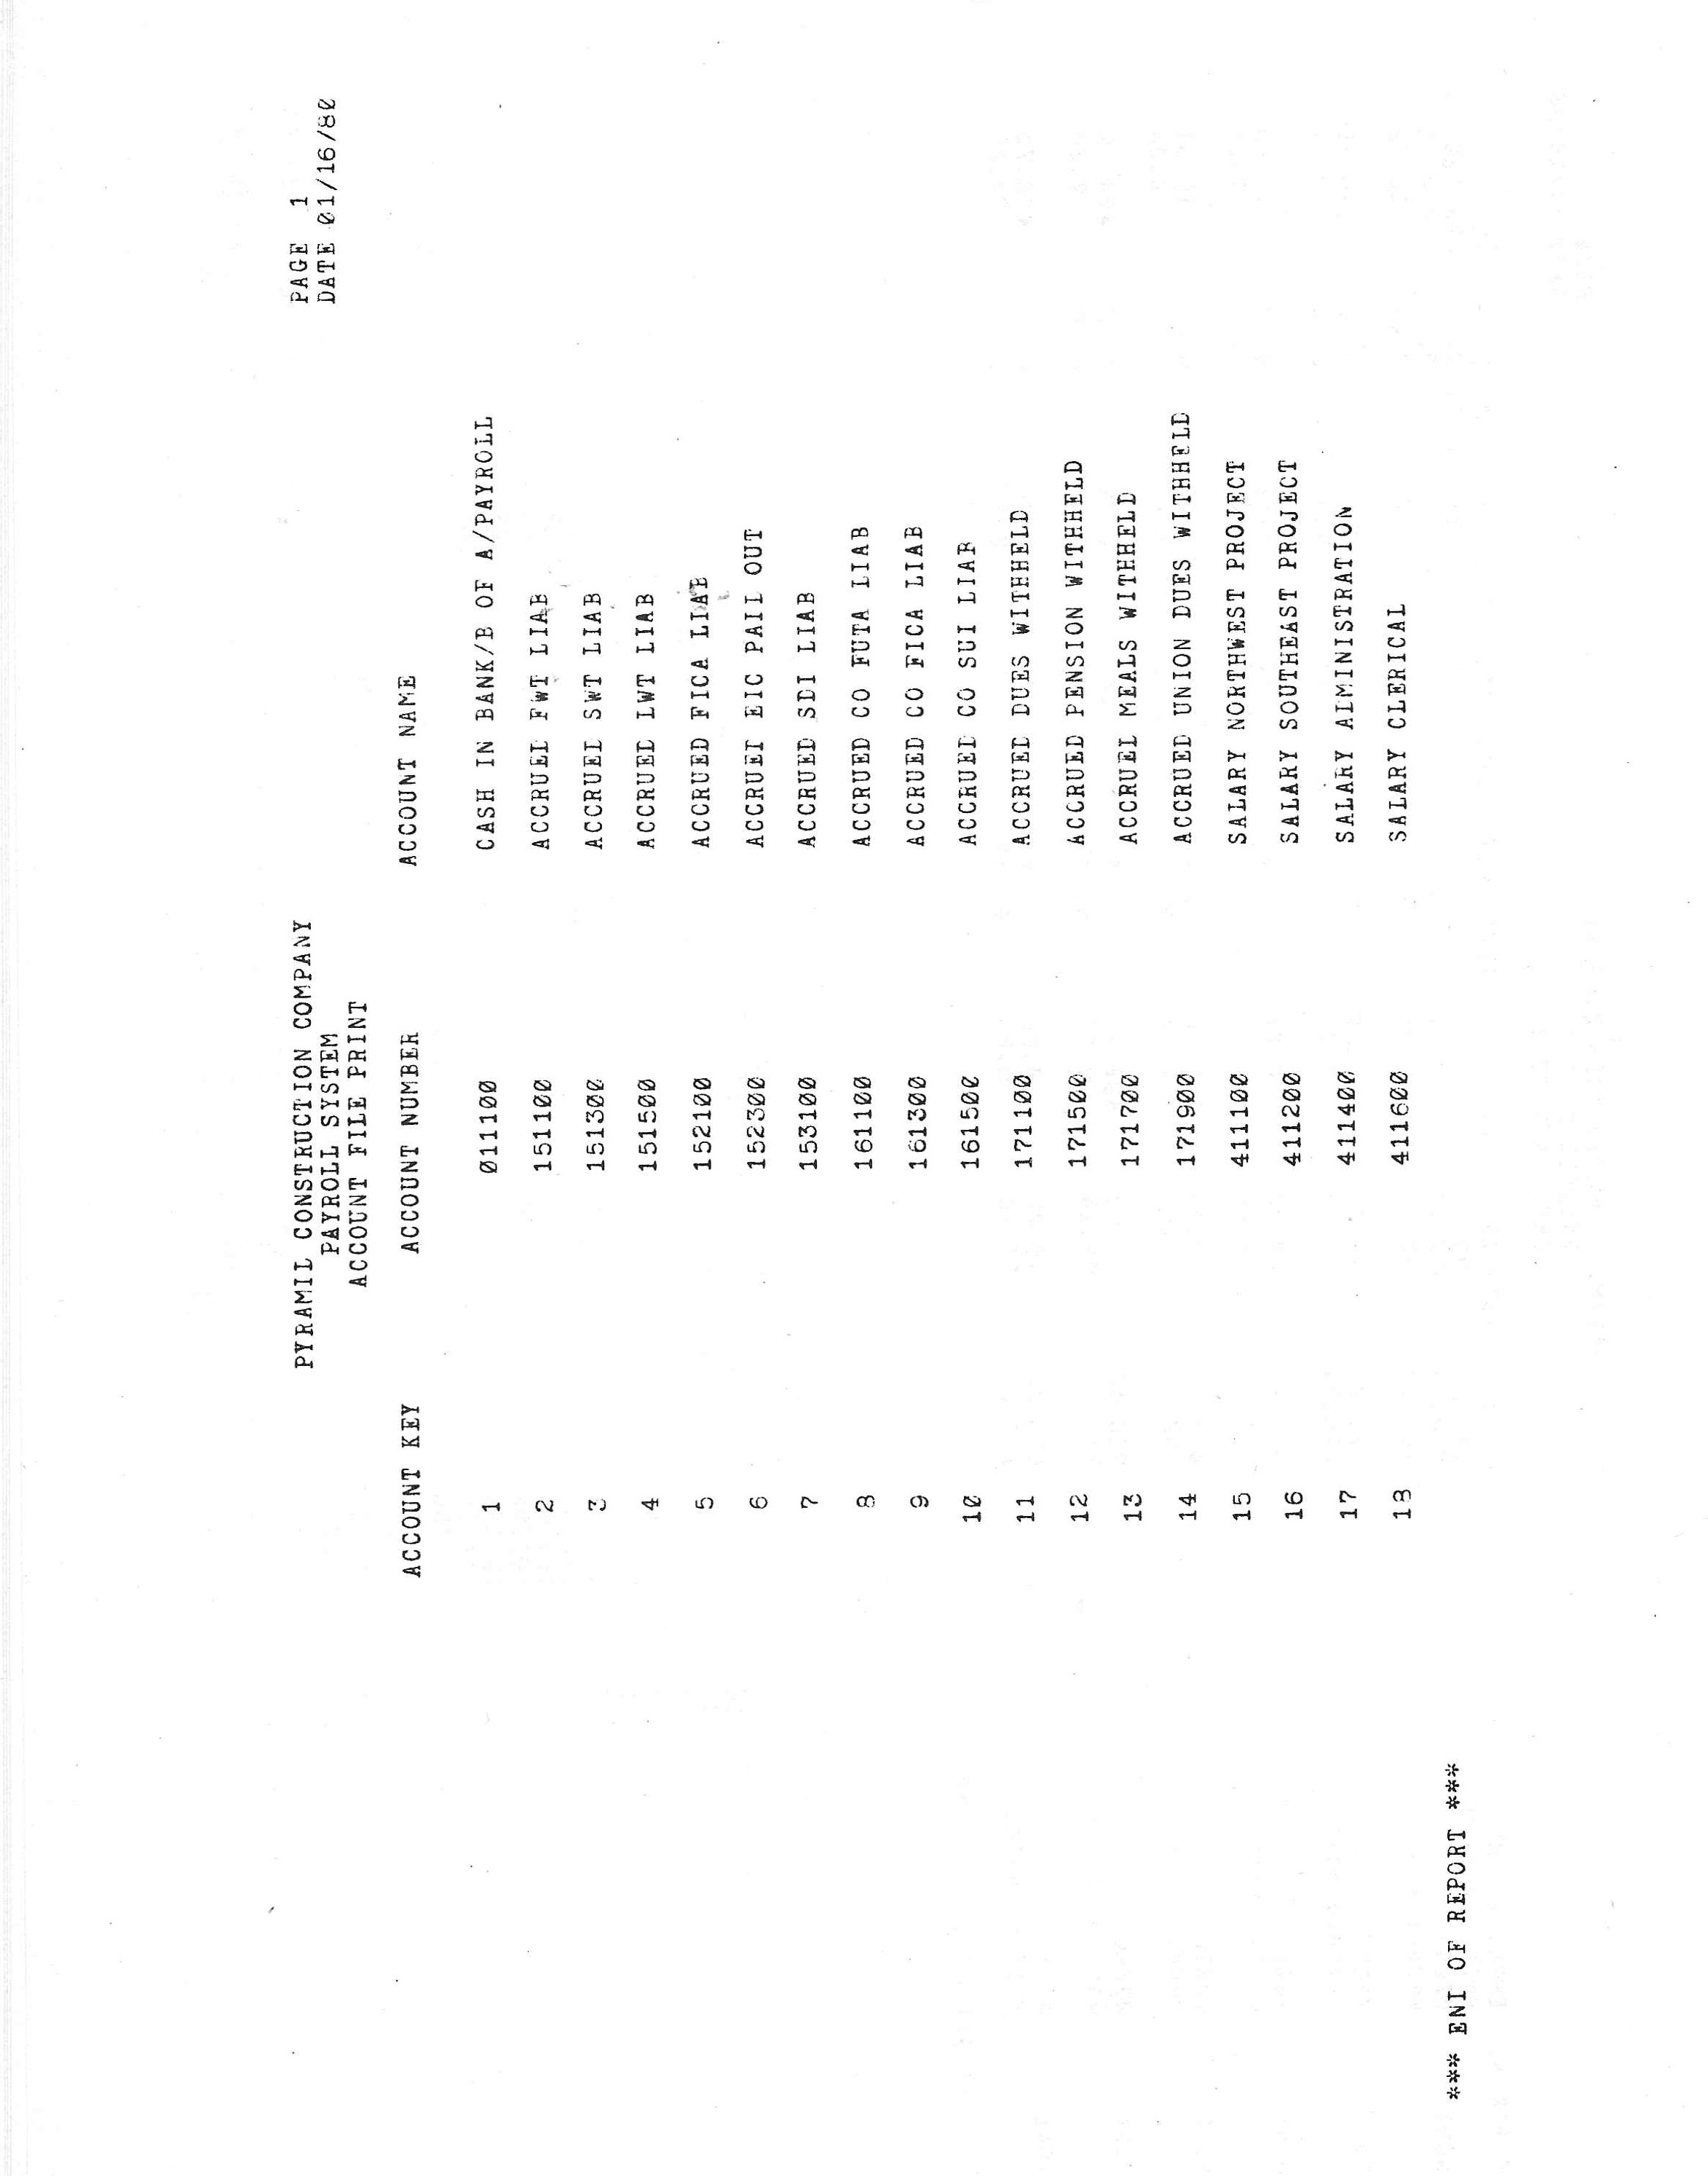
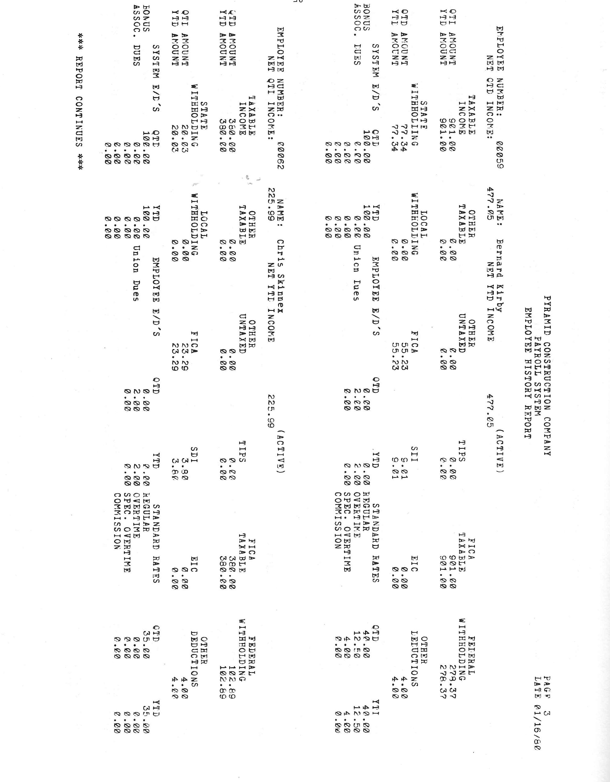
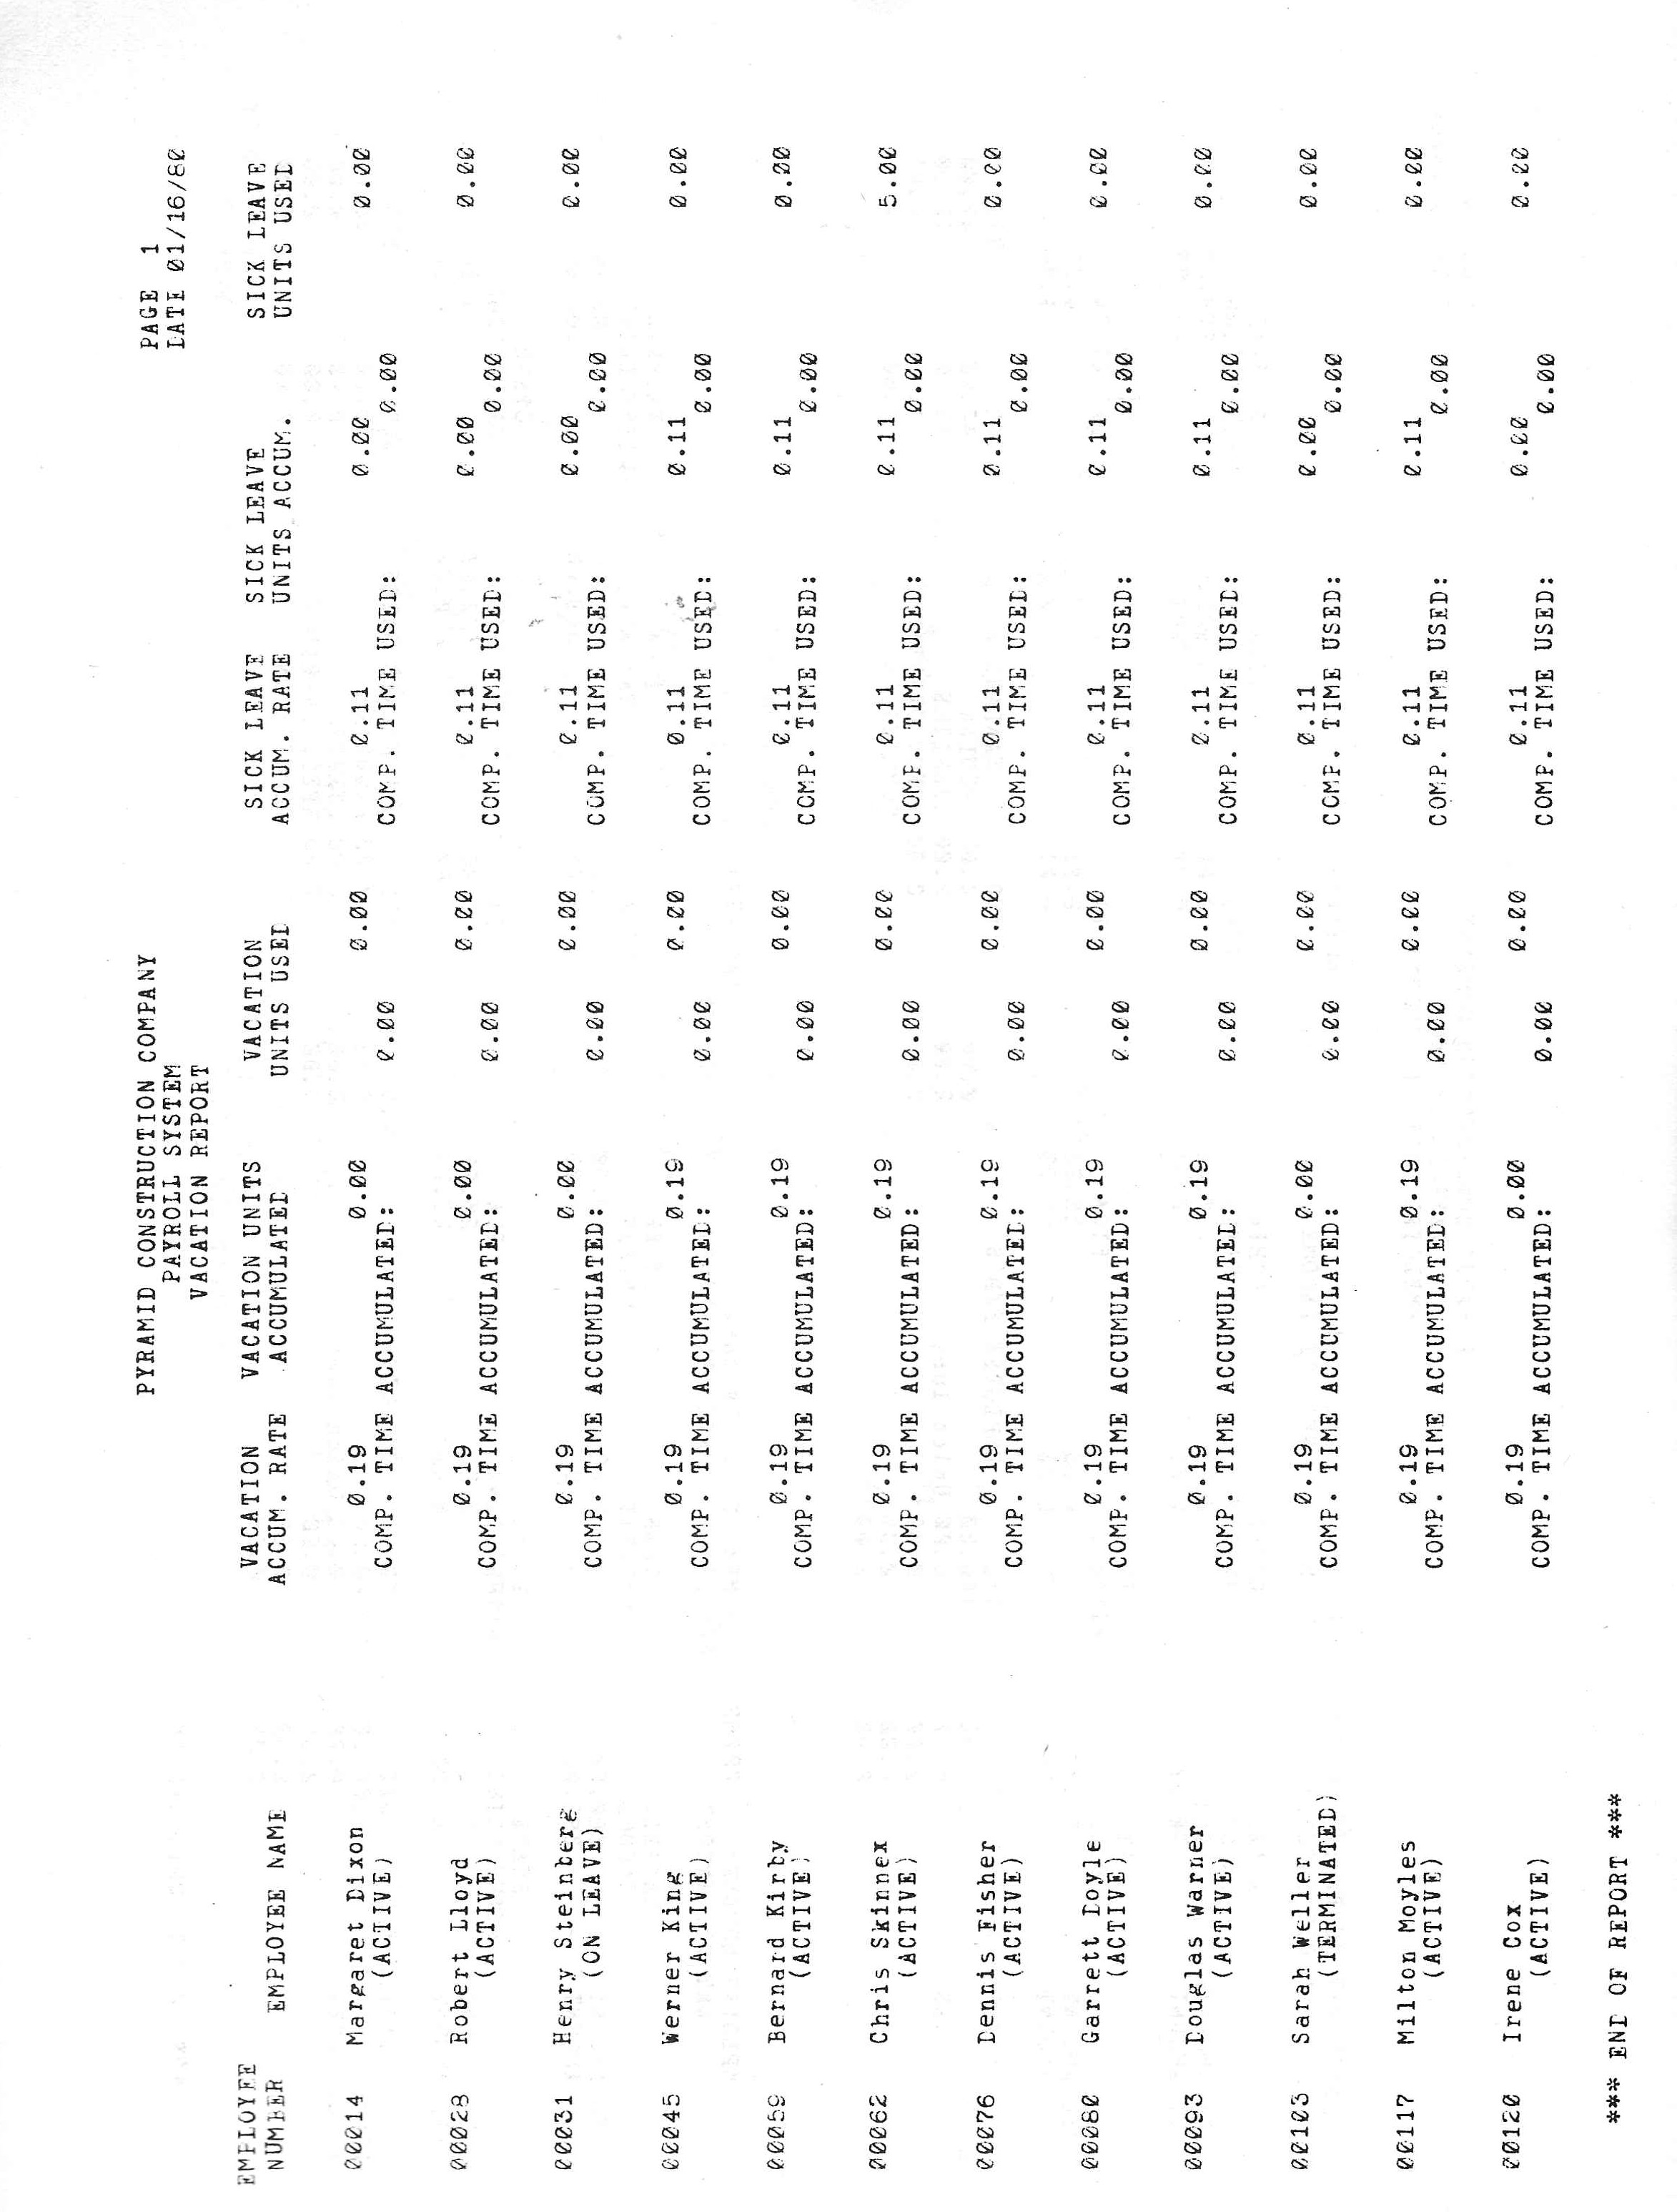

Operation Section

18. Interacting with the System

This chapter explains how to interact with the Payroll System, and provides additional information that may be useful to those new to computer operations.

How to Answer a Request

First, move the cursor to the bracketed field that corresponds to the request. (The cursor is the moving spot of light on the screen, usually triangular or rectangular in shape. It may or may not be blinking, depending on your equipment.) If the field is empty, type in your response, and then press the RETURN key. If the field is full, type in your response over the current value and press RETURN. For example,

COMPANY NAME: [Universal Enterprises ] <Current Value>

COMPANY NAME: [Universal Enterprises ] <Your Entry>

COMPANY NAME: [Universal Inc. ] <After RETURN>

If the current value is acceptable, just press RETURN.

How to move from Request to Request

After you type in your response to a request and hit RETURN, the cursor moves along a fixed path to the next request, or around to the first request. To change the value currently in a field, you press RETURN to move the cursor forward to the desired request, and type in your response. To move back one field (that is, one request) in a Display Management System entry screen, give the command:

CTRL-B

Note, however, that when the cursor is at a field labelled Employee Number or Record number, the CTRL-B command means something different. At those locations CTRL-B causes the program to display the previous record on the file (i.e., "go BACK and get the previous record").

How to "Thumb" through a File

When you select the Employee Entry, Employee Ded/Earn and Cost, or the Employee Rate Entry programs, the appropriate entry screen appears with the cursor waiting at the Employee Number request. If there are records on the Employee Master file, you can "thumb" through the file by any combination of the following three methods:

1. Give the command CTRL-N to get the NEXT record on the file. When no records have been accessed, this command gets the first record on the file.

2. Give the command CTRL-B to go BACK and get the previous record on the file. When no records have been accessed, this command brings up the last record on the file.

3. Enter the five digit employee number to get the record for that employee.

When you select the Pay Transaction Entry, or the Account Entry programs the appropriate entry screen appears with the cursor waiting at the Record Number request. If valid records exist on the file you can "thumb" through the file by any combination of the following three methods:

1. Give the command CTRL-N to get the NEXT record on the file. When no records have been accessed, this command gets the first record on the file.

2. Give the command CTRL-B to go BACK and get the previous record on the file. When no records have been accessed, this command gets the last record on the file.

3. Enter the "relative record number" of the record you want to access. The relative record number is the position of the record relative to the beginning of the file. For example, the first record on the file has relative record number 1, the second has relative record number 2, etc. The Payroll System Account Reference Number is the same thing as the relative record number of an Account File record.

How to fix a typographical Error

To back up and erase one character before pressing RETURN, give the command:

CTRL-H

as many times as necessary to back up to the erroneous entry, then type in the correct characters. Hit RETURN to continue.

If you've already pressed RETURN, give the command CTRL-B to go back to the previous field and type in the correct response.

How to Cancel an Entry

While adding an employee record through the Employee Entry program, an account through the Account Entry program, or a pay transaction through the Pay Transaction Entry program, before hitting ESCAPE to begin the next record, you can cancel the entire employee, account, or transaction record by giving the command:

CTRL-X

Once the entry has been completed and entered onto the system by hitting ESCAPE, the cancel command has no effect.

How to give a Control Command

To give a CONTROL command, such as CTRL-H or CTRL-N, you hold down the CONTROL key (CTRL or CTL on some keyboards) as you would a SHIFT key on a typewriter, and while holding it down, type the appropriate letter (either upper or lower case). You can depress the CONTROL key for as long as it takes to enter the command.

How to enter a Number

When you answer a request with a Multi-digit number or dollar amount, do not type in the commas, if any. The program inserts them where needed. Two is the largest number of digits allowed to the right of the decimal point. You must type in the decimal point (period) when you enter a decimal number. When you enter a flat dollar amount (no cents), you need not type in the period and two zeros, the program inserts them for you.

EXAMPLE: To enter $4,520.00 into the MAX PAY field, type in:
MAX PAY: [4520 ]

After hitting RETURN, the field shows,

MAX PAY: [ 4,520.00]

EXAMPLE: To enter $4,520.35 into the MAX PAY field, type in:
MAX PAY: [4520.35 ]

After hitting RETURN, the field shows,

MAX PAY: [ 4,520.35]

How to enter a Date

The Payroll System checks all date entries to make sure they are valid dates and conform to the date format (MM/DD/CCYY or DD/MM/CCYY) specified in Parameter Entry. The system bars you from entering a date such as April 31 (since April has only 30 days). Nor will it let you enter February 29 for a non-leap-year. The American date format (MM/DD/CCYY) is used unless you specifically request the international format (DD/MM/CCYY). You need not type leading zeros for single digit months or days, but you are required to type in the slash marks (/).

EXAMPLE: To enter March 5, 2025, you would type:
[3/5/2025 ]

and then RETURN. After RETURN, the field would show:

[03/05/2025]

How to end the current function or program

Hitting the ESCAPE key takes you one "layer" out of the system. For example, while adding employees to the Employee Master file in the Employee Entry program, ESCAPE signals that you have completed the record for that employee and are ready to add another. An ESCAPE right after the previous ESCAPE (before you begin the next employee record), takes you out of the Add-Records mode, and returns the cursor to the Employee Number field where you can give other commands (such as CTRL-N or
CTRL-B). A third ESCAPE ends the Employee Entry program and returns you to the main system menu. ESCAPE at the system menu ends the Payroll System altogether. When the CP/M prompt appears and the access light goes out, you can remove the disks.

How to end a print out

If your paper should jam in the printer, or if you want to end a printout for some other reason, just press any key on the keyboard. To restart where you left off, type "RUN". To end the program, type "STOP".

19. Setting Up

SKIP MOST OF THIS for ACAS Cobol version
The first step in setting up your Payroll System is to make two copies of the distribution disks. One distribution disk contains the Start up programs, another contains the normal processing programs, and a third contains the state and local tax table files and two utility programs.

To copy the disks place a formatted disk containing the CP/M operating system, and PIP on drive A. Place the (write protected) Start up distribution disk on drive B and hit the RESET switch on your machine. Type the command,

A>PIP A:=B:*.*[ov]

and follow with RETURN. When the PIP is complete, remove the distribution disk from drive B, replacing it with a formatted disk that has the CP/M system SYSGEN'ed onto it. Enter CTRL-C or RESET the machine, and give the command,

A>PIP B:=A:*.*[ov]

You now have a Start up Master Disk and a Start up Work Disk. Repeat the same process to create a Processing Master Disk and a Processing Work Disk. Copy the Tax disk in the same way. Label one copy the Tax Master Disk and the other copy the Payroll Data Disk.
The two work disks with the programs will need CRUN2.COM PIP'ed onto them. If you are operating in single density you will probably not be able to fit CRUN2 and PIP on the disks together. Remove PIP from the work disks (if it is on them) and PIP CRUN2 onto the work disks from another disk that does have PIP. CRT.DEF (if used) should also be PIP'ed onto these disks before you can begin.

If you can use the two disk configuration described in Chapter 7, the programs on the Start up Disk and the Processing Disk may be combined on one disk.

The second step in setting up the Payroll System is to define the characteristics of your CRT to the Display Management System.

If you have the Hazeltine 1500 CRT, the Payroll system will run immediately; you may erase all files with the filetype of DEF, and the CRTDEF.INT program from your system master and work disks (but not the SSG distribution disk!). You can use the commands,

ERA *.DEF
and, ERA CRTDEF.INT

If you have one of the CRT devices listed below, you must use the CP/M REN command to rename the DEF file corresponding to your CRT to the name CRT.DEF:

CRT DEF FILE
--------------------------------------------------

ADM 3A ADM3A.DEF
BEEHIVE 150 B150.DEF
BEEHIVE 152 B152.DEF
BEEHIVE 157 B157.DEF
CROMEMCO 3100 CRO3100.DEF
DYNABYTE NAKED TERMINAL DYNABYTE.DEF
SOROC IQ 120 SOROC120.DEF
IMSAI VIOC VIOC.DEF

With the disk holding the DEF files on drive A, type the command:

A>REN A:CRT.DEF=A:nnnnnnnn.ttt

where nnnnnnnn.ttt stands for the filename and filetype (suffix) of your CRT definition file. Erase the remaining DEF files from your disk one at a time (for example, ERA ADM3A.DEF, ERA B150.DEF, etc.). Erase also the CRTDEF.INT program. The Payroll system always expects to find the CRT.DEF file on the currently logged disk drive.

If you have neither the Hazeltine 1500 device, nor one of the CRT's listed above, see Chapter 32 for instructions on how to create a CRT.DEF file that defines your CRT to the Display Management System by running the CRTDEF.INT program.

The third step in setting up the Payroll system is to erase the state tax table files you do not need from your data disk and rename the local tax table file. The state withholding tax table files (except for California) take the form,

PYSWTaa.101

where "aa" is the two character state abbreviation. There are four tax table files for California:

PYCALS.101 [S=Single]
PYCALM.101 [M=Married]
PYCALH.101 [H=Head of Household]
PYCALX.100

Be sure to keep all four on the data disk if the California tables are to be used.

The local tax table files have the file type of LWT, and a file name that indicates the locality (for example, NEWYORK.LWT). Find the one for your locality and rename it to PYLWT.101. For example,

A>REN A:PYLWT.101=A:NEWYORK.LWT

Mid year Set up Procedures

When you set up the Payroll System in mid-year, after the other set up steps are complete, you must run the History Update program. This program can be run by choosing it from the menu. You can run it as often as necessary until the first payroll application has taken place. After the first application, the History Update program will not run.

When you select the History Update program from the menu the Update Employee History entry screen appears with the cursor waiting at the Employee Number field. You can enter the number of the employee whose history you wish to update (all employees must be updated before the first application), or give one of the following commands:

CTRL-N: Get the NEXT record on the file; or the first if none have been
accessed.
CTRL-B: Go BACK to the previous record; or to the last if none have been
accessed.
ESCAPE: End the Employee History Update section of the program and go on to
the remaining section.

After accessing an employee record, move the cursor to the first request by hitting RETURN. Type in the information and then hit ESCAPE to return the cursor to the Employee Number field where you can call up the record for the next employee. ESCAPE again (form the Employee Number field) ends this section of the program, begins a short processing program, and then brings up the "mini" menu shown in Figure 19.1. The standard commands, CTRL-B, CTRL-S, AND CTRL-R (go back a field, save data to disk, and refresh a garbled DMS screen) can be given at any point (although CTRL-B means something different when issued from the Employee Number field).

Y O U R C O M P A N Y N A M E
PAYROLL SYSTEM
00/00/00 HISTORY UPDATE MENU

1. UPDATE EMPLOYEE HISTORY TOTALS
2. UPDATE COMPANY LIABILITIES, VACATION, ETC.
3. UPDATE PAYMENTS HISTORY

ENTER SELECTION NUMBER: [ ]

The Update Employee History Totals entry screen is an exact reproduction of the Update Employee History screen, except that there is no Employee Number field since this screen presents the totals of the individual employees. You can make changes if necessary, but if the sum of the individual totals does not equal the actual company totals you should make sure that the individual employee information has been entered correctly. Press ESCAPE to end this section of the program and return to the History Update Menu.

Menu choices 2 and 3 are explained in Chapter 7. To enter the information requested by those menu items, simply choose them from the menu and type in the data. Hit ESCAPE to return to the History Update Menu. ESCAPE from the menu brings up the Payroll System menu.

If you want to change historical information for individual employees or enter information for the first time for a newly added employee (before the first payroll application), you would run the program again. Of course, if you do so you may have to adjust the new totals through the Update Employee History Totals program again.

20. Setting System Parameters

At first time start up, after you type CRUN2 PY to call up the system the system menu appears. The program asks you if you want to use the default Payroll System or answer the full range of Parameter Entry requests (QUICK PARAMETER ENTRY or PARAMETER ENTRY, respectively).

If you choose the default Payroll System (menu item 10) a limited parameter entry screen appears, allowing you to enter your company name, address, and government ID numbers. You also enter the pay interval you want to use (the default system allows only one pay schedule), and the last day of the previous pay period. When you finish answering these requests and hit ESCAPE, the start up sequence continues. It creates the default account file, the default System Deductions and Earnings file, the Sort Parameter file, and then presents the system menu. Once your system is set up, to examine or change the parameter values choose the Parameter Entry program from the menu.

If you choose not to use the default system, select the Parameter Entry program from the menu (menu item 9). A "mini" menu lists the three parts of the Parameter Entry program. Answer the requests for part one, part two, and part three, hitting ESCAPE when you finish answering the requests for each part. Press ESCAPE at the "mini" menu to end the Parameter Entry program. The Payroll System start up sequence will call up the Account Entry program automatically, allow you to enter or change account information, then call up the System Deductions Entry program, and allow you to enter or change that information. After the program goes on to Create Sort Parameters, the system menu returns. Any further parameter changes can be made by calling the Parameter Entry, Account Entry, or System Deduction Entry programs directly from the menu.

The list below shows selected parameter requests and restrictions on their responses. See Chapter 18 for instructions on how to enter numbers and dates.

CO NAME: 60 characters maximum
ADDRESS: 3 lines of 30 characters each
CITY: 18 characters maximum
STATE: Official two-character state abbreviation
ZIP: 5 digit number only
GOVT ID NOS.: 10 digit number maximum
VACATION RATE: 99,999.99 maximum entry
S.L. RATE: 99,999.99 maximum entry
RATE1,2,3, and 4 DESCRIPTIVE NAME: 15 characters each
RATE1 DEFAULT: 99,999.99 maximum entry
RATE2 FACTOR: 99,999.99 maximum entry
RATE3 FACTOR: 99,999.99 maximum entry
MAX PAY FACTOR: 99,999.99 maximum entry
NORMAL UNITS: 99,999.99 maximum entry
USER DEFINED PROGRAM NAME: Valid 8 character CP/M file name; No asterisks,
periods, colons, double quotes, or question marks. It may not start with a number.
USER DEFINED PROGRAM DESC: 30 characters maximum
CHECK WRITING MAX AMOUNT (BEFORE VOIDING): 9,999,999.99 max
OFFSET CASH ACCOUNT: 1 to 3 digit Payroll System Account Reference Number
DEFAULT DIST ACCOUNT: 1 to 3 digit Payroll System Account Reference Number

Disk Drive Allocation - This requirement must be removed from sources on migration.

The default disk drive allocation scheme is presented below (Figure 20.1). Most people will not need or want to alter it. Those with more than two drives may want to assign the Employee Master file, the Employee History file, or the Pay Transaction (Hours) file to drive C or D if they have a large number of employees, or expect many transactions.

TAX TABLES [B] PAYROLL ACCOUNTS [B] TRANS BATCH [B]
SYSTEM DED/EARN [B] EMPLOYEE MASTER [B] PAY CHECK [B]
COMPANY HISTORY [B] EMPLOYEE HISTORY [B] PAY DETAIL [B]

(Figure 20.1: Default Disk Drive Allocation Scheme)

The system creates the two parameter files (PYPR1 and PYPR2) on the drive you specify as the System File Drive at first time start up. It always expects them on that drive and issues an error message if they are not. The System File Drive can be either drive A or B only. If you chose the default Payroll System no request is issued for the System File Drive since drive B is assumed. Answering the System File Drive request with RETURN defaults to the currently logged drive. The Sort Parameter file is also created on the System File Drive.

If you choose the General Ledger interface option, never make the GL DATA DRIVE the same as the PAYROLL ACCOUNT FILE.

The CRT.DEF file, if used, should always reside on the currently logged drive.

21. The Account File and GL Interface

At first time start up, after parameter entry is complete, the Payroll System goes automatically to the Account Entry program. If you have chosen the default Payroll System, no requests are issued and the default account file shown below (Figure 21.1) is created. If you do not choose the default Payroll System, the Account Entry program gives you the opportunity to add to or modify the existing account information. Whether you have chosen the default Payroll System or not, after the start up sequence is over, you can examine or modify the Payroll Account file by choosing the Account Entry program from the menu.

Payroll System (General Ledger)
Account Reference Account Name Account Number
No.

1 CASH 011100
2 ACCRUED LIABILITY 121100
3 SALARY EXPENSE 411100
4 ACCRUED PAYROLL COSTS LIAB. 131100

(Figure 21.1: The Default Account File)

If you have selected the General Ledger interface option the Account Entry program prompts you to insert the disk with your GL Chart of Accounts file into the drive you named as the GL DATA DRIVE during parameter entry. On a two drive system with the Account file on B, this would have to be drive A. Remove the A disk when instructed and insert the GL data disk. At the end of Account Entry, switch them back to the original configuration when instructed.

When the cursor is waiting at the RECORD NUMBER field, you may enter the Payroll System Account Reference Number (the relative record number, see Chapter 9) of the account you wish to examine or change, or issue one of the following commands:

CTRL-N: Get NEXT account on the file.
CTRL-B: Go BACK to previous record.
CTRL-A: ADD new accounts to the file.
CTRL-S: SAVE newly entered or changed account information to disk.
CTRL-R: Refresh garbled DMS screen
RETURN: Move cursor to ACCOUNT NUMBER field.
ESCAPE: End the Account Entry program.

Once established, an account may not be deleted from the file, and should not be reused in the current year. The CTRL-A command puts the program in an Add-Records mode. While in this mode, after entering the Account Number and Name, hit ESCAPE to add the record to the file and begin the next. If no more additions are needed, hit ESCAPE again to leave the Add-Records mode. You can then issue any of the commands above, or ESCAPE once more to end the Account Entry program.

The CTRL-S command saves additions and modifications to the Account file out to disk. Although the Account Entry program saves new account information out to disk automatically when it ends, the CTRL-S command minimizes the loss of data (and thus the loss of time and labour) that might occur should an equipment or other failure occur before the program ends normally.

The CTRL-R command can be issued from any Display Management System screen to refresh the screen. No data is changed and the cursor remains where it was when the command was given. You will need this command rarely, if ever.

When the cursor is at either the ACCOUNT NUMBER or ACCOUNT NAME field, the following commands are available:

RETURN: Move cursor to next field.
CTRL-B: Move cursor BACK one field.
CTRL-X: Cancel current account entry transaction.
ESCAPE: Enters the account information and returns the cursor to the Record
Number field; when in add-records mode, begins next record or
leaves add-records mode.
CTRL-R: Refresh garbled DMS screen.

If you have chosen the General Ledger interface option, the Account Entry program checks each account number you enter to make sure it is a valid GL account and displays the current GL account name in the Payroll Account Name field as the default. The fourth digit from the left should not be a zero (e.g., 411000), since this indicates the account is a title account and not a balance holding account (see your GL Reference Manual). Changing the account name does not alter your GL chart of accounts file.

Whether GL interface is selected or not the following rules apply to account numbers:

- The first digit of a CASH account must be 0 (zero).
- The first digit of a LIABILITY account must be 1 (one).
- The first digit of an EXPENSE account must be 4 (four).

If GL interface has been selected, the Payroll Application program creates a General Ledger batch file that can be processed by SSG's General Ledger after it is PIP'ed over to the GL data disk. There is no provision for switching disks to receive the GL batch file as it is output by the Payroll Application program. If you have a three or four drive system, however, you can assign the GL batch file (through Parameter Entry) to a drive separate from the other Payroll system files. When you run the Payroll Application program, it places the GL batch on the disk in that drive.

22. System wide Earnings and Deductions

To enter or change standard withholding and deduction information, alter the Federal tax table, and enter or change the five user-definable earnings and deductions categories, select the menu choice "System Deduction Entry". A "mini" menu will appear from which you can make the desired selection:

1. STANDARD DEDUCTION RATES
2. FEDERAL WITHHOLDING TAX TABLE ENTRY
3. SYSTEM EARNING AND DEDUCTION INFORMATION

After the appropriate Display Management System screen appears, you can move the cursor along a fixed path from field to field indefinitely, or until you have made all the entries you wish to make. RETURN moves the cursor to the next field, CTRL-B moves the cursor back one field. ESCAPE at any point returns you to the "mini" menu shown above; ESCAPE from there returns you to the main system menu.

1. STANDARD DEDUCTION RATES

Each deduction category can be enabled or disabled system wide by answering Yes or No to the USED? request. Enter Y for Yes and N for No (in upper or lower case).

An account number may also be entered for each category. Enter the Payroll System account reference number, not the General Ledger account number. A printout of the accounts on the account file is available at any time from the system menu.

Rate and Limit information for FICA, COMPANY FICA, SDI, COMPANY FUTA, COMPANY SUI, AND EIC (Earned Income Credit) can be entered with up to two digits to the right of the decimal. Commas are inserted automatically.

If any employees have requested advance payment of their Earned Income Credit by filing form W-5 (Earned Income Credit Advance Payment Certificate), enter the rate used to figure the payment, and the highest ANNUAL wage upon which the payment may be based. For example, if the current rate is 10% of wages up to an annual equivalent wage of $5,000, enter 10% and $5,000. The advanced EIC payment for employees whose annual equivalent wage is over a certain limit must be reduced by a given percentage of the wages over that limit. (The "annual equivalent wage" is the amount an employee would earn yearly based on the wage he or she receives in one pay period. For example, if an employee earns $1,000 per month, the annual equivalent wage is $12,000.) Enter the rate at which the payment is reduced, and the annual equivalent wage beyond which the reduction must occur. For example, if the advanced payment must be reduced by 12.5% of the amount over $6,000, enter those figures as the EIC EXCESS RATE and LIMIT, respectively.

2. FEDERAL WITHHOLDING TAX TABLE ENTRY

Federal withholding is calculated by the percentage method, as explained in the IRS Employer's Tax Guide (Circular E), using the Annual Payroll Period table. SSG distributes the Payroll System with the current withholding table, but if the table changes you must enter the new information. There is a separate table for married and single employees. Do not enter commas. The table published by the IRS should appear somewhat like the one below:

Over-- But not over-- of excess over--
$1,420 --$3,300 15% --$1,420
$3,300 --$6,800 $282.00 plus 18% --$3,300
$6,800 --$10,200 $912.00 plus 21% --$6,800
etc...

Take the figure in the "Over--" column, and enter it into the "Wages Over" column on the Federal Withholding Tax Table Entry screen. Take the corresponding percentage (15%, 18%, 21%, etc.) from the IRS table, and enter it into the "Percent" column on the Tax Table Entry screen. For example,

S I N G L E
WAGES OVER PERCENT
[ 1,420] [ 15]
[ 3,300] [ 18]
[ 6,800] [ 21]
etc...

3. SYSTEM EARNING AND DEDUCTION INFORMATION

To create a system-wide earnings or deduction category, enter a 15 character description, and state whether it is an earning or deduction (E=Earning, D=Deduction). For a deduction, enter the number of the Payroll System account to which the liability will be credited. For earnings and deductions enter the Check Category where it should be printed (see Chapters 15 and 28), and enter the information required to calculate the earning or deduction.

If there is a limit to the amount that can be earned or deducted in one year, enter a Y for Yes to the LIMIT? request, and enter the amount of the limit into the LIMIT field. If you answer the Limit Used? (LIMIT?) request with N (No), the earning or deduction is calculated every pay period.

The FACTOR can be either a flat amount to be added or subtracted each pay period, or a percentage of the employee's gross pay. If a flat amount, enter A (Amount) at the A/P? request; if a percentage, enter a P (Percentage). The factor may contain two digits to the right of the decimal. Do not enter commas.

To enter the tax status of an earnings category, key one of the numbers below into the EXCLD (Excluded) field:

1 Fully taxable.
2 Subject to all taxes except FICA.
3 Subject to all taxes except Federal, state, and local income taxes.
4 Not subject to taxation.
(Figure 22.1: Tax Exclusion Code)

EXAMPLE: If a $500 bonus is to be paid to all employees at the rate of $50 per pay period you would make the entry below. No account number is needed since earnings are distributed according to the distribution accounts set for each employee.

USED? E/D DESC E/D ACCT A/P FACTOR LIMITED LIMIT XLCD CAT

[Y][BONUS ] [E] [ ] [A] [ 50.00] [Y] [ 500.00][1][ 6]

EXAMPLE: If 2% of the employees' gross pay is to be deducted for a supplemental health care plan every pay period, make the entry as shown here:

[Y][SUPP HEALTH ] [D] [ 2] [P] [ 2.00] [N] [ ][ ][15]

23. Entering and changing Employee Information

Putting an employee on the Payroll System is a three step process:

1. Create an employee record using the EMPLOYEE ENTRY program.

2. Enter deduction/earnings and cost information using the EMPLOYEE
DED/EARN AND COST program.

3. Enter pay rate, vacation rate, sick leave rate, and other information with the
EMPLOYEE RATE ENTRY program.

Steps one and two are covered in this chapter, step three in the following chapter (Chapter 24). The information entered through these three programs is stored on the Employee Master file.

EMPLOYEE ENTRY

When you select the Employee Entry program from the Payroll system menu the Employee Entry screen (see Chapter 32) appears with the cursor waiting at the EMPLOYEE NUMBER field. From there you can give commands to change, examine, or save employee records:

CTRL-A: ADD records to the employee file.
CTRL-N: Get the NEXT record on the file.
CTRL-B: Go BACK to the previous record.
CTRL-S: SAVE newly entered or changed records to disk.
CTRL-R: REFRESH garbled DMS screen.
ESCAPE: End the Employee Entry program.

ADD AN EMPLOYEE RECORD

To add an employee to the file, give the command CTRL-A when the cursor is at the EMPLOYEE NUMBER field. The program finds the first available employee number, displays it in the Employee Number field, and moves the cursor to the NAME field where you can begin entering data for the employee.

Employee numbers are assigned automatically; the lowest available number is always assigned first. Employee numbers take the following form:

nnnnc

where "nnnn" is any number from 1 to 9999 and "c" is a "check digit" that protects against miskeys and transposition errors. When an employee number is requested, enter all five digits. The relative position of the record on the file can be easily determined by ignoring the check digit.

Press ESCAPE after entering the data for each employee. The program will display the next available employee number and mode the cursor to the Name field where you can begin the next record. An ESCAPE at the first request of the next record takes the program out of the Add-Records mode and returns the cursor to the Employee Number field. ESCAPE from there ends the Employee Entry program.

NAME: Enter the name in the form:

Firstname Middlename Lastname

Up to 30 characters are allowed.

ADDRESS: Up to 30 characters per line.

CITY: 18 characters maximum.

STATE: Official two character abbreviation. If the state is California (CA), special requests are issued for head of household status and number of special withholding allowances.

ZIP: Five digits. This field accepts only numbers.

SOCIAL SECURITY NO.: Accepts only the numbers 1 through 9, and dashes (-). Must have the format (nnn-nn-nnnn).

BANK ACCOUNT NO.: Accepts only the numbers 1 through 9, and dashes (-). Optional entry. 25 characters maximum.

BIRTH DATE: Accepts only the numbers 1 through 9, and slashes (/). Enter in the form MM/DD/YY or DD/MM/YY, depending on the date format you chose in Parameter Entry.

SEX: Male = M, Female = F.

PENSION (Y/N): Y = Yes, the employee is on a company pension plan; N = No, the employee is not on a company pension plan.

JOB CODE: 3 characters, letters or numbers. Informational only.

START DATE: Enter MM/DD/YY or DD/MM/YY, depending on the date format you chose in Parameter Entry.

TERM. DATE: Enter MM/DD/YY or DD/MM/YY, depending on the date format you chose in the Parameter Entry.

EMPLOYMENT STATUS: A = Active, L = On Leave, T = Terminated. Transactions may not be entered for employees who are On Leave or Terminated (unless the Display Employee Name option in Transaction Entry is declined). Autogen pay is suppressed for Employees On Leave. A terminated employee's record remains on the file until year's end. After you print a (W-2) form , and Close for the Year the employee's number is available for reassignment.
CHANGE AN EMPLOYEE RECORD

To the change information on an employee record, with the cursor at the Employee Number field call up the record for the employee by any combination of the following methods:

1. Enter the 5 digit Employee Number.
2. Give the CTRL-N, get next record command.
3. Give the CTRL-B, get previous record command.

If no record is present, CTRL-N gets the first record on the file, CTRL-B the last. Hit RETURN to move the cursor to the field you want to change and type in the new response. Outside of the Employee Number field CTRL-B backs the cursor up one field. ESCAPE at any point enters the changes onto the file and returns the cursor to the Employee Number field where you can call up more records or issue other commands.

EXAMINE AN EMPLOYEE RECORD

Call up the record as explained above for changing a record.

SAVE NEWLY ENTERED OR CHANGED RECORDS

The SAVE command, which can be given when the cursor is at the Employee Number field, updates the disk file with the newly created records or the changes made to the old records. Diligent use of this command can save you hours of work should a system failure occur due to a hardware or other type of problem (such as a pulled plug or write protected disk). As a rule of thumb, use the Save command as soon as you enter more records than you would care to enter again. One hard lesson is usually enough to demonstrate the value of this command.

EMPLOYEE DED/EARN AND COST DIST.

The Employee Deduction/Earnings and Cost Dist. program is used to specify the accounts to which an employee's gross earnings and associated costs should be distributed, to exempt an employee from system-wide earnings or deductions, or to enter earnings or deductions that apply to a particular employee only.

When you select the program from the menu an entry screen appears with the cursor waiting at the EMPLOYEE NUMBER field. You may call up an employee record by any combination of the following methods:

1. Enter the five digit employee number.

2. Give the CTRL-N command to call up the first record on the file, or if a
record is already present, the next record.

3. Give the CTRL-B command to call up the last record on the file, or if a
record is already present, the previous record.

GL COST DISTRIBUTION OF EMPLOYEE GROSS AND EMPLOYER COST: The total cost of an employee to the employer can be distributed to up to five ledger accounts. Enter the Payroll System Account Reference Number and the percentage of the total to be distributed to that account. The total of the percentages must equal 100.00 before you can go on to the next employee. For example, if the employee cost is to be divided evenly between three accounts, the following entry would be correct:

ACCOUNT [ 10] PERCENT [ 33.33]
ACCOUNT [ 11] PERCENT [ 33.33]
ACCOUNT [ 12] PERCENT [ 33.34]
ACCOUNT [ ] PERCENT [ ]
ACCOUNT [ ] PERCENT [ ]
TOTAL [ 100.00]

EXEMPTIONS FROM TAX WITHHOLDING: To exempt an individual employee from Federal, state, local, FICA, or SDI withholding, enter Y for Yes, the employee is exempt, and N for No, the employee is not exempt.

EXEMPTIONS FROM SYSTEM DEDUCTIONS: To exempt an individual employee from any of the five user-defined system-wide earnings or deduction categories, enter a Y for Yes, the employee is exempt, or N for No, the employee is not exempt.

EMPLOYEE SPECIFIC DEDUCTIONS: Up to three earnings or deduction categories can be established for a specific employee. The procedure is exactly the same as described for creating the system wide earnings or deductions. See Chapter 23 for instructions.

After entering or adjusting the information in the entry fields, an ESCAPE will update the employee file and return the cursor to the Employee Number field. From there, you can call up another employee record, or press ESCAPE to end the program.

24. Entering and Changing Pay Rate Information

When you select the Employee Rate Entry program from the system menu, the Employee Rate Entry screen (see Chapter 32) appears with the cursor waiting at the Employee Number field. You can call up the record for an employee by any combination of the following methods:

1. Enter the five digit employee number.
2. Give the CTRL-N command to call up the first record on the file, or if a record
is already present, the next record.
3. Give the CTRL-B command to call up the last record on the file, or if a record
is already present, the previous record.

After the program displays the record, hit RETURN to begin entering data. After answering the requests for an employee, press ESCAPE to return the cursor to the Employee Number field. You can then call up additional records or press ESCAPE again to end the program.

PAY INTERVAL AND PAY RATES

PAY TYPE: H = Hourly, S = Salaried.

PAY INTERVAL: Enter the frequency with which the employee is paid:

W = Weekly
B = Bi-weekly
M = Monthly
S = Semi-monthly

RATE1 THROUGH RATE4: The descriptive names of Rate1 through Rate4 set in Parameter Entry appear beside the pay rates currently in effect. If the default or current value is acceptable, you can hit RETURN at each field.

The largest values allowed in the Rate fields are as follows:

Rate1.........99,999.99
Rate2.........99,999.99
Rate3.........99,999.99
Rate4.........99,999.99

Do not enter commas.

RATE4 TAX EXCLUSION TYPE: See Chapter 36, Command Summary for the Tax Exclusion Type code.

AUTOGEN UNITS: Enter the number of units per pay period. This is usually 1 (one) for salaried employees. If an hourly employee is to receive automatically generated pay enter the number of hours per pay period (for example, 40 for weekly pay, 80 for bi-weekly, etc.). If the employee is not to receive automatic pay, enter 0 (zero) autogen units.

NORMAL UNITS: Enter the number of Rate1 pay units an employee normally receives in one pay period. When a Rate0 transaction is entered through the Pay Transaction entry program, the employee will automatically be paid at Rate2 for all units over the normal units value. The largest value allowed in the Normal Units field is 999.99.

MAXIMUM PAY: Warnings appear on screen during payroll application and journal printout for employees whose gross pay exceeds this amount in one pay period. The largest value allowed in this field is 999,999.99.

TAX WITHHOLDING ALLOWANCES

MARITAL STATUS: M = Married, S = Single.

FEDERAL WH ALLOWANCES:

STATE WH ALLOWANCES:

LOCAL WH ALLOWANCES: Enter the number of withholding allowances claimed by the employee for Federal, state, and local tax purposes. These fields accept only numbers from 1 to 99.

STATE OF CALIFORNIA SPECIAL INFORMATION

HEAD OF HOUSEHOLD: Enter Y for Yes, the employee is considered the head of household for California tax purposes, or N for No, the employee is not considered the head of household.

SPECIAL WITHHOLDING ALLOWANCES: Enter the number of special withholding allowances claimed by the employee for California tax purposes. This field accepts only numbers from 1 to 99.

VACATION, SICK LEAVE, AND COMP TIME INFORMATION

VACATION RATE: Enter the number of vacation units the employee should receive every pay period. For example, if an employee earns 10 days of vacation per year, and is paid on a monthly schedule, enter the vacation rate as 10/12 = .83 days per month. If an employee earns 80 hours of vacation per year and is paid bi-weekly, calculate the number of hours of vacation he or she earns every two weeks and enter that number as the vacation rate (80/26 = 3.08). The largest value allowed by this field is 99,999.99. Only two digits to the right of the decimal are allowed.

VACATION ACCUMULATED: Enter the number of vacation units the employee has accumulated. Note that this is not the number of units the employee has remaining. The largest value accepted by the field is 99,999.99.

VACATION USED: Enter the number of vacation units the employee has used so far this year. The difference between Vacation Used and Vacation Accumulated is the number of vacation units the employee has remaining.

SICK LEAVE RATE: Enter the sick leave rate as explained above for the Vacation Rate. The largest value accepted by the field is 99,999.99.

SICK LEAVE ACCUMULATED: Enter the number of sick leave units the employee has accumulated, as explained above for Vacation Accumulated. The largest value accepted by the field is 99,999.99.

SICK LEAVE USED: Enter the number of sick leave units the employee has used so far this year as explained above for Vacation Used. The difference between Used and Accumulated is the number of sick leave units the employee has remaining.

COMP TIME ACCUMULATED: Enter the number of comp time units he or she has accumulated so far this year. This is not the number of comp time units the employee has remaining. The largest value accepted by the field is 99,999.99.

COMP TIME USED: Enter the amount of comp time the employee has used so far this year. The difference between Comp Time Accumulated and Comp Time Used is the amount of compensatory time the employee has remaining. The largest value accepted by this field is 99,999.99.

25. The Payroll Processing Cycle

Once the set up steps have been completed you can begin the regular processing cycle you will repeat every pay period. There are seven steps in the payroll processing cycle:

1. Enter Pay Transactions
2. Print a Pay Transaction Batch Proof
3. Back up all files.
4. Sort the Pay Transaction batch.
5. Run the Apply Payroll program.
6. Print the Payroll Journal.
7. Print pay checks and/or the Paycheck Register.

Chapter 26 covers the first four steps. Chapter 27 handles five and six, and Chapter 28 step seven.

(1) ENTER PAY TRANSACTIONS: To do this step, choose the Enter Pay Transactions program from the system menu. This program creates a "batch" file of pay transactions; the file is named PYHRS.001 when unsorted and PYHRS.101 after it has been sorted. You can add transactions to the batch, change transactions, delete transactions, and examine transactions. Working proofs of the batch may be printed at any time until the final audit proof is taken. The file is completely consumed by the Apply Payroll program.

(2) PRINT A PAY TRANSACTION AUDIT PROOF: When the Pay Transaction batch is accurate and complete, run the Pay Transaction Proof program from the system menu to generate a hard copy audit proof.

(3) BACK UP ALL FILES: Before taking any further steps, copy all of your disks. Use the full disk copy program provided with the Payroll System (SDCOPY) for copying single density 8" IBM standard format disks, or some other copy program such as PIP.

(4) SORT THE PAY TRANSACTION BATCH: To sort the batch of pay transactions, choose the Sort Pay Transactions program from the system menu. Be sure there is room on the disk with the Pay Transaction file for both the sorted and unsorted version, and for temporary work files whose total size will never be larger than the input file. Use the CP/M STAT command to find the size of the input (unsorted) PYHRS.001 file, and the amount of space remaining on the disk (for example, STAT PYHRS.001). If your CP/M derivative operating system does not have the SUBMIT command, run the sort outside the Payroll System as explained in Chapter 26.

(5) RUN THE PAYROLL APPLICATION PROGRAM: Call the Apply Payroll program from the system menu, enter the date you wish printed on the checks, and state whether the application is for month-based or week-based employees. Make sure there is room on the disk for both the old and the new Pay Detail files, since both exist at the same time during processing. The program may take some time to run with many employees on the system.

(6) PRINT THE PAYROLL JOURNAL: Before the next payroll application can take place you must print at least one copy of the Payroll Journal. Choose the Print Payroll Journal program from the system menu.

(7) PRINT pay checks AND/OR THE PAYCHECK REGISTER: If you have chosen automatic pay check printing, load the printer with the pay checks, print a dummy pay check until they are aligned properly, and then print the pay checks for employees to be paid that period. Also print the pay check register. If you did not choose automatic pay check printing, print the Pay check Register so you can prepare checks from it.

26. Entering Employee Pay Transactions

When you select the Pay Transaction Entry program from the Payroll System menu, if no transaction batch exists the program asks if you want to create one. Answer Yes to create a new batch, and No if for some reason (such as if the wrong disk is inserted) you do not. If you answer No, the Pay Transaction Entry program ends and the menu returns. If you answer Yes, the program asks if you want to Display Employee Names. If you answer Yes, the program displays an employee's name beside his or her employee number to help make sure you enter the correct transaction information for the employee. The Employee Name option also causes the Pay Transaction Entry program to reject transactions for Terminated employees, and issue a warning when a transaction is entered for an employee On Leave.

After you answer the employee name option request, the transaction entry screen appears with the cursor waiting in the Record Number field. The following commands are available while the cursor is in the Record Number field:

CTRL-A: ADD transactions to the file.
CTRL-N: Gets the NEXT record on the file; when no records have been accessed,
gets the first transaction record.
CTRL-B: Goes BACK one record on the file; when no records have been accessed,
brings up the last transaction on the file.
CTRL-D: DELETE the transaction.
CTRL-S: SAVE newly entered or changed records to disk.
CTRL-R: REFRESH garbled DMS screen.
RETURN: Move the cursor to the first request (when a record has been accessed).
ESCAPE: End the Pay Transaction Entry program.

ENTER RELATIVE RECORD NUMBER: To call up a particular transaction, enter the position of the transaction record relative to the beginning of the file. Transactions are stored in the order they are entered. For example, the third record entered is third on the file, and thus has the relative record number of 3.

ADDING TRANSACTIONS

To add transactions to the file give the command CTRL-A. This puts the program in the Add-Records mode and moves the cursor to the Employee Number field. Enter the 5 digit employee number, the transaction code, and the number of units (dollars, hours, pieces, etc.), and a date. Figure 26.1 lists the Payroll System transaction codes and the check category where the item prints, if applicable. Refer to Chapter 13 for a description of each transaction type. The date can be the date you enter the transaction, or any reference date you choose. The default date is the run date you give when you call up the Payroll System.

While in the Add-Records mode, RETURN moves the cursor forward one field, and CTRL-B moves it back one field. After you answer all the requests for a transaction, you can move through the fields indefinitely with RETURN or CTRL-B to adjust the information, or you can press ESCAPE at any point to begin the next record. ESCAPE enters the transaction onto the file and returns the cursor to the Employee Number field, where you can enter another employee number and begin a new transaction. To leave the Add-Records mode, after hitting ESCAPE to enter the transaction, press ESCAPE at the first request of the next transaction. This moves the cursor to the Record Number field where you can give one of the commands listed above, or ESCAPE again to end the program.

PAYROLL SYSTEM TRANSACTION CODES

TRANSACTION TRANSACTION CHECK
CODE TYPE CATEGORY

(0) Rate0 Pay
(1) Rate1 Pay 2
(2) Rate2 Pay 3
(3) Rate3 Pay 4
(4) Rate4 Pay 5
(5) Vacation Taken
(6) Sick Leave Taken
(7) Comp Time Taken
(8) Comp Time Earned
(9) Bonus 6
(10) Tips Collected 7
(11) Advance 6
(12) Sick Pay 6
(13) Vacation Pay 6
(14) Other Excluded Pay 6
(15) Expense Reimbursement 6
(17) Other Pay 6
(18) Tips Reported 14
(27) Advance Repay 14
(28) FWT Add-On 9
(29) SWT Add-On 10
(30) LWT Add-On 11
(31) FICA Add-On 12

(Figure 26.1 Transaction Codes and Check Categories)

CHANGING TRANSACTIONS

To change a transaction entered previously, first locate it by giving the CTRL-N, CTRL-B, or Relative Record Number command at the Record Number field. When the transaction you wish to change is showing, hit RETURN to move the cursor from the Record Number field to the Employee Number field. Press RETURN to move the cursor forward to the response you wish to change, and type in the new response. You can use the CTRL-B command to move the cusor back one field. When the changes are complete, hit ESCAPE to return the cursor to the Record Number field where you can issue one of the commands listed above.

EXAMINING TRANSACTIONS

To examine previously entered transactions you simply locate the transaction by giving one of the following commands from the the Record Number field:

1. Enter the Relative Record Number of the Transaction. For example, to bring up the fifteenth record on the file, you would enter 15 and hit RETURN.

2. Give the CTRL-N command to display the NEXT transaction on the file; gets the first record if none are showing.

3. Give the CTRL-B command to display the previous transaction on the file ("Go BACK one record"); gets the last record is none are showing.

DELETING TRANSACTIONS

To delete a transaction, first bring up the transaction by the CTRL-N, CTRL-B, or Relative Record Number command, and then give the command,

CTRL-D

Once you delete a transaction, you can no longer access it. The remaining transactions keep their same relative record numbers since the deleted transaction is not physically removed from the file, but only marked as deleted.

SAVING NEWLY ENTERED OR CHANGED TRANSACTIONS

The CTRL-S command protects you against the possible loss of perhaps hours of labour in the event of an equipment failure. The CTRL-S command saves the transactions added or changed during the current run of the program out to disk. Should the program end prematurely for any reason, all transactions saved up to the point of system failure would be stored safely on disk. A rule of thumb is to give the CTRL-S command when you have keyed in more transactions than you would care to enter again. It usually takes one hard lesson to appreciate the value of this command.

REFRESH GARBLED DMS SCREEN

If for some reason a Display Management System screen should become garbled, the CTRL-R command refreshes it. The cursor position and data showing on the screen remain unchanged. You can issued this command at any point. You will rarely, if ever, need to use it.

PROOFING THE TRANSACTION BATCH

At any point during the development of the Pay Transaction batch file you can order a numbered printout of the transactions exactly as they have been entered. To do so, choose the Transaction Proof program from the Payroll System menu. When you finish entering transactions for all employees to be paid on the next payroll application, print a final proof report and save it as part of your audit trail. If you enter additional transactions, the sorting program will warn you that not all of the transactions have been proofed, and give you an opportunity to do so. Check your transaction entries very carefully to make sure all employees will be paid the correct amounts. Once a Payroll Application is run, it cannot be run over, except from your backup files.

SORTING THE TRANSACTION BATCH

Before it can be processed by the Apply Payroll program, the Pay Transaction file must be sorted into employee number order. To do so, select the Sort the Transaction Batch program from the system menu. Be sure there is room on the disk for both the sorted and unsorted versions (they are of equal size), and if the file is large, for temporary work files whose total size will never exceed the size of the input (unsorted) file. Use the CP/M STAT command to find the size of the input file and the amount of space remaining on the disk. When the STAT command is on drive A and you wish to find the space available on B, give the command:

A>STAT B:

and follow with RETURN. To find the size of the unsorted transaction batch, you would enter:

A>STAT B:PYHRS.001

since PYHRS.001 is the name of the unsorted file.

Because the sorting program (QSORT.COM) is not a CBASIC language program, when you choose the Sort Transaction Batch program from the menu, the Payroll System ends automatically, performs the sort under the CP/M environment, and then returns. To do this it uses the SUBMIT command. If your CP/M derivative operating system does not have this command (most do), you cannot sort the transaction batch from the menu. Instead, you must end the Payroll System, and with QSORT on the currently logged drive, and the Sort Parameter file on the System File Drive (if B), type:

A>QSORT B:PYHOURS

When sorting is complete, re-enter the Payroll System by typing CRUN2 PY.

27. Payroll Application

The Apply Payroll program is the central processing program of the Payroll System. It is the program that calculates earnings and deductions, updates historical information, and creates a check file to be used by the check printing program. If General Ledger interface is selected, it creates the batch of transactions that can be processed without alteration by the SSG General Ledger.

Before running the Apply Payroll program be certain the following steps have been taken:

1. MAKE SURE THE PAY TRANSACTION BATCH FILE IS COMPLETE AND ACCURATE.
Study the final transaction proof (the audit proof) to be certain that pay transactions have been entered correctly or an appropriate number of Autogen Units set for each employee. You cannot run the Apply Payroll program over again, except by using your backup files.

2. MAKE SURE A FINAL (AUDIT) PROOF OF THE BATCH HAS BEEN PRINTED.
The proof should be taken before the batch is sorted.

3. MAKE SURE YOU HAVE MADE DUPLICATE COPIES OF EVERY DISK. This "backing up" is crucial to many error recovery procedures. If you forget to pay an employee or enter incorrect transaction information, you must have these backup disks to repair the error. Copy all of your processing disks after printing the audit proof and before sorting the transaction batch. See Chapter 35 for error recovery procedures and instructions for using SDCOPY, the single-density full-disk copying program distributed with the Payroll System. If you neglect this step error recovery will consume much more time than it should. The information on the disk is far more valuable than the disk itself.

4. MAKE SURE THE BATCH HAS BEEN SORTED BY EMPLOYEE NUMBER. See Chapter 26 for instructions.

RUNNING THE APPLY PAYROLL PROGRAM

To apply payroll for the period, select the Apply Payroll program from the system menu and enter the Check Date. This is the pay date that will be printed on the checks, and also the reference date of the General Ledger transactions. It is the date you incur withholding liabilities. See Chapter 18 for instructions on how to enter a date.

If the program cannot tell, it will ask you to state whether the application is for week-based or month-based employees. Enter W for week-based and M for month based. Type "RUN" to begin the processing.

The Apply Payroll program knows whether to process "fast" interval employees (weekly or semi-monthly), "slow" interval employees (bi-weekly or monthly), or both fast and slow interval employees by checking Ending Day of Last Period for the interval.

28. Printing Pay Checks and the Pay Check Register

To print the pay checks, select the Print Pay Checks program from the system menu. The program displays the last check number and requests the starting check number. This can be any number you want.

The program gives you an opportunity to align the check forms in the printer. Type Y or hit RETURN to print a test form. When the forms are aligned properly, respond to the test form request with N.

Should your forms jam in the printer, you can press ESCAPE to stop or RETURN to continue. There is no facility for reprinting individual checks. If a check is spoiled rerun the printout from the beginning. If someone didn't get paid or got paid the wrong amount, rerun the application with your backup files.

To print the check register, select the Print Pay Check Register program from the system menu. Be sure your paper is aligned properly.

29. Ending the Quarter

The end of quarter processing steps should be taken after the last payroll application of the quarter and before the first payroll application of the next quarter. The Apply Payroll program will not let you continue if the Check Date you enter falls within the new quarter and the quarter end processing steps have not been taken. These steps are:

1. Print 941 Report.
2. Run Close for the Quarter program.

(Figure 29.1: Quarter End Processing Steps)

PRINT 941 REPORT

To print the Federal 941 report, Employer's Quarterly Federal Tax Return, select the Print 941 Report program from the system menu. The first half of a facsimile reproduction of the 941 report appears on screen with the current values inserted in the appropriate fields. If you wish to use the stick-on label provided with the government form, you can suppress printing of your company's name and address information by answering No (N) to the PRINT NAME AND ADDRESS request.

You may change two of the fields on this screen:
ADJUSTMENT OF WITHHELD INCOME TAX FROM PREVIOUS QUARTERS and ADJUSTMENT OF FICA TAXES. The values in these fields are subtracted from the INCOME TAX WITHHELD and TOTAL FICA TAXES figures respectively. Hit RETURN until the cursor is at the field you wish to change and type in the new value. The new adjusted totals are computed automatically. When the data on this screen is complete and accurate, press ESCAPE to bring up the second half of the facsimile form.

This screen lets you change the date of deposit and the amount deposited to conform to the actual dates and amounts. The program assumes your deposits are the same as your liabilities for the period. If this is not the case, move the cursor forward to the fields that need to be changed by RETURN (or CTRL-B to go back), and type in the new value. The totals are re-computed automatically. Hit ESCAPE when the data is correct and follow the instructions to align the form in your printer.

To align the form, insert it into the printer so that the line of dashes prints directly on top of the black line below the space for the company name and address. If the line prints high or low, move the form up or down in the printer accordingly until it is aligned properly. You may repeat the alignment process until it is correct. When the form is aligned properly, press RETURN as instructed. Alternatively, print the report on plain paper and transfer the information by hand. You can run the Print 941 Form program as many times you want.

RUN CLOSE FOR THE QUARTER PROGRAM

After you print the 941 form, run the Close For the Quarter program. This program issues no requests, except for confirmation that it should be run. The program will not continue if the 941 form has not been printed, or not enough applications have taken place. New internals may only be added at the start of a new quarter.

30. Ending the Year

The end of the year processing steps should be taken after end of quarter processing is complete for the fourth quarter, and before the first payroll application of the new year. The Apply Payroll program will not let you continue if the Check Date you enter falls within the new year and the year end processing steps have not been taken.

1. Close for the fourth quarter.
2. Print 940 Report
3. Print W-2 forms for all employees.
4. Run Close For the Year program.

(Figure 30.1: Year End Processing Steps)

PRINT 940 REPORT

To print the Federal 940 Report, after closing the fourth quarter (October, November, December) in the usual way (see Chapter 29), select the Print 940 Report program from the system menu. Since the 940 report is designed to be printed on plain paper and the information transferred to the government form manually, check to make sure the paper is aligned correctly in your printer, and press RETURN to begin printing.

PRINT W-2 FORMS FOR ALL EMPLOYEES

To print W-2 forms, select the Print W-2 Report program from the system menu. A screen will appear from which you can choose various printing options:

1. Select ALL EMPLOYEES, RANGE OF EMPLOYEES, TERMINATED EMPLOYEES, or A SINGLE EMPLOYEE. ALL EMPLOYEES instructs the program to print W-2 forms for all Active, On Leave, and Terminated employees. The ALL EMPLOYEES selection must be chosen before you are allowed to close for the year. If you select a RANGE OF EMPLOYEES, you will be asked to enter the starting employee number and the ending employee number. The program checks to make sure the range you enter is valid. If you select A SINGLE EMPLOYEE, the program asks for the five digit employee number. Selecting TERMINATED EMPLOYEES causes the program to print W-2 forms for terminated employees only. This can be done at any time during the year.

2. PRINT STATE AND LOCAL AMOUNT: To suppress printing of the state and local withholding information, enter N for No.

3. NUMBER OF FORMS PER EMPLOYEE: Enter the number of forms to print for each employee. For example, when you print on three part carbon forms (one part for the Federal return, one for the state, and one for the employee's personal records), you would enter 1. If you do not use carbon forms, and want to print one form for Federal, one for state, one for local, and one for the employee, you would enter 4. If a form for local income tax is not needed you would enter 3.

4. NUMBER OF LINES BETWEEN FORMS: Enter the number of lines between the last print line of the previous form and the first print line of the next form.

5. STARTING PRINT COLUMN: If you need to shift the printing to the left or the right, add or subtract the required number of positions to or from the current value.

After answering the above requests, align your continuous form W-2's in the printer and answer Y for Yes to the PRINT TEST FORM question. When you hit RETURN a dummy W-2 form will be printed. Adjust the alignment of the forms in the printer and print another dummy form. If the alignment is correct, answer N for No to the PRINT TEST FORM request and hit RETURN. Otherwise repeat the alignment process until the forms are aligned properly.

RUN CLOSE FOR THE YEAR PROGRAM

After you print the 940 form and W-2 forms for ALL EMPLOYEES who worked for you in the previous year, run the Close For the Year program. This program issues no requests, except for confirmation that it should be run. The program will not continue if the 940 and W-2 forms have not been printed.

31. Producing the Optional Reports

The reports listed below can be printed at any time by choosing the print program from the menu. A 132 column printer is assumed. Be sure your printer is in the REMOTE mode if it has a Local/Remote switch, and the paper aligned properly. If a printer malfunction should occur, press any key on the keyboard to halt the printout. To continue, type "RUN". To end the print program, type "STOP".

THE OPTIONAL REPORTS

1. ACCOUNT PRINT
2. EMPLOYEE MASTER REPORT
3. EMPLOYEE HISTORY REPORT
4. VACATION REPORT

(Figure 31.1: The Optional Reports)

The Account Print, Employee History Report, and Vacation Report programs issue no requests. Just align the paper in your printer and select them from the menu.

The Employee Master List offers a full and a short version. The full Employee Master Report prints one employee per page, the short report one employee per line. Answer the request for which version you want by typing F for the full page version and S for the single line version.

The Employee Master Report also offers a wide range of printing options. These are presented in menu form (see Chapter 32 for a reproduction of the menu). Select the desired print option. If you opt to print a range of employees, the program asks you to enter the starting and ending employee numbers. The program checks your entries to make sure the range is valid.

Appendixes

32. DMS Screen Formats

Y O U R C O M P A N Y N A M E
PAYROLL SYSTEM
00/00/00 PAYROLL SYSTEM MENU

1. PAY TRANSACTION ENTRY 15. PRINT QUARTERLY 941 REPORT
2. PAY TRANSACTION PROOF 16. END THE CURRENT QUARTER
3. PAY TRANSACTION SORT 17. PRINT W2 REPORT
4. APPLY PAYROLL 18. PRINT YEARLY 940 REPORT
5. PRINT PAYROLL JOURNAL 19. END THE CURRENT YEAR
6. PRINT pay checks
7. PRINT CHECK REGISTER 20. PRINT EMPLOYEE MASTER LIST
8. SET SYSTEM DATE 21. PRINT HISTORY REPORT
22. PRINT VACATION REPORT
9. PARAMETER ENTRY 23. PRINT ACCOUNT LIST
10. QUICK PARAMETER ENTRY
11. ACCOUNT ENTRY 24. EMPLOYEE ENTRY
12. DEDUCTION/EARNING ENTRY 25. EMPLOYEE DED/EARN AND COST DIST.
13. CREATE SORT PARAMETER FILES 26. EMPLOYEE PAY RATE ENTRY
14. HISTORY ENTRY 27. USER DEFINED PROGRAM

ENTER A SELECTION NUMBER [ ]
ENTER TODAY'S DATE [ ]

Y O U R C O M P A N Y N A M E
PAYROLL SYSTEM
00/00/00 PARAMETER ENTRY

---------------------------------------------------------------------------
PAY INTERVAL USED(S,M,W,B IF MORE THAN ONE, SELECT SCREEN 2)[ ]
DATE FORM (1=MM/DD/YY, 2=DD/MM/YY) [ ] LAST QUARTER ENDED [ ]
ENDING DAY OF LAST PAY PERIOD [ ] CURRENT YEAR [ ]
---------------------------------------------------------------------------
COMPANY
NAME [ ]
ADDRESS 1 [ ] CITY [ ]
ADDRESS 2 [ ] STATE [ ] ZIP [ ]
ADDRESS 3 [ ] PHONE [ ]
GOVT ID FEDERAL STATE LOCAL
NUMBERS [ ] [ ] [ ]
-----------------------------------------------------------------------
LINES PER PAGE [ ] SUPPRESS CONSOLE BELL [ ] DEBUGGING AID [ ]

1. COMPANY ID AND GENERAL PARAMETERS
2. PAY INTERVALS AND DEFAULT EMPLOYEE PAYROLL DATA
3. PAYROLL SYSTEM CONFIGURATION AND GL INTERFACE

SELECT A SCREEN [ ]

ENTER TODAY'S DATE [ ]

ENTER THE SYSTEM FILE DRIVE (A OR B) [ ]

Y O U R C O M P A N Y N A M E
PAYROLL SYSTEM
00/00/00 PARAMETER ENTRY

-------------------------------------------------------------------
| P A Y I N T E R V A L U S A G E |
| SEMI-MONTHLY [ ] END OF LAST SEMI-MONTHLY PAY PERIOD [ ] |
| MONTHLY [ ] END OF LAST MONTHLY PAY PERIOD [ ] |
| BIWEEKLY [ ] END OF LAST BIWEEKLY PAY PERIOD [ ] |
| WEEKLY [ ] END OF LAST WEEKLY PAY PERIOD [ ] |
-------------------------------------------------------------------
D E F A U L T E M P L O Y E E V A L U E S
-- RATE NAME ----------- DEFAULT ------ DESCRIPTION ---------
VACATION RATE [ ] (UNITS EARNED PER PAY PERIOD)
SICK LEAVE RATE [ ] (UNITS EARNED PER PAY PERIOD)
1 [ ] RATE [ ] (DOLLARS PER UNIT)
2 [ ] FACTOR [ ] (RATE 1 * FACTOR = DEFAULT RATE 2)
3 [ ] FACTOR [ ] (RATE 1 * FACTOR = DEFAULT RATE 3)
4 [ ] EXCLUSION TYPE [ ] (RATE 4 CAN BE EXEMPTED FROM TAXES)
--------------------------------------------------------------------------
DEFAULT PAY INTERVAL (ANY USED INTERVAL) [ ] MAX PAY FACTOR [ ]
DEFAULT PAY TYPE (H=HOURLY, S=SALARIED) [ ] NORMAL UNITS [ ]

Y O U R C O M P A N Y N A M E
PAYROLL SYSTEM
00/00/00 PARAMETER ENTRY

D I S K D R I V E A L L O C A T I O N
SINGLE RECORD FILES STATIC FILES PAY CYCLE FILES
TAX TABLES [ ] PAYROLL ACCOUNTS [ ] HOURS BATCH [ ]
SYSTEM DED/EARN [ ] EMPLOYEE MASTER [ ] PAY CHECK [ ]
COMPANY HISTORY [ ] EMPLOYEE HISTORY [ ] PAY DETAIL [ ]
-----------------------------------------------------------------------
G E N E R A L L E D G E R | C H E C K W R I T I N G
GL INTERFACE USED (Y OR N) [ ] | COMPUTER CHECK PRINT (Y OR N) [ ]
GL BATCH FILE OUTPUT DRIVE [ ] | VOID CHECKS OVER MAX (Y OR N) [ ]
GL COA FILE SUFFIX [ ] | MAXIMUM AMOUNT [ ]
GL DATA DRIVE [ ] |-----------------------------------
------------------------------------------| PAYROLL SYSTEM ACCOUNTS
U S E R D E F I N E D P R O G R A M | OFFSET CASH ACCOUNT [ ]
PROGRAM USED [ ] PROGRAM NAME [ ] | DEFAULT DIST ACCOUNT [ ]
DESC. [ ] |
-----------------------------------------------------------------------
DISTRIBUTE EMPLOYEE COST TO 1-5 GL ACCOUNTS (Y OR N) [ ]
(IF N, ONE ACCOUNT CAN BE ENTERED PER EMPLOYEE)

Y O U R C O M P A N Y N A M E
PAYROLL SYSTEM
00/00/00 ACCOUNT ENTRY

RECORD NO. [ ]

ACCOUNT NUMBER:[ ]
ACCOUNT NAME: [ ]

PLACE GL CHART OF ACCOUNTS FILE IN DRIVE: d
REPLACE DISKETTES IN ORIGINAL CONFIGURATION

TYPE RETURN TO CONTINUE:

Y O U R C O M P A N Y N A M E
PAYROLL SYSTEM
00/00/00 SYSTEMWIDE DEDUCTION MENU

1. STANDARD DEDUCTION RATES
2. FEDERAL WITHOLDING TAX TABLE ENTRY
3. SYSTEM EARNING AND DEDUCTION INFORMATION

ENTER SELECTION NUMBER: [ ]

Y O U R C O M P A N Y N A M E
PAYROLL SYSTEM
00/00/00 STANDARD DEDUCTION RATES

ACCT
USED NO RATE LIMIT

FWT: [ ] [ ]
SWT: [ ] [ ]
LWT: [ ] [ ]
FICA: [ ] [ ] [ ] [ ]
CO FICA: [ ] [ ] [ ] [ ]
SDI: [ ] [ ] [ ] [ ]
CO FUTA: [ ] [ ] [ ] [ ]
FUTA MAX STATE CREDIT: [ ]
CO SUI: [ ] [ ] [ ] [ ]
EIC: [ ] [ ] [ ] [ ]
EIC EXCESS: [ ] [ ]

Y O U R C O M P A N Y N A M E
PAYROLL SYSTEM
00/00/00 FEDERAL WITHHOLDING TAX TABLE ENTRY

ALLOWANCE AMOUNT: [ ]

M A R R I E D S I N G L E
WAGES OVER: PERCENT WAGES OVER: PERCENT
1. [ ] [ ] [ ] [ ]
2. [ ] [ ] [ ] [ ]
3. [ ] [ ] [ ] [ ]
4. [ ] [ ] [ ] [ ]
5. [ ] [ ] [ ] [ ]
6. [ ] [ ] [ ] [ ]
7. [ ] [ ] [ ] [ ]

(Use ANNUAL tables from IRS CIRCULAR 'E' only!)

Y O U R C O M P A N Y N A M E
PAYROLL SYSTEM
00/00/00 SYSTEM EARNING AND DEDUCTION INFORMATION

USED EARN/DED DESC E/D ACCT. A/P FACTOR LIMITED LIMIT XLCD CAT
1[ ][ ] [ ] [ ] [ ] [ ] [ ] [ ][ ][ ]
2[ ][ ] [ ] [ ] [ ] [ ] [ ] [ ][ ][ ]
3[ ][ ] [ ] [ ] [ ] [ ] [ ] [ ][ ][ ]
4[ ][ ] [ ] [ ] [ ] [ ] [ ] [ ][ ][ ]
5[ ][ ] [ ] [ ] [ ] [ ] [ ] [ ][ ][ ]

Y O U R C O M P A N Y N A M E
PAYROLL SYSTEM
00/00/00 EMPLOYEE ENTRY

EMPLOYEE NUMBER [ ] ------------------------------------------------
| NAME [ ] |
| ADDRESS 1 [ ] |
| 2 [ ] |
| CITY [ ] STATE [ ] ZIP [ ] |
| PHONE [ ] |
---------------------------------------------------------------------
SOC SEC NO. [ ] | PENSION (Y/N) [ ]
BANK ACCT NO. [ ] | JOB CODE [ ]
BIRTH DATE [ ] | TAXING STATE [ ]
SEX [ ] |
---------------------------------------------------------------------
START DATE [ ] | EMPLOYMENT STATUS [ ]
TERM. DATE [ ] | (A=ACTIVE, L=ON LEAVE, T=TERMINATED)

THE EMPLOYEE MASTER AND HISTORY FILES ARE NOT PRESENT
TYPE ""RUN"" TO CREATE BOTH FILES. PRESS THE ESCAPE
KEY TO RETURN TO THE PAYROLL SYSTEM MENU [ ]

Y O U R C O M P A N Y N A M E
PAYROLL SYSTEM
00/00/00 EMPLOYEE EARN/DED AND COST

EMPL NO. [ ] NAME SSN
--------------------------------------------------------------------------
C O S T D I S T R I B U T I O N | E X E M P T I O N S F R O M
O F E M P L O Y E E G R O S S | T A X W I T H O L D I N G
A N D E M P L O Y E R C O S T | FICA EXEMPT [ ] FEDERAL EXEMPT [ ]
ACCOUNT [ ] PERCENT [ ] | FUTA EXEMPT [ ] STATE EXEMPT [ ]
ACCOUNT [ ] PERCENT [ ] | SUI EXEMPT [ ] LOCAL EXEMPT [ ]
ACCOUNT [ ] PERCENT [ ] | SDI EXEMPT [ ]
ACCOUNT [ ] PERCENT [ ] | ---------------------------------
ACCOUNT [ ] PERCENT [ ] | EXEMPTIONS FROM SYSTEM DEDUCTIONS
TOTAL nnn.nn | 1[ ] 2[ ] 3[ ] 4[ ] 5[ ]
--------------------------------------------------------------------------
E M P L O Y E E S P E C I F I C D E D U C T I O N S / E A R N I N G S

USED EARN/DED DESC E/D ACCT. A/P FACTOR LIMITED LIMIT XCLD CAT
1[ ][ ] [ ] [ ] [ ] [ ] [ ] [ ][ ][ ]
2[ ][ ] [ ] [ ] [ ] [ ] [ ] [ ][ ][ ]
3[ ][ ] [ ] [ ] [ ] [ ] [ ] [ ][ ][ ]

ACCOUNT NUMBER [ ]

Y O U R C O M P A N Y N A M E
PAYROLL SYSTEM
00/00/00 EMPLOYEE RATE ENTRY

EMPL NO [ ] NAME SSN
---------------------------------------------------------------------------
PAY INTERVAL AND PAY RATES | T A X W I T H O L D I N G
PAY TYPE (H=HOURLY,S=SALARIED) [ ] | A L L O W A N C E S
PAY INTERVAL (S=SEMI-MONTHLY, [ ] | MARITAL STATUS(M=MARRIED,S=SINGLE)[ ]
(M=MONTHLY, W=WEEKLY, B=BIWEEKLY) | FEDERAL WH ALLOWANCES [ ]
rate1 desc. name RATE [ ] | STATE WH ALLOWANCES [ ]
rate2 desc. name RATE [ ] | LOCAL WH ALLOWANCES [ ]
rate3 desc. name RATE [ ] | EARNED INCOME CREDIT USED (Y OR N)[ ]
rate4 desc. name RATE [ ] | S T A T E O F C A L I F O R N I A
RATE 4 TAX EXCLUSION TYPE(1-4) [ ] | S P E C I A L I N F O R M A T I O N
AUTOGEN UNITS [ ] | HEAD OF HOUSEHOLD (Y OR N)[ ]
NORMAL UNITS [ ] | SPECIAL WITHOLDING ALLOWANCES [ ]
MAXIMUM PAY [ ] |---------------------------------------
(VAC. AND S.L. RATES ARE UNITS EARNED PER PAY INTERVAL)
VACATION RATE [ ] ACCUMULATED [ ] USED [ ]
SICK LEAVE RATE [ ] ACCUMULATED [ ] USED [ ]
COMPENSATORY TIME ACCUMULATED [ ] USED [ ]

Y O U R C O M P A N Y N A M E
PAYROLL SYSTEM
00/00/00 PAY TRANSACTION ENTRY BATCH: nnn

RECORD NUMBER [ ]--------------------------------------|
| |
| EMPLOYEE NO. [ ] employee name |
| TRANS CODE [ ] description |
| UNITS [ ] |
| DATE [ ] |
| |
|-------------------------------------------------------|

DISPLAY EMPLOYEE NAMES [ ]

Y O U R C O M P A N Y N A M E
PAYROLL SYSTEM
00/00/00 PRINT PAY CHECKS

TYPE ""Y"" OR PRESS RETURN TO PRINT A TEST FORM
TYPE ""N"" WHEN THE FORMS ARE PROPERLY ALIGNED [ ]

THE LAST CHECK PRINTED WAS CHECK NUMBER nnnnn

THE STARTING CHECK NUMBER WILL BE [ ]

THE COMPUTER IS PRINTING CHECK NUMBER nnnnn
THE CHECK IS PAYABLE TO EMPLOYEE NUMBER nnnnn

PRESS THE ESCAPE KEY TO STOP
PRESS THE RETURN KEY TO CONTINUE [ ]

THE CHECK AMOUNT EXCEEDS THE MAXIMUM ALLOWED.
THIS CHECK WILL BE VOIDED.

ALL CHECKS HAVE BEEN PRINTED

Y O U R C O M P A N Y N A M E
PAYROLL SYSTEM
00/00/00 EMPLOYEE MASTER LIST PRINT MENU

1. ALL EMPLOYEES 8. ALL HOURLY EMPLOYEES
2. ALL WEEKLY EMPLOYEES 9. ALL SALARIED EMPLOYEES
3. ALL BI-WEEKLY EMPLOYEES 10. ALL ACTIVE EMPLOYEES
4. ALL SEMI-MONTHLY EMPLOYEES 11. ALL ON-LEAVE EMPLOYEES
5. ALL MONTHLY EMPLOYEES 12. ALL TERMINATED EMPLOYEES
6. ALL WEEK BASED EMPLOYEES 13. ALL DELETED EMPLOYEES
7. ALL MONTH BASED EMPLOYEES 14. A RANGE OF EMPLOYEES

ENTER YOUR SELECTION NUMBER: [ ]

RANGE FROM [ ] TO [ ]

FULL INFORMATION OR SINGLE LINE (F OR S) [ ]

Y O U R C O M P A N Y N A M E
PAYROLL SYSTEM
00/00/00 PRINT 941 REPORT
company name date qtr ended
trade name
address I.D. number
address
city state zipcode
PRINT NAME AND ADDRESS [ ]
NUMBER OF EMPLOYEES
TOTAL WAGES AND TIPS
TOTAL INCOME TAX WITHHELD
ADJUSTMENT OF WITHHELD INCOME TAX FROM PREVIOUS QUARTERS [ ]
ADJUSTED TOTAL OF INCOME TAX WITHHELD
TAXABLE FICA WAGES PAID TIMES 12.26% =
TAXABLE TIPS REPORTED TIMES 6.13% =
TOTAL FICA TAXES
ADJUSTMENT OF FICA TAXES [ ]
ADJUSTED TOTAL OF FICA TAXES
TOTAL TAXES
EARNED INCOME CREDIT
NET TAXES

DEPOSIT PER END 00/00/00 LIABILITY DATE AMOUNT
OVERPAYMENT FROM PREVIOUS QUARTER...........................[ ]
FIRST | DAYS 1 THROUGH 7 n,nnn,nnn.nn [ ] [ ]
MONTH | DAYS 8 THROUGH 15 n,nnn,nnn.nn [ ] [ ]
OF | DAYS 16 THROUGH 22 n,nnn,nnn.nn [ ] [ ]
QUARTER | DAYS 23 THROUGH END n,nnn,nnn.nn [ ] [ ]
FIRST MONTH TOTAL: n,nnn,nnn.nn
SECOND | DAYS 1 THROUGH 7 n,nnn,nnn.nn [ ] [ ]
MONTH | DAYS 8 THROUGH 15 n,nnn,nnn.nn [ ] [ ]
OF | DAYS 16 THROUGH 22 n,nnn,nnn.nn [ ] [ ]
QUARTER | DAYS 23 THROUGH END n,nnn,nnn.nn [ ] [ ]
SECOND MONTH TOTAL: n,nnn,nnn.nn
THIRD | DAYS 1 THROUGH 7 n,nnn,nnn.nn [ ] [ ]
MONTH | DAYS 8 THROUGH 15 n,nnn,nnn.nn [ ] [ ]
OF | DAYS 16 THROUGH 22 n,nnn,nnn.nn [ ] [ ]
QUARTER | DAYS 23 THROUGH END n,nnn,nnn.nn [ ] [ ]
THIRD MONTH TOTAL: n,nnn,nnn.nn
TOTAL FOR QUARTER: n,nnn,nnn.nn [ ]
FINAL DEPOSIT FOR QUARTER:...................[ ] [ ]
TOTAL DEPOSITS FOR QUARTER:.................................
OVERPAYMENT:.... UNDEPOSITED TAXES DUE:....

Y O U R C O M P A N Y N A M E
PAYROLL SYSTEM
00/00/00 PRINT W-2 REPORT

---------------------------------------------------------------------------
|
1 ALL EMPLOYEES | PRINT STATE AND LOCAL AMOUNTS [ ]
2 RANGE OF EMPLOYEES |
3 TERMINATED EMPLOYEES | NUMBER OF FORMS PER EMPLOYEE [ ]
4 A SINGLE EMPLOYEE |
| NUMBER OF LINES BETWEEN FORMS [ ]
ENTER SELECTION [ ] |
| STARTING PRINT COLUMN [ ]
--------------------------- ---|------------------------------------------
STARTING EMPLOYEE NUMBER [ ] |
EMPLOYEE NUMBER [ ] | PRINT TEST FORM [ ]
ENDING EMPLOYEE NUMBER [ ] |
---------------------------------------------------------------------------

NOW PRINTING EMPLOYEE NUMBER nnnnn

Y O U R C O M P A N Y N A M E
PAYROLL SYSTEM
00/00/00 HISTORY UPDATE MENU

1. UPDATE EMPLOYEE HISTORY TOTALS
2. UPDATE COMPANY LIABILITIES,VACATION ETC.
3. UPDATE PAYMENTS HISTORY

ENTER SELECTION NUMBER: [ ]

Y O U R C O M P A N Y N A M E
PAYROLL SYSTEM
00/00/00 UPDATE EMPLOYEE HISTORY
EMP NO:[ ]
QTD EARNINGS BY TAX CATAGORIES
INCOME:[ ] OTHER:[ ] NO TAXES:[ ] FICA:[ ]
EIC CREDIT:[ ] TIPS:[ ] NET:[ ]
QTD TAXES WITHHELD: FWT:[ ] SWT:[ ] LWT:[ ]
FICA:[ ] SDI:[ ]
QTD EARNINGS AND DEDUCTIONS
SYS: 1:[ ] 2:[ ] 3:[ ] 4:[ ] 5:[ ]
EMP: 1:[ ] 2:[ ] 3:[ ] OTHER DEDUCTIONS:[ ]
UNITS BY PAY TYPE: 1:[ ] 2:[ ] 3:[ ] 4:[ ]
YTD EARNINGS BY TAX CATAGORIES
INCOME:[ ] OTHER:[ NO TAXES:[ ] FICA:[ ]
EIC CREDIT:[ ] TIPS:[ ] NET:[ ]
YTD TAXES WITHHELD: FWT:[ ] SWT:[ ] LWT:[ ]
FICA:[ ] SDI:[ ]
YTD EARNINGS AND DEDUCTIONS
SYS: 1:[ ] 2:[ ] 3:[ ] 4:[ ] 5:[ ]
EMP: 1:[ ] 2:[ ] 3:[ ] OTHER DEDUCTIONS:[ ]
UNITS BY PAY TYPE: 1:[ ] 2:[ ] 3:[ ] 4:[ ]

Y O U R C O M P A N Y N A M E
PAYROLL SYSTEM
00/00/00 EMPLOYEE HISTORY TOTALS
QTD EARNINGS BY TAX CATAGORIES
INCOME[ ]OTHER[ ]NO TAXES[ ]FICA[ ]
EIC CREDIT[ ] TIPS[ ] NET[ ]
QTD TAXES WITHHELD: FWT[ ] SWT[ ] LWT[ ]
FICA[ ] SDI[ ]
QTD EARNINGS AND DEDUCTIONS
SYS:1[ ]2[ ]3[ ]4[ ]5[ ]
EMP:1[ ]2[ ]3[ ]OTHER DEDUCTIONS[ ]
UNITS BY PAY TYPE: 1[ ]2[ ]3[ ]4[ ]

YTD EARNINGS BY TAX CATAGORIES
INCOME[ ]OTHER[ ]NO TAXES[ ]FICA[ ]
EIC CREDIT[ ] TIPS[ ] NET[ ]
YTD TAXES WITHHELD: FWT[ ] SWT[ ] LWT[ ]
FICA[ ] SDI[ ]
YTD EARNINGS AND DEDUCTIONS
SYS:1[ ]2[ ]3[ ]4[ ]5[ ]
EMP:1[ ]2[ ]3[ ]OTHER DEDUCTIONS[ ]
UNITS BY PAY TYPE: 1[ ]2[ ]3[ ]4[ ]

Y O U R C O M P A N Y N A M E
PAYROLL SYSTEM
00/00/00 UPDATE COMPANY LIABILITIES

COMPANY LIABILITIES(NOT TOTALED FROM HISTORY)
QUARTER TO DATE
FICA:[ ] FUTA:[ ] SUI:[ ]
YEAR TO DATE
FICA:[ ] FUTA:[ ] SUI:[ ]

QUARTER TO DATE(NOT TOTALED)
EARNED TAKEN
VACATION TIME: [ ] [ ]
SICK LEAVE: [ ] [ ]
COMP TIME: [ ] [ ]

YEAR TO DATE(TOTALED FROM EMPLOYEE RECORDS)
EARNED TAKEN
VACATION TIME: [ ] [ ]
SICK LEAVE: [ ] [ ]
COMP TIME: [ ] [ ]

Y O U R C O M P A N Y N A M E
PAYROLL SYSTEM
00/00/00 UPDATE PAYMENTS HISTORY
FWT TAX PAYMENTS FOR QUARTER
1. [ ] ON [ ]
2. [ ] ON [ ]
3. [ ] ON [ ]
4. [ ] ON [ ]
5. [ ] ON [ ]
6. [ ] ON [ ]
7. [ ] ON [ ]
8. [ ] ON [ ]
9. [ ] ON [ ]
10.[ ] ON [ ]
11.[ ] ON [ ]
12.[ ] ON [ ]
QUARTERLY TAX PAYMENTS
FWT: 1.[ ] 2.[ ] 3.[ ] 4.[ ]
FICA: 1.[ ] 2.[ ] 3.[ ] 4.[ ]
FUTA: 1.[ ] 2.[ ] 3.[ ] 4.[ ]

33. DMS Setup for non standard CRT's

To create a new CRT.DEF file, run the CRTDEF program, answering all the requests that pertain to the CRT you are using. When the program requests the name of the CRT definition file to create, respond with CRT. The program will create a file named CRT.DEF. This file should always reside on the disk which is on the currently logged drive. All of the other DEF files can be omitted from your work disks or system master (but not from the original SSG distribution disk!), as well as the CRTDEF.INT program. The CRTDEF program should only have to be executed once to define the CRT you are using.

The utility program CRTDEF is used to define the physical characteristics of a CRT display device (e.g., number of rows and columns, screen clear sequence, cursor addressing sequence, etc.) to the Display Management System. The program will prompt for values for all CRT control sequences which are supported by the DMS system.

The CRTDEF program does not use screen formatting and will work on any serial CRT. It will request data for almost every conceivable type of CRT control procedure. Not all of these procedures are need by the Payroll System programs. The only control sequences that are necessary are the direct cursor addressing control characters and translation tables, destructive backspace, and the clear screen character. Any other requests can be ignored by pressing RETURN. Some control items will cause the system to execute faster because it can take advantage of more sophisticated hardware features.

If you are modifying an existing CRT definition file, the CRTDEF program will present a menu so you can choose which section of the program to run by entering the number of the desired selection. If you are creating a CRT defintion file for the first time, the menu does not appear; all of the requests that are not applicable can be answered with a RETURN.

When the program issues a request, the current value of the control sequence is displayed and your are prompted for a new value or acceptance of the current value. To accept the current value, just press the RETURN key.

When the program starts, it requests the name of the CRT definition file. For the Payroll System, always enter CRT. This is the name of the definition file that is created by CRTDEF and the DEF file the Payroll System will look for.

CRTDEF then requests whether this run will create the initial version of the file or edit an existing copy. The first time you run this program enter a "C" for create. If you are modifying a DEF file that was entered incorrectly, enter an "M" for modify.

The Control Sequence Requests:

Most of the CRT control sequences are entered in the form:
<number of items>,<item-1>,<item-2>, . . .

The values of the items are the data characters which will be transmitted to the CRT device to effect the specified control operation. These values are specified as decimal integers between 0-255. To enter an ESCAPE, for example, use the decimal equivalent of the ASCII value which is 27 in decimal. If a control sequence consisted of an ESCAPE followed by a left parenthesis, you would enter:

2,27,40

Where the 2 indicates that there are two characters that must be sent to the CRT for this function, and the 27 and 40 are the decimal representations of an ESCAPE and a left parenthesis.

Please note that the CRTDEF program does not check the values for validity. Valid values range from 0 to 255 but any integer value may be supplied. The value modulo 256 will be used.

The values specified are stored in character strings and are written to the disk file as such. CBASIC and CP/M impose restrictions on the values which may be contained in these strings. The restrictions are:

CP/M: CTRL-Z (26) is used as an end-of-file marker.

CBASIC: A RETURN (10) or a LINE-FEED (13) character denotes an end of line
sequence.

The way around the restrictions for most terminals which might happen to use these characters for CRT control is to specify the value as <value>+128. This sets the ASCII parity bit to ON. For example, to send a decimal 10, send 138 instead.

The ASCII terminals will ignore the parity bit because the defined ASCII set is 7 bits. (Normally the CBIOS [operating system] will force the parity bit to a fixed value before transmitting it to the terminal, so the problem never really arises.)

Requests Issued By Crtdef:

NUMBER OF ROWS FOR DISPLAY:

This is the number of rows (lines) of vertical display on your CRT.

NUMBER OF COLUMNS FOR CRT DISPLAY:

This is the number of columns (characters across) displayed on your CRT.

SPECIFY CURSOR ROW ADDRESS POSITIONING CONTROL CHARACTERS:
row 1 current value: 0
new value:

Enter the value required by the CRT to position the cursor at the desired row. Don't include the position control character sequence, merely the number that will be translated into a row address. This request will be issued once for every possible row.

SPECIFY CURSOR COLUMN ADDRESS POSITIONING CONTROL CHARACTERS:
column 1 current value: 0
new value:

Enter the value required by the CRT to position the cursor at the desired column. Don't include the position control character sequence, merely the number that will be translated into a column address. This request will be issued once for every possible column.

CRT CONTROL: SET CURSOR ADDRESS:
As described above, this request starts with "CRT control:" and thus requires the number of elements to precede the values of the elements and for them to be separated by commas.

Enter the values only if your CRT uses one control character sequence to send the cursor to both row and column. Enter the characters required to send the cursor to a ROW and a COLUMN at the same time.

SET ROW ADDRESS PREFIX:
If the CRT requires different control characters for ROW and COLUMN, enter the row characters here (the previous request can be left a zero). If the CRT address row and column at the same time this can be left zero.

SET COLUMN ADDRESS PREFIX:
If the CRT requires different control characters for ROW and COLUMN, enter the column characters here. If the CRT addresses row and column at the same time this can be left zero.

SPECIFY ORDER OF PRESENTATION OF ROW AND COLUMN ADDRESS:
Enter an "R" or a "C" for the order in which the control characters are to be sent.

SPECIFY FORMAT OF ROW AND COLUMN CURSOR CONTROL CHARACTERS:
Most CRT's require control information to be sent as hexadecimal characters, but some require ASCII numbers. Enter an "H" or a "D" for the correct format.

CLEAR SCREEN:
Enter the characters for clearing the CRT screen. This is a required entry.

CLEAR FOREGROUND DATA FIELDS:
If your CRT supports different display intensities, enter the foreground/background control characters for this and the next 2 requests.

ENTER FOREGROUND MODE:

ENTER BACKGROUND MODE:

RETURN CURSOR TO HOME POSITION:

MOVE CURSOR UP ONE ROW:

MOVE CURSOR DOWN ONE ROW:

MOVE CURSOR LEFT ONE COLUMN:

MOVE CURSOR RIGHT ONE COLUMN:

DESTRUCTIVE BACKSPACE:
This sequence must be entered. This is the sequence of characters that will erase the previously typed in character. This will almost always be a backspace followed by a blank followed by a backspace. In decimal, this translates to an 8, a 32, another 8. Key in: 3,8,32,8.

SOUND CONSOLE ALARM
This is normally a 1,7.

ERASE TO END OF CURRENT LINE:

ERASE TO END OF SCREEN:

INSERT A NEW LINE INTO THE DISPLAY:

DELETE CURRENT LINE FROM DISPLAY:

NUMBER OF STORAGE LOCATIONS TO BE SET AT CRT INITIALIZATION:
Specify number of storage locations to be set or press RETURN. If your CRT requires memory to be initialized before operating, enter the number of bytes that must be set at this request.

CURRENT STORAGE ENTRY AND VALUES: 0 0
SET STORAGE ENTRY 1:

Specify memory location and value. This request will be issued for each location specified in the previous request. Enter the decimal value for each byte.

INITIALIZATION SUBROUTINE ADDRESS:
If a machine code routine resides in memory that must be branched to on start up, enter its address in decimal.

INITIALIZATION I/O PORT:
If data needs to be transmitted to an I/O port, enter its number.

DATA TO BE TRANSMITTED TO I/O PORT:
Enter the number of values and the decimal values of the characters that must be sent to the I/O port.

DATA TO BE TRANSMITTED TO CONSOLE:

If data must be sent to the console device itself at start up time, enter the number of bytes and their decimal values here.

The requests which follow, or options 8 and 10 on the CRTDEF menu, are provided to allow you to change the normal definition of the special function control keys in the system. If, for example, your operating system or computer does not allow free use of a CONTROL-A character (enter adding mode), the CRTDEF program would allow you to define a CONTROL-Y entered at the keyboard to be interpreted by the program as though you had entered a CONTROL-A. Because the facility is completely generalized, it should be possible to compensate for the special requirements of all of the CP/M derivative operating systems.

In addition, the use of control keys can be completely bypassed if necessary. A prefixing character can be defined that substitutes for a control key. In this manner, for example, an at-sign (@) or an up arrow (^) can be designated as the prefix character. Then an @A sequence would be interpreted the same as a CONTROL-A.

The menu option #8 requests allow a control character translation table to be entered. It issues up to 31 requests for each control character possible. If, for example, your system has forced you to not use a CONTROL-A (ASCII value of 1) and you will substitute a CONTROL-Y (ASCII value of 25), when the request:

CHARACTER 25 CURRENT TRANSLATION 25
ENTER NEW VALUE (OR STOP) >

is issued, respond with the value 1. Don't forget that 8 is the backspace and 13 is the carriage return.

The menu option #10 requests are used only if you cannot use any control characters at all. They will define instead a prefix character and the individual values represented by the prefix character followed by one of the 127 possible ASCII values.

The first request issued is for the value of the prefix character itself. Enter its decimal ASCII value. An at-sign, for example, would be 64. Remember that once a character is defined as the prefixing character it cannot be used as a valid data character anywhere else. This is very important, so choose carefully.

The next request is used merely to quickly fill all 127 elements of the table with a default. The default should be some invalid character combination such as a zero.

The program will then issue up to 127 requests for translation of individual characters. If you wish for the character sequence "prefix-A" (65), don't forget to enter the same interpreted value at the lower-case value of "A" (97).

If you use the prefix character facility of option 10, you should use the control character translation facility of option 8 to "mask" out all special function control characters. This involves setting them to some harmless but invalid value, such as a zero or 10 (LINE FEED). All programs will then reject this character with an explicit error message.

After all requests have been answered (when the menu is not used) or after each menu function (when the menu is used), the program will display:
Specify S(ave), E(dit), or Q(uit)

If all the data was entered correctly, enter an S. If the data needs to be edited, enter an E and the menu will appear, allowing the data just entered to be modified. If you are unsure about the entries appropriate for your device, see your dealer.

34. Error Messages

Cobol Error Messages

To be replaced in full from ACAS system manuals etc.

Payroll System Error Messages
All to be replaced by new program messages etc.

SYSTEM WIDE MESSAGES

PY016 CONTROL CHARACTER NOT ACCEPTED

PYO17 LENGTH LIMIT EXCEEDED

PY044 INVALID COMMAND SEQUENCE: Contact your distributor.

PY045 INVALID COMMAND SEQUENCE: Contact your distributor.

PAY TRANSACTION ENTRY (HRSENT.INT)

PY051 EMPLOYEE FILE NOT FOUND ON DRIVE d: Where "d" is a drive name. Make sure the proper disk has been inserted. The employee master file should be named PYEMP.101.

PY052 EMPLOYEE FILE IS NULL: Use the CP/M TYPE command to examine the file. If giving the TYPE command returns the CP/M prompt, erase the null employee file and bring your backup disks up to date, or re-run the employee Entry program.

PY053 Y OR N ONLY

PY054 INVALID RESPONSE

PY055 HOURS FILE OF TYPE 000 FOUND: A previous run the the Pay Transaction Entry program ended prematurely. TYPE the file to determine if it is null. If it is, erase it and re-enter the transactions. If it is not, rename the file to PYHRS.001, print a proof of the file, and make sure the transactions are complete and correct.

PY056 MUST BE NUMERIC INTEGER

PY057 NOT NUMERIC

PY058 EXCEEDS NUMBER OF RECORDS ON HOURS FILE

PY059 INVALID CONTROL CHARACTER: See the documentation.

PY060 INVALID CHECK DIGIT: The check digit is the rightmost digit of the five digit employee number. The check digit is calculated from the other four digits to insure against miss typing and transposition errors. A list of employees and their employee numbers can be printed at any time.

PY061 INVALID EMPLOYEE NUMBER: This employee number is not on file. The short version of the Employee Master List lists the valid employee numbers.

PY062 TRANS CODE CANNOT BE LESS THAN ZERO OR GREATER THAN 50: See Chapter 13 or 26 for a list of valid transaction codes.

PY063 INVALID DATE: See Chapter 18 for instructions on How to Entry a Date.

PY064 PR2 FILE NOT FOUND ON SYSTEM DRIVE: Should not occur. Contact your distributor.

PY065 INVALID TRANS CODE: See Chapter 13 or 26 for a list of valid transaction codes.

PY066 THERE ARE NO HOURS FILE RECORDS: Make sure the wrong disk was not inserted, or give the CTRL-A command to begin adding records.

PAYROLL SYSTEM MENU (PY.INT)

PY101 ONE OF THE TWO PARAMETER ENTRY OPTIONS MUST BE SELECTED: One of your parameter files is not present. At first time startup this is normal. Make sure the correct disk is inserted. If the missing file is the PR1 file, it can be recreated by running Parameter Entry. If it is the PR2 file, the problem is more serious. Parameter Entry will create this file, but the information on it is updated in the course of Payroll System processing and will most likely be inaccurate. To bring it up to date may require the use of an editor. Check the file specifications to find which fields should be changed. This recovery procedure is recommend for those with substantial data processing knowledge only.

PY102 DMS ERROR: The CRT.DEF file is invalid for some reason. Determine the reason, then PIP a valid CRT.DEF file onto the disk using the [vo] option of PIP (e.g., PIP A:=B:CRT.DEF[vo]).

PY103 ERROR DURING CHAIN TO SORT: Check to see if your disk or directory is full. If not, contact your distributor.

PY104 ERROR DURING CHAIN TO SORT: See PY103.

PY105 THE PROGRAM IS NOT ON THE CURRENTLY LOGGED DISK: INT files are expected to be on the currently logged drive. Make sure the correct programs disk is inserted.

PY106 THE SORT PARAMETER FILE IS NOT ON THE SYSTEM DISK: The Sort Parameter file PYHOURS.SRT is expected to be on the drive named as the System File Drive at first time startup. A new file can be created by running the Create Sort Parameters program.

PY107 UNABLE TO OPEN PARAMETER FILE: This error should not occur. Contact your distributor.

PY110 INVALID SECOND PARAMETER FILE: Invalid information is on the second parameter file (PYPR2). A new one can be created by running the Parameter Entry program, but since this file contains information that is updated in the course of normal payroll processing, the new file will most likely be inaccurate. Check the file specifications and use an editor to change the file where necessary. This recovery procedure is recommended only for those with substantial data processing knowledge.

PY111 QSORT IS NOT ON THE CURRENTLY LOGGED DISK: Make sure the correct disk is inserted.

PY112 THAT'S NOT A VALID RESPONSE: The number of a menu item, ESCAPE, and CTRL-R are the only valid responses.

PY114 THE SYSTEM DRIVE HAS NOT BEEN INITIALIZED: This error should not occur. Contact your distributor.

PY115 INVALID DATE: See Chapter 18 for instructions on how to enter a date.

PY116 INVALID PARAMETER FILE: The first parameter file (PYPR1) contains invalid information. A new file may be created by running Parameter Entry.

PY117 OPERATOR REQUESTED RETURN TO MENU: Should not occur. Contact your distributor.

PY118 **ERROR** THE PROGRAM WAS TERMINATED BEFORE COMPLETION: Should not occur. Contact your distributor.

PY119 THE PARAMETER ENTRY PROGRAM IS NOT ON THE PROGRAM DISK: Check to make sure the correct disk has been inserted.

EMPLOYEE ENTRY (EMPENT.INT)

PY131 THIS PROGRAM MODULE MUST BE SELECTED FROM THE PAYROLL MENU:
Payroll System programs must be run from the menu.
Call up the menu by typing CRUN2 PY.

PY132 DOUBLE QUOTES (") ARE INVALID CHARACTERS: Use single quotes (') if needed.

PY133 ONLY INTEGERS ARE ACCEPTED AT THIS FIELD: Integers are whole numbers with no decimals (5, but not 5.23).

PY134 THAT'S NOT AN ACCEPTABLE NUMERIC FORMAT FOR THIS FIELD: See Chapter 18 for instructions on How to Enter a Number.

PY135 VALID DATES ARE THE ONLY ACCEPTABLE ENTRIES AT THIS FIELD: See Chapter 18 on How to Enter a Date.

PY136 Y OR N ARE THE ONLY ACCEPTABLE ENTRIES AT THIS FIELD

PY138 TYPE RUN TO CONTINUE, PRESS THE ESCAPE KEY TO STOP: RUN creates the Employee Master File, ESCAPE ends the Employee Entry program.

PY139 SYSTEM STARTUP DETECTED: Informational only.

PY140 THERE IS NO EMPLOYEE FILE, BUT A HISTORY FILE EXISTS: The Employee Master file (PYEMP.101) and the Employee History File (PYHIST.101) are created together and always have the same number of records. Make sure your files are in the drives specified in Parameter Entry. Bring your backup files up to date if necessary.

PY141 THE EMPLOYEE FILE IS INVALID OR IS A NULL FILE: TYPE the file to see if it is null (if it is, the CP/M prompt simply returns). Bring your backup files up to date.

PY142 UNEXPECTED END OF FILE ON EMPLOYEE FILE: The record count on the header record does not match the actual number of records. This error should not occur. Bring your backup files up to date to recover.

PY145 UNABLE TO CREATE THE EMPLOYEE FILE - DISK WRITE-PROTECTED?: Should not occur. Contact your distributor.

PY150 THERE IS NO HISTORY FILE, BUT AN EMPLOYEE FILE EXISTS: Make sure the correct disks are inserted. Bring your backups up to date to recover.

PY151 THE HISTORY FILE IS INVALID OR IS A NULL FILE: TYPE the file to determine if it is null (the CP/M prompt will return immediately). Bring your backups up to date to recover.

PY152 UNABLE TO ADD THE HISTORY RECORD TO THE HISTORY FILE: See if your disk is full by the STAT command (for example, A>STAT B:). If it is not, contact your distributor.

PY155 UNABLE TO CREATE THE HISTORY FILE - DISK WRITE-PROTECTED?: Check to see if the disk is write protected. If it is not, contact your distributor.

PY160 UNABLE TO UPDATE THE SECOND PARAMETER FILE: This error should not occur. Run the Employee Entry program again. If this error occurs repeatedly, contact your distributor.

PY161 ERROR DURING FILE SAVE: The SAVE did not work properly. Run Employee Entry to see if any data has been lost and re-enter it if necessary. If the error occurs repeatedly, contact your distributor.

PY169 THE SECOND PARAMETER FILE DOES NOT EXIST OR IS NULL: This error is not likely to occur. Re-run the menu program (CRUN2 PY). See if the parameter files (PYPR1.101 and PYPR2.101) are on the correct disk.

PY171 THAT'S NOT A VALID CONTROL RESPONSE: See the documentation.

PY172 THERE AREN'T THAT MANY EMPLOYEES ON THE SYSTEM

PY173 THAT'S NOT A VALID EMPLOYEE NUMBER: Your response contained or non-numeric character or an invalid check digit.

PY174 SOCIAL SECURITY NUMBERS MUST BE OF THE FORMAT 000-00-0000: You are required not type in the dashes (-).

PY175 THE ONLY THING I KNOW ABOUT SEX IS M OR F

PY176 EMPLOYEE STATUS CAN BE A(ACTIVE) L(ON LEAVE) T(TERMINATED): This field accepts A, L, or T only.

PY180 THAT'S AN UNUSED EMPLOYEE NUMBER: Employee status has been changed from Terminated to Deleted by the Close for the Year program. This number will be reassigned after lower unused employee numbers are assigned.

EMPLOYEE RATE ENTRY (RATENT.INT)

PY201 THIS PROGRAM MODULE MUST BE SELECTED FROM THE PAYROLL MENU: See PY131.

PY202 THAT'S NOT A VALID CONTROL RESPONSE: See the documentation.

PY203 THAT'S NOT A VALID CONTROL RESPONSE: See the documentation.

PY205 ONLY INTEGERS ARE ACCEPTED AT THIS FIELD: See PY133.

PY206 THAT'S NOT AN ACCEPTABLE NUMERIC FORMAT FOR THIS FIELD: See PY134.

PY207 DOUBLE QUOTES (") ARE INVALID CHARACTERS: See PY132.

PY208 Y AND N ARE THE ONLY ACCEPTABLE ENTRIES AT THIS FIELD

PY209 THAT'S NOT A VALID DATE: See Chapter 18 on How to Enter a Date.

PY210 THE EMPLOYEE FILE WAS NOT FOUND: Make sure the correct disks are inserted and the files on the drives set for them during Parameter Entry. Bring your backup files up to date to recover.

PY211 THE EMPLOYEE FILE WAS NULL OR INVALID: See PY141.

PY212 UNABLE TO READ THE EMPLOYEE RECORD -- END OF FILE FOUND: The counter in the header record disagrees with the actual number of records on the file. Bring your backup files up to date.

PY213 UNABLE TO WRITE THE EMPLOYEE RECORD: Check to see if disk is write protected. If it is not, contact your distributor.

PY216 THAT'S NOT A VALID EMPLOYEE NUMBER: See PY173.

PY217 THERE AREN'T THAT MANY EMPLOYEES ON THE SYSTEM

PY218 THAT'S AN UNUSED EMPLOYEE NUMBER: See PY180.

PY219 THERE ARE NO EMPLOYEES ON THE SYSTEM: No employees were added during Employee Entry. See Chapter 23 for instructions on adding employees.

PY221 H AND S ARE THE ONLY VALID ENTRIES AT THIS FIELD:
H=Hourly, S=Salaried.

PY222 THAT'S NOT ONE OF THE PAY INTERVALS CURRENTLY USED:
The pay intervals to be used are set through the Parameter Entry program.
PY223 M AND S ARE THE ONLY VALID ENTRIES AT THIS FIELD:
M=Married, S=Single.

PY226 THERE ARE FOUR TAX EXCLUSION TYPES NUMBERED ONE THRU FOUR: See Chapter 10 or Chapter 22 for the four tax exclusion codes.

PY229 THIS EMPLOYEE HAS BEEN EXEMPTED FROM FEDERAL TAX WITHHOLDING: An employee's exemption status can be changed through the Employee Ded/Earn and Cost program.

PY230 THIS EMPLOYEE HAS BEEN EXEMPTED FROM STATE TAX WITHHOLDING: See PY229.

PY231 THIS EMPLOYEE HAS BEEN EXEMPTED FROM LOCAL TAX WITHHOLDING: See PY229.

EMPLOYEE EARN/DED AND COST (EMPDENT.INT)

PY241 THIS PROGRAM MODULE MUST BE SELECTED FROM THE PAYROLL MENU: See PY131.

PY242 THAT'S NOT A VALID CONTROL RESPONSE: See the documentation.

PY243 THAT'S NOT A VALID CONTROL RESPONSE: See the documentation.

PY245 ONLY INTEGERS ARE ACCEPTED AT THIS FIELD: See PY133.

PY246 THAT'S NOT AN ACCEPTABLE NUMERIC FORMAT FOR THIS FIELD: See PY134.

PY247 DOUBLE QUOTES (") ARE INVALID CHARACTERS: See PY132.

PY248 Y AND N ARE THE ONLY ACCEPTABLE ENTRIES AT THIS FIELD

PY249 THAT'S NOT A VALID DATE: See Chapter 18 on How to Enter a Date.

PY250 THE EMPLOYEE FILE WAS NOT FOUND: See PY210.

PY251 THE EMPLOYEE FILE WAS NULL OR INVALID: See PY141.

PY252 UNABLE TO READ THE EMPLOYEE RECORD -- END OF FILE FOUND: See PY212.

PY253 UNABLE TO WRITE THE EMPLOYEE RECORD: See PY213.

PY256 THAT'S NOT A VALID EMPLOYEE NUMBER: See PY173.

PY257 THERE AREN'T THAT MANY EMPLOYEES ON THE SYSTEM

PY258 THAT'S AN UNUSED EMPLOYEE NUMBER: See PY180.

PY259 THERE ARE NO EMPLOYEES ON THE SYSTEM: See PY219.

PY264 AN INVALID CHECK CATEGORY HAS BEEN ENTERED: See Chapter 15 and Chapter 28.

PY265 E AND D ARE THE ONLY VALID ENTRIES AT THIS FIELD: E=Earning
D=Deduction.

PY266 THERE ARE FOUR TAX EXCLUSION TYPES NUMBERED ONE THRU FOUR: See PY226.

PY267 A AND P ARE THE ONLY VALID ENTRIES AT THIS FIELD: A=flat Amount,
P=Percentage of gross taxable earnings.

PY268 CHECK CATEGORIES CAN BE 2-7 (EARNINGS) OR 9-16 (DEDUCTIONS):
See Chapter 15 and Chapter 28 for a treatment of check categories.

PY269 THAT'S NOT A VALID PAYROLL SYSTEM ACCOUNT: Accounts must always be referred to be their Payroll System Account Reference Number, which is the relative position of the account on the account file. An account must have been entered onto the Account file through the Account Entry program before it is considered a valid account.

PY270 THE ACCOUNT DISTRIBUTION PERCENTAGES MUST TOTAL 100.0%: The program will not let you leave until the percentages total 100.0.

PARAMETER ENTRY (PYPARENT.INT)

PY281 PROGRAM MUST BE SELECTED FROM THE PAYROLL MENU: See PY131.

PY281 ONLY INTEGERS ARE ACCEPTED AT THIS FIELD: See PY133.

PY283 THAT'S NOT AN ACCEPTABLE NUMERIC FORMAT FOR THIS FIELD: See PY134.

PY284 DOUBLE QUOTES ARE INVALID CHARACTERS: See PY132.

PY285 Y AND N ARE THE ONLY ACCEPTABLE ENTRIES AT THIS FIELD

PY286 THAT'S NOT A VALID DATE: See Chapter 18 for instructions on How to Enter a Date.

PY287 THAT'S NOT AN ACCEPTABLE ENTRY FOR THIS FIELD

PY288 THAT'S NOT IN THE ACCEPTABLE RANGE FOR THIS FIELD

PY289 THAT'S NOT A VALID PAYROLL SYSTEM ACCOUNT: See PY269.

PY290 THE ACCOUNT ENTRY MODULE IS NOT ON THE PROGRAM DISK: Your system may be set up incorrectly. See Chapter 19 for detailed instructions. Run Account Entry to create the default account file.

PY291 THAT PARAMETER ENTRY MODULE IS NOT ON THE PROGRAM DISK: Your system may be set up incorrectly. See Chapter 19 for detailed instructions.

PY292 UNABLE TO UPDATE PARAMETER FILE AT END OF PROGRAM: Make sure the parameter files are on the correct disk. Rerun Parameter Entry to create a new PYPR1 file. This error should not occur.

PY293 UNABLE TO UPDATE SECOND PARAMETER FILE AT END OF PROGRAM: Make sure the PYPR2 file is on the correct disk. This error should not occur.

PY294 THAT'S NOT A VALID PAY INTERVAL: Valid pay intervals are W(eekly),
B(i-weekly), S(emi-monthly), and M(onthly).

PY295 COULDN'T CREATE THE PARAMETER FILE: Check to see if your disk if write-protected or the directory full.

PY296 COULDN'T WRITE TO THE PARAMETER FILE: Check to see if your disk is full.

PY297 COULDN'T CREATE THE SECOND PARAMETER FILE: See PY295.

PY298 COULDN'T WRITE TO THE SECOND PARAMETER FILE: See PY296.

PY300 THE SYSTEM DRIVE MUST BE A OR B: Other drives are not allowed.

PARAMETER ENTRY (PYPAR2.INT)

PY311 PROGRAM MUST BE SELECTED FROM THE PARAMETER ENTRY MENU: To call up the Parameter Entry menu, call up the Payroll System by CRUN2 PY, and then select the Parameter Entry program from the system menu.

PY311 ONLY INTEGERS ARE ACCEPTED AT THIS FIELD: See PY133.

PY313 THAT'S NOT AN ACCEPTABLE NUMERIC FORMAT FOR THIS FIELD: See PY134.

PY314 DOUBLE QUOTES ARE INVALID CHARACTERS: See PY132.

PY315 Y AND N ARE THE ONLY ACCEPTABLE ENTRIES AT THIS FIELD

PY316 THAT'S NOT A VALID DATE: See Chapter 18 for instructions on How to Enter a Date.

PY317 THAT'S NOT AN ACCEPTABLE ENTRY FOR THIS FIELD

PY318 THAT'S NOT IN THE ACCEPTABLE RANGE FOR THIS FIELD

PY319 THAT'S NOT A VALID PAYROLL SYSTEM ACCOUNT: See PY269.

PY322 UNABLE TO UPDATE PARAMETER FILE AT END OF PROGRAM: See PY292.

PY323 UNABLE TO UPDATE SECOND PARAMETER FILE AT END OF PROGRAM: See PY293.

PY324 THAT'S NOT A VALID PAY INTERVAL: See PY294.

PARAMETER ENTRY (PYPAR3.INT)

PY331 PROGRAM MUST BE SELECTED FROM THE PARAMETER ENTRY MENU: See PY311.

PY332 ONLY INTEGERS ARE ACCEPTED AT THIS FIELD: See PY131.

PY333 THAT'S NOT AN ACCEPTABLE NUMERIC FORMAT FOR THIS FIELD: See PY134.

PY334 DOUBLE QUOTES ARE INVALID CHARACTERS: See PY132.

PY335 Y AND N ARE THE ONLY ACCEPTABLE ENTRIES AT THIS FIELD

PY336 THAT'S NOT A VALID DATE: See Chapter 18 for instructions on How to Enter a Date.

PY337 THAT'S NOT AN ACCEPTABLE ENTRY FOR THIS FIELD

PY338 THAT'S NOT IN THE ACCEPTABLE RANGE FOR THIS FIELD

PY339 THAT'S NOT A VALID PAYROLL SYSTEM ACCOUNT: See PY269.

PY342 UNABLE TO UPDATE PARAMETER FILE AT END OF PROGRAM: See PY292.

PY344 THAT'S NOT A VALID DRIVE: Valid drive names under CP/M are A, B, C, and D.

SYSTEM DEDUCTION ENTRY MENU (DEDENT.INT)

PY351 DEDENT MUST BE RUN FROM PY MENU: To call up the Payroll System menu, type CRUN2 PY.

PY353 PYDED - DEDUCTION FILE NOT PRESENT: At first time start up the program should ask if you want to create it.

PY354 IMPROPERLY FORMED NUMBER OR OUT OF RANGE: The numbers 1 through
3 are the only valid responses.

STANDARD DEDUCTION RATES (DEDENT1.INT)

PY351 DEDENT MUST BE RUN FROM PY MENU: To call up the Payroll System menu,
type CRUN2 PY.

PY352 INVALID RESPONSE

PY353 PYDED - DEDUCTION FILE NOT PRESENT: Have you switched disks? This error should not occur under normal circumstances. Recreate the file through the System Deduction Entry program.

PY354 IMPROPERLY FORMED NUMBER OR OUT OF RANGE: See Chapter 18 for How to Enter a Number. The maximum rate must be less than 100.0%.

PY355 ANSWER MUST BE 'Y' OR 'N'

FEDERAL WITHOLDING TABLES (DEDENT2.INT)

PY351 DEDENT MUST BE RUN FROM PY MENU: To call up the Payroll System menu, type CRUN2 PY.

PY352 INVALID RESPONSE

PY353 PYDED - DEDUCTION FILE NOT PRESENT: See PY353 under Standard Deduction Rates above.

PY354 IMPROPERLY FORMED NUMBER OR OUT OF RANGE: See PY354 under Standard Deduction Rates above.

PY356 FWT CUTOFFS AND PERCENTS MUST BE IN ASCENDING ORDER: Change the incorrect data. See Chapter 10 for a discussion of how to enter Federal Tax Withholding information.

PY357 INVALID USE OF CONTROL CHARACTER: See the documentation.

SYSTEM WIDE EARNINGS AND DEDUCTIONS (DEDENT3.INT)

PY351 DEDENT MUST BE RUN FROM PY MENU: To call up the Payroll System menu, type CRUN2 PY.

PY352 INVALID RESPONSE

PY353 PYDED - DEDUCTION FILE NOT PRESENT: See PY353 under Standard Deduction Rates above.

PY354 IMPROPERLY FORMED NUMBER OR OUT OF RANGE

PY355 ANSWER MUST BE 'Y' OR 'N'

PY358 ANSWER MUST BE 'E' OR 'D': E=Earning D=Deduction.

PY359 ANSWER MUST BE 'A' OR 'P': A=flat Amount P=Percentage of gross taxable pay.

PY360 CHK CAT MUST BE 2-7 FOR EARNINGS, 9-16 FOR DEDUCTIONS: See Chapter 15 and Chapter 28.

ACCOUNT ENTRY (PYACTENT.INT)

PY451 INVALID RESPONSE

PY452 PROGRAM NOT RUN FROM MENU: This program must be selected for the system menu. To call up the Payroll System menu, type CRUN2 PY.

PY454 UNEXPECTED END OF ACCOUNT FILE: The counter on the header record disagrees with the actual number of records on the file. Bring your backup file up to date, or recreate the account file.

PY455 RECORD INFORMATION IS NOT VALID: Enter a valid account number into the record or give the CTRL-X command to cancel the addition or change.

PY456 INVALID RECORD NUMBER: Your entry was out of the range of account records, or not an integer.

PY459 CHART OF ACCOUNTS FILE NOT FOUND,INSERT CORRECT DISK: If you have chosen the General Ledger interface option, this message prompts you to insert the GL data disk with the Chart of Accounts file into the drive you set as the GL Date Drive during parameter entry. Be sure the two character file suffix that identifies the Chart of Accounts file as that of your company has been correctly entered in Parameter Entry.

PY460 UNEXPECTED END OF CHART OF ACCOUNTS FILE: This error should not occur. Contact your distributor.

PY461 INVALID ACCOUNT NUMBER: If the GL interface option has been chosen, the account number you enter must be a number already on the Chart of Accounts. A four digit Chart of Accounts number is valid. However, you may not enter an account number with a zero in the fourth position (1120 or 112034) since this signifies a title account. If GL interface is not selected, any 1 to 6 digit number is acceptable.

PY462 MISSING PR2 FILE, NOT UPDATED: Did you reinsert the disk with the second parameter file? May occur if you try to give the CTRL-S command to save newly entered or changed information while the disk with the parameter file is switched out to make room for the GL data disk. If so, end the program, reinsert the disk, and then Save the file.

PY463 ACCOUNT FILE NOT PRESENT,INSERT CORRECT DISK: Is the Account file on the disk you removed to make room for the GL data disk? Find or recreate the file.

CREATE SORT PARAMETER FILE (PYSRTPRM.INT)

PY482 UNABLE TO CREATE PYHOURS.SRT: Check to see if there is space on your disk or if the disk is write protected. If there is space and the disk is write-enabled, contact your distributor since this error should not occur.

APPLY PAYROLL (APPLY1.INT)

PY501 INVALID DATE: See Chapter 18 for instructions on How to Enter a Date.

PY502 CHECK DATE IS NOT IN CURRENT QUARTER: If you want the checks to carry that pay date, you'll have to run the end of period processing steps first. See Chapters 16, 29, and 30.

PY503 CHECK DATE IS NOT IN CURRENT YEAR: If you want the checks to carry that pay date, you'll have to close for the fourth quarter and close for the year first. See Chapters 16, 29, and 30.

PY504 MUST BE M OR W: M=Month-based employees, W=Week based employees.

PY505 CURRENT CHECKS NOT PRINTED: The Print Pay Checks and Print Pay Check Register programs must be run before another payroll application may take place. Pay Check printing is not required if you did not order automatic check writing during parameter entry.

PY506 CHECK DATE EARLIER THAN PREVIOUS CHECK DATE: The check date must
always be past the last check date.

PY507 PYPAY.100 FOUND: The previous payroll application ended prematurely.
Determine the reason, then rerun the apply using updated backup files.

PY508 CURRENT PAYROLL JOURNAL NOT PRINTED: You must print at least one copy of the Payroll Journal report before you can run the Apply Payroll program again.

PY509 EMP FILE NOT FOUND: Make sure the correct disk has been inserted, and the file is on the drive specified for it in Parameter Entry. If necessary, bring your backup files up to date and use them.

PY510 DED FILE NOT FOUND: See PY509.

PY511 SWT OR CALx FILE NOT FOUND: See PY509.

PY512 LWT FILE NOT FOUND: See PY509.

PY513 HIS FILE NOT FOUND: See PY509.

PY514 YES, ESCAPE OR BACK ONLY: The only valid responses to this request are YES to continue processing, ESCAPE to end the program, and CTRL-B to go back to the previous request to change your response.

PY515 ACT FILE NOT FOUND: See PY509.

PY516 PR2 FILE NOT FOUND: See PY509.

PY517 YES OR ESCAPE ONLY: Type YES to continue, and press ESCAPE to end the program.

PY518 YES OR ESCAPE ONLY: The Company History file does not exist until after the first payroll application. The first time you run the Apply Payroll program, type YES to continue. If the file has been created by a previous application, end the current application with ESCAPE, and check to see if the correct disk has been inserted or if the Company History file is on the drive you set for it during Parameter Entry.

PY519 CAN'T APPLY. QUARTER NEEDS ENDING: You're trying to apply too many times in one quarter.

PY520 CAN'T APPLY. QUARTER NEEDS ENDING: See PY519.

PY521 CAN'T APPLY. YEAR NEEDS ENDING: You've closed for the fourth quarter, but not for the year.

PY522 CURRENT REGISTER NOT PRINTED: You must print the Check Register before the program allows another payroll application.

PY523 CHK.100 FILE FOUND: The previous payroll application ended prematurely. Determine the reason, then bring your backup files up to date and rerun the application.

APPLY PAYROLL (APPLY2.INT)

PY552 NOT PROPERLY CHAINED: This error should not occur. Contact your distributor.

PY553 HOURS TRANS REJECTED FOR TERMINATED OR ON-LEAVE EMP: The Apply Payroll program found pay transactions for terminated or on leave employees. If you want the transaction to be put through, change the employee's status through the Employee Entry program.

APPLY PAYROLL (APPLY3.INT)

PY562 NOT PROPERLY CHAINED: This error should not occur. Contact your distributor.

PY563 NET PAY EXCEEDS EMPLOYEE MAXIMUM: Informational message. You can change the MAX PAY amount for any employee through the Employee Rate Entry program.

PY564 NET PAY EXCEEDS SYSTEM LIMIT - CHECK WILL BE VOIDED: Informational message. You can suppress voiding or change maximum amount through the Parameter Entry program.

PY565 NET PAY CALCULATED FOR LESS THAN ZERO - NO CHECK MADE: Make sure the employee's earning, deduction, and pay transaction information is correct.

PRINT 940 REPORT (PRINT940.INT)

PY581 PR2 FILE NOT FOUND: This error should not occur. Contact your distributor.

PY582 COH FILE NOT FOUND: Check to make sure the correct disks were inserted and that the file is on the drive specified during Parameter Entry.

PY583 DED FILE NOT FOUND: See PY582.

PY584 SYSTEM HAS NOT ACHIEVED YEAR-END STATUS: The program allows you to continue, but the report will be inaccurate.

PY585 UNABLE TO WRITE TO PR2: This error should not occur. Contact your distributor.

PY586 HIS FILE NOT FOUND: See PY582.

PY587 UNEXPECTED EOF ON HIS FILE: The counter in the header record disagrees with the actual number of records on the Employee History file. Try to determine the reason before you continue. Bring your backup files up to recover.

PRINT 941 REPORT (PRINT941.INT)

PY601 SYSTEM HAS NOT ACHIEVED QUARTER-END STATUS: The program allows you to continue, but the report generated will be inaccurate.

PY602 PR2 FILE NOT FOUND: This error should not occur. Contact your distributor.

PY603 COH FILE NOT FOUND: See PY582.

PY604 UNABLE TO WRITE PR2 FILE: This error should not occur. Contact your distributor.

PY605 'Y' OR 'N' ONLY

PY606 NOT NUMERIC

PY607 INVALID DATE: See Chapter 18 for How to Enter a Date.

PY609 INVALID RESPONSE

PY610 PR2 FILE NOT FOUND--SECTION TWO: This error should not occur. Contact your distributor.

PY611 UNABLE TO WRITE PR2--SECTION TWO: See PY610.

PY612 COH FILE NOT FOUND--SECTION TWO: See PY610.

PRINT W2 REPORT (PRINTW2.INT)

PY621 SYSTEM HAS NOT ACHIEVED YEAR-END STATE: Informational message. W-2
forms are normally produced at the end of the year, although they may be printed at any time.

PY622 EMPLOYEE FILE NOT FOUND: See PY582.

PY623 UNEXPECTED EOF ON EMPLOYEE FILE: The count of employee records held
on the PR2 file disagrees with the actual number. Determine the reason for this, then bring your backup files up to date to recover.

PY624 HISTORY FILE NOT FOUND: See PY582.

PY625 UNEXPECTED EOF ON HISTORY FILE: The count of employee records held on the PR2 file disagrees with the actual number of records on the Employee History file. Determine the reason for this, then bring your backup files up to date to recover.

PY626 PR2 FILE NOT FOUND: This error should not occur. Contact your distributor.

PY627 UNABLE TO WRITE TO PR2 FILE

PY628 INVALID RESPONSE

PY629 Y, YES, N, OR NO ONLY

PY630 NUMERIC INTEGER ONLY

PY631 INVALID CHECK DIGIT

PY632 EMPLOYEE NUMBER TOO HIGH

PY633 STARTING EMPLOYEE NUMBER CANNOT BE GREATER THAN ENDING NUMBER

PY634 OUT OF RANGE

PRINT PAY CHECKS (PYCHECKS)

PY641 THIS MODULE MUST BE SELECTED FROM THE PAYROLL SYSTEM MENU: See PY131.

PY642 THE SECOND PARAMETER FILE IS NOT ON THE SYSTEM DRIVE: Make certain you have the correct disk inserted.

PY643 CHECK FILE WAS NOT RENAMED FOLLOWING EARLIER PROCESSING: A check file was left with the file type of 100. Try to determine why the rename failed. TYPE the file to see if it is null (the CP/M prompt will simply return). If it is not null, rename it to 101 and continue.

PY644 NO CHECK FILE FOUND: Check to make sure the correct disks are inserted. The file should have been created by the last run of the Apply Payroll program.

PY645 CHECK FILE RENAME WAS UNSUCCESSFUL: A rename failed. Your disk may be write-protected; check for this, then try again. If it fails repeatedly, contact your distributor.

PY646 THE CHECK FILE IS A NULL FILE: Some problem must have occurred during earlier processing. Use your backup files to rerun the last payroll application.

PY647 UNABLE TO READ CHECK RECORD: The counter in the header record disagrees with the actual number or records on the file. Use your backup files to rerun the last payroll application.

PY648 ERROR WHILE WRITING CHECK RECORD: Your disk may be write-protected. If the Check file has the wrong file type of 100, rename to type 101.

PY649 NO EMPLOYEE MASTER FILE FOUND: Check to make sure the correct disk is inserted. Bring your backup files up to date and use them.

PY650 THE EMPLOYEE FILE IS A NULL FILE: Bring your backup files up to date and use them.

PY651 UNABLE TO READ EMPLOYEE MASTER RECORD: The count of records that is kept on the header record is wrong. Check to see if data is missing from the employee file. Bring your backup files up to date and use them.

PY652 UNABLE TO UPDATE THE SECOND PARAMETER FILE: This error should not occur. Contact your distributor.

PY660 THAT'S NOT A VALID RESPONSE: Valid responses are Y or RETURN to print another test form, N to begin printing checks, and ESCAPE to end the program.

PY661 THAT'S NOT A VALID CHECK NUMBER: Enter a valid 5 digit check number. The number you enter at this request will be the number of the first check printed by the computer.

PY662 ESC AND RETURN ARE THE ONLY RESPONSES ACCEPTED AT THIS FIELD

PRINT EMPLOYEE MASTER LIST (EMPPRINT.INT)

PY671 INVALID RESPONSE

PY672 PROGRAM NOT RUN FROM MENU: See PY131.

PY674 UNEXPECTED END OF EMPLOYEE FILE: If you have not yet created the Employee Master file through the Employee Entry program, do so now. This error should not occur if a valid Employee Master file exists.

PY675 SELECTION MUST BE 1 TO 14

PY676 INVALID OR NON-EXISTANT EMPLOYEE NUMBER: The Employee Master List shows all the valid employee numbers.

PY677 FROM NUMBER MUST NOT BE GREATER THAN TO NUMBER

PY678 TO NUMBER MUST NOT BE LESS THAN FROM NUMBER

PY679 ANSWER MUST BE 'F' OR 'S': F=Full detail, S=Short version.

PY680 UNEXPECTED END OF ACCOUNT FILE: The Account file is not present, or the counter in the header record disagrees with the actual number of records on the file. Check to see if the correct disk is inserted, build a new account file, or use your backup file.

PY681 INVALID ACCOUNT NUMBER: An account number set for an employee's GL Cost Distribution or an Employee Specific deduction is invalid. A three digit Payroll System Account Reference numbers is the only valid response to an account number request.

PRINT PAY CHECK REGISTER (PYRGSTR.INT)

PY701 INVALID RESPONSE

PY702 PROGRAM NOT RUN FROM MENU: See PY131.

PY704 UNEXPECTED END OF EMPLOYEE FILE: The Employee Master file may not be present. Make sure you inserted the correct disk. If the Employee Master file is present, contact your distributor.

PY705 UNEXPECTED END OF CHECK FILE: The check file may not be present. Determine whether the last payroll application was run to successful completion. If this is not the problem, contact your distributor.

CLOSE FOR QUARTER, CLOSE FOR YEAR (PYPEREND.INT)

PY721 EMP FILE NOT FOUND: Check to make sure the correct disks have been inserted, and that the file is on the drive you specified for it during Parameter Entry.

PY722 HIS FILE NOT FOUND: See PY721.

PY723 COH FILE NOT FOUND: See PY721.

PY724 UNEXPECTED EOF ON COH FILE: This error should not occur. Contact your distributor.

PY725 PR2 FILE NOT FOUND: See PY721.

PY726 CAN'T END YEAR. FOURTH QUARTER NOT CLOSED: Close for the fourth quarter before closing for the year. See Chapters 16, 29, and 30.

PY727 CAN'T END YEAR. FOURTH QUARTER NOT CLOSED: See PY726.

PY728 CAN'T END YEAR. 940 NOT PRINTED: The 940 report must be printed before you can run the Close for the Year program. See Chapter 30.

PY729 CAN'T END YEAR. W2 NOT PRINTED: W-2 forms must be printed for all employees (Active, On Leave, and Terminated) before you can run the Close for the Year program. See Chapter 30.

PY730 CAN'T END QUARTER. NOT ENOUGH WEEK BASED APPLIES: There must be at least 13 weekly applications and at least 7 bi-weekly application before you can close for the quarter.

PY731 CAN'T END QUARTER. NOT ENOUGH MONTH BASED APPLIES: There must be 3 monthly applications, and 6 semi-monthly applications before you can close for the quarter.

PY732 CAN'T END QUARTER. 941 NOT PRINTED: Must print the 941 Report before you close for the quarter. See Chapter 16 and Chapter 29.

PY733 CAN'T END YEAR. JUST ENDED YEAR: You've already run the Close for the Year program.

PRINT PAYROLL JOURNAL (PYJOURN.INT)

PY761 PAY FILE NOT FOUND: See PY721.

PY762 EMP FILE NOT FOUND: See PY721.

PY763 ACT FILE NOT FOUND: See PY721.

PY764 DED FILE NOT FOUND: See PY721.

PY765 NET PAY EXCEEDS SYSTEM MAX. CHECK WILL BE VOIDED: See PY564.

PY767 NET PAY LESS THAN ZERO. CHECK WILL BE VOIDED: See PY564.

PRINT PAYROLL JOURNAL (PYJOURN1.INT)

PY771 ACT FILE NOT FOUND: This error should not occur. Contact your distributor.

PY772 UNEXPECTED EOF ON PAY FILE: The file exists but has no header record. This error should not occur. Contact your distributor.

PY773 BATCH TOTAL NOT ZERO: If you are not using the GL interface option this error is not serious. If you are using GL interface, the batch of GL transactions created by the last payroll application is incorrect. This error means the accounts have not been set up correctly. For example, you may have given the number of a cash account for accrued liabilities. In general, the Ledger Account Summary printed at the end of the Payroll Journal will be off by twice the offending amount. Change the incorrect account information and rerun the application with updated backup files, or change the batch through the General Ledger facilities and correct the accounts before the next application. See Chapter 9 and Chapter 21.

TRANSACTION PROOF (HRSPROOF.INT)

PY781 INVALID RESPONSE

PY782 PROGRAM NOT RUN FROM MENU

PY784 UNEXPECTED END OF TRANSACTION FILE: The Pay Transaction (Hours) file may not be present. Make sure it has been created. If it is present, contact your distributor.

PY785 UNEXPECTED END OF EMPLOYEE FILE: The Employee Master file may not be present. Check to make sure the correct disk has been inserted. If the file is present, contact your distributor.

PRINT HISTORY REPORT (HISPRINT.INT)

PY801 INVALID RESPONSE

PY802 PROGRAM NOT RUN FROM MENU: See PY131.

PY803 INVALID USE OF CONTROL CHARACTER

PY804 UNEXPECTED END OF HISTORY FILE: The count of employee history records held on the header record disagrees with the actual number. Determine the reason for this, then bring your backup files up to date to recover.

PY805 HISTORY FILE NOT FOUND: See PY582.

PY806 EMPLOYEE FILE NOT FOUND: See PY582.

PY807 UNEXPECTED END OF EMPLOYEE FILE: There are fewer records on the Employee Master file than on the Employee History file. Determine the reason, then bring your backup files up to date to recover.

PY808 DEDUCTION FILE NOT FOUND: See PY582.

PRINT VACATION REPORT (VACPRINT.INT)

PY821 INVALID RESPONSE

PY822 PROGRAM NOT RUN FROM MENU: See PY131.

PY823 INVALID USE OF CONTROL CHARACTER

PY824 UNEXPECTED END OF EMPLOYEE FILE: See PY623.

PY825 EMPLOYEE FILE NOT FOUND: See PY582.

HISTORY UPDATE (PYUPDHIS.INT)

PY921 INVALID RESPONSE

PY922 PROGRAM NOT RUN FROM MENU: See PY131.

PY923 INVALID USE OF CONTROL CHARACTER: The CTRL-A command is not allowed.
An employee must first have been entered through the Employee Entry program.

PY924 UNEXPECTED END OF FILE: Make sure the Employee Master file, the Employee History file, and the Company History files are on the correct disk. If this is not the problem, contact your distributor.

PY925 NON-NUMERIC INPUT OR EXCEEDS 999,999.99

PY929 HISTORY UPDATE MAY NOT RUN AFTER APPLY HAS RUN: The History Update program not be run after the first run of the Apply Payroll program in order to protect the auditability of the Payroll System.

PY930 EMPLOYEE FILE AND HISTORY FILE MUST BE PRESENT: Check to see if the correct disks have been inserted or that these files have been created through Employee Entry.

PY931 INVALID OR NON-EXISTANT EMPLOYEE NUMBER

PY933 NON-NUMERIC INPUT OR EXCEEDS 9,999,999.99

PY934 IMPROPERLY FORMED DATE: See Chapter 18 for instructions on How to Enter a Date.

PRINT ACCOUNTS (PYACTPRT.INT)

PY961 INVALID RESPONSE

PY962 PROGRAM NOT RUN FROM MENU: See PY131.

PY963 INVALID USE OF CONTROL CHARACTER

PY964 UNEXPECTED END OF ACCOUNT FILE: The counter on the header record disagrees with the number of records actually on the file. Determine the reason, then bring your backup account file up to date or create a new one.

PY965 ACCOUNT FILE NOT FOUND: See PY582.

SORT Error Messages

All to be replaced or just deleted.

35. Error Recovery

All to be replaced or deleted as needed.

When certain programs end abnormally they may leave a file with an improper file type. Under normal conditions the file type of most files in the system should end with a 1 (one) to indicate the file is a valid current file. Since the 1 is changed to a 0 (zero) when the file is being processed, and renamed back to 1 when processing is complete, you will never see a zero as the third digit unless the program ended before the rename took place, or the rename failed for some other reason.

Before renaming the file with the CP/M REN command, you should try to learn why the program ended prematurely or the rename failed. It is quite possible that the problem is hardware related, and it may even be due to a problem with the operating system.

To rename a file, give the REN command in the following form:

REN D:nnnnnnnn.ttt=D:nnnnnnnn.ttt

where D is a drive reference, nnnnnnnn an 8 character file name, and ttt the 3 character file type. The file name and type to the left of the equal sign is that to which the file on the right will be renamed. For example, to rename PYPAY.100 to PYPAY.101 give the command,

REN B:PYPAY.101=B:PYPAY.100

if the PYPAY.100 file is on B and you want the PYPAP.101 file on B also. The rename cannot take place if a file with the same name as that to which the other file is to be renamed already exists on the designated drive.

Certain error conditions may arise because a disk or its directory is full, or the disk write-protected. If the disk is write-protected, remove the write-protect tab or apply a write-enable tab (whichever is appropriate for your system). Unless your disk contains many other files besides those used and created by the Payroll System, the disk directory should not be full. However, since the number of files a directory can hold does vary, you should find out the capacity of the directory you are using.

To check to see if a disk is full, use the CP/M STAT command. Although this command should be on the currently logged drive, it can give you the status of files on other drives. For example, to find the number of bytes remaining on the B drive with STAT on the A drive, type the command,

STAT B:

See the CP/M Features and Facilities manual for complete instructions on how to use the STAT command.

If a header record is incorrect, you may be able to correct it using a file editor. Check the file specifications for the necessary information. Be certain to get the record length correct. This recovery procedure is suggested only for those with substantial operating experience or data processing knowledge. In any case, back up your files before attempting to modify them with an editor. For others, the best solution is to bring your backup files up to date.

USING SDCOPY

A utility program is distributed with every Payroll System that can be used to back up single density disks in a minimum amount of time. The program, called SDCOPY.COM, also verified the copied data to ensure the copy is identical to the original.

To execute the program, type SDCOPY at the CP/M prompt and follow with RETURN. The program responds with the log-on message and "mount" message shown in figure 35.1. The program is now stopped and either or both disks may be removed from their drives. The disk to be copied (the "source" disk) must be place in drive A and the backup disk in drive B. The "destination" disk in drive B may be a freshly formatted, blank disk, or any other disk. Any data or programs on the destination disk are irretrievably destroyed and replaced with the contents of the source disk.

A>sdcopy rs1
SDCOPY VER:2.0
PUT SOURCE ON A, DESTINATION ON B, THEN TYPE RETURN [return]

SUCCESSFUL COPY
PUT SOURCE ON A, DESTINATION ON B, THEN TYPE RETURN [return]

SUCCESSFUL COPY
PUT SOURCE ON A, DESTINATION ON B, THEN TYPE RETURN [CTRL/c]

INSERT SYSTEM DISKETTE, THEN TYPE RETURN TO REBOOT [return]
A>

(Figure 35.1: The SDCOPY mount message)

When both the source and destination disks have been inserted, hit RETURN and the SDCOPY program will begin to copy. When the copy is complete, you can repeat (if the repeat option has been specified, as above), or enter CTRL-C to end the program. After entering CTRL-C, put the program disk in drive A, and hit RETURN. The system will then be in the normal operating mode awaiting further commands. The new backup copy should be placed in a secure location.

The SDCOPY program offers several options. Each option may be specified by typing a single character following the program name and separated by at least one space. If an "R" is typed, the copy program repeats. The program repeatedly displays the mount message (allowing both disks to be changed) until a CTRL-C is entered instead of the RETURN key. This allows several disks to be conveniently copied at one time.

If an "S" is typed, the copy program stops copying at the first empty data "track". For partially full disks this option can speed up program execution. This option may only be used to copy source disks that have been "SYSGEN'ed".

Because the access times of various manufacturer's disk controllers vary, data is spread around the revolving disks at varying distances. Consecutive items of data in a file may not necessarily occupy physically consecutive positions on the disk. This is termed "skewing". The SDCOPY program will run up to ten times faster if the skewing is properly set. Nine different skews are possible and they are specified by typing a number from one to nine after the name SDCOPY. Trial and error is the best way to find the optimum skewing for each manufacturer's drives. A one is the best for Digital System and a four is best for Micromation. If no skewing number is used, the SDCOPY program defaults to four.

Any combination of the options may be specified for any run of SDCOPY. The characters may be in any order and need not separated by spaces.

The SDCOPY program will only run on standard CP/M systems that are based on 8 inch, 3740 compatible floppy disks. The program will not work on double density systems. The disk drive manufacturer should have provided a full disk copy program with the hardware.

36. COMMAND SUMMARY
All to be replaced by the ACAS standards.

ESCAPE: Ends the current function or program.

RETURN: Enters data and advances to next request; accepts default value; moves cursor forward through DMS screen.

CTRL-H: Backs cursor up one position, erasing character in that position.

CTRL-R: Refreshes garbled DMS screen.

CTRL-X: Cancels current addition or change, works only before ESCAPE has been pressed.

CTRL-A: Add records to the file.

CTRL-D: Delete record currently accessed.

CTRL-S: Save records added or changed so far.

CTRL-N: Get the next record on the file.

CTRL-B: Get the previous record on the file; go back one request.

Needed or even here as in the screen display section.

TRANSACTION CODES TAX EXCLUSION CODES

0 Rate0 Pay 12 Sick Pay 1 Subject to all taxes
1 Rate1 Pay 13 Vacation Pay and percent deductions
2 Rate2 Pay 14 Other Excl. Pay
3 Rate3 Pay 15 Exp. Reimburse. 2 Subject to all taxes
4 Rate4 Pay 17 Other Pay and percent deductions
5 Vacation Taken 18 Tips Reported except FICA
6 Sick Leave Taken 27 Advance Repay.
7 Comp Time Taken 28 FWT Add-On 3 Subject to all taxes
8 Comp Time Earned 29 SWT Add-On and percent deductions
9 Bonus 30 LWT Add-On except FWT, SWT, & LWT
10 Tips Collected 31 FICA Add-On
11 Advance 50 Other Deds. 4 Not subject to taxes or
percent deductions.

TO CALL UP THE PAYROLL SYSTEM:

payroll

37. Payroll Specifications Manual

Payroll
Specification Manual

All of this need to be replaced.

I. Distribution Disk Programs and Files

Startup Disk Normal Processing Disk Data Disk

DEDENT.INT APPLY1.INT ADM3A.DEF
DEDENT1.INT APPLY2.INT B150.DEF
DEDENT2.INT APPLY3.INT B152.DEF
DEDENT3.INT EMPPRINT.INT B157.DEF
EMPDENT.INT HISPRINT.INT COLUMBUS.LWT
EMPENT.INT HRSENT.INT CRO3100.DEF
PY.INT HRSPROOF.INT DYNABYTE.DEF
PYACTENT.INT PRINT940.INT HAZ1500.DEF
PYACTPRT.INT PRINT941.INT NEWYORK.LWT
PYPAR2.INT PRINTW2.INT PTVDM.DEF
PYPAR3.INT PRNT941B.INT PYCALH.101
PYPARENT.INT PY.INT PYCALM.101
PYSRTPRM.INT PYCHECKS.INT PYCALS.101
PYTOTHIS.INT PYJOURN.INT PYCALX.101
PYUPDHIS.INT PYJOURN1.INT PYSWTIL.101
PYUPDLI.INT PYPEREND.INT PYSWTNJ.101
PYUPDMEN.INT PYRGSTR.INT PYSWTNY.101
PYUPDPM.INT VACPRINT.INT PYSWTOH.101
PYUPDTH.INT QSORT.COM PYSWTPA.101
RATENT.INT SOROC120.DEF
VIOC.DEF

* Check with your supplier for SSG for additional state tax tables or CRT definition files.

ENTRY PROGRAMS:

Parameter Entry: PYPARENT.INT
PYPAR2.INT
PYPAR3.INT

Account Entry: PYACTENT.INT

Deduction/Earning Entry:
DEDENT.INT
DEDENT1.INT
DEDENT2.INT
DEDENT3.INT
Employee Entry: EMPENT.INT

Employee Ded/Earn and Cost Dist.: EMPDENT.INT

Employee Pay Rate Entry: RATENT.INT

History Entry: PYUPDHIS.INT
PYTOTHIS.INT
PYUPDMEN.INT
PYUPDTH.INT
PYUPDLI.INT
PYUPDPM.INT

Pay Transaction Entry: HRSENT.INT

PROCESSING PROGRAMS:

Apply Payroll: APPLY1.INT
APPLY2.INT
APPLY3.INT

End the Current Quarter: PYPEREND.INT

End the Current Year: PYPEREND.INT

UTILITY PROGRAMS:

Pay Transaction Sort: QSORT.COM

Payroll System Menu: PY.INT

CRT Definition Program: CRTDEF.INT

Single-Density Copy Program: SDCOPY.COM
PRINT PROGRAMS:

Print Account List: PYACTPRT.INT

Print Employee Master List: EMPPRINT.INT

Print History Report: HISPRINT.INT

Print Vacation Report: VACPRINT.INT

Pay Transaction Proof: HRSPROOF.INT

Print Payroll Journal: PYJOURN.INT
PYJOURN1.INT

Print pay checks: PYCHECKS.INT

Print Check Register: PYRGSTR.INT

Print Quarterly 941 Report:
PRINT941.INT
PRNT941B.INT

Print Yearly 940 Report: PRINT940.INT

Print W2 Report: PRINTW2.INT

II. File Accessing

PAY TRANSACTION ENTRY (HRSENT.INT)

Data files read: Files written to:
-------------------------------------------------------------------------------------------------
PYHRS.000 PYHRS.000

Files created: When
-------------------------------------------------------------------------------------------------
PYHRS.000 At start if PYHRS.001 not found

Files renamed:
From: To: When
-------------------------------------------------------------------------------------------------
PYHRS.001 PYHRS.000 At start if present
PYHRS.000 PYHRS.001 At end

Files deleted: When
-------------------------------------------------------------------------------------------------
PYHRS.101 At start if present

Header records updated:
Files: When: Fields:
--------------------------------------------------------------------------------------------------
PYHRS.000 At save time no.recs%,proofed%,proof.no%
and at EOJ

Employee entry (EMPENT.INT)

Data files read: Files written to:
----------------------------------------------------------------------------------------------------
PYEMP.101 PYEMP.101
PYHIS.101

Files created: When
------------------------------------------------------------------------------------------------------
PYEMP.101 At start if not present
PYHIS.101 At start if not present

Files renamed:
From: To: When
----------------------------------------------------------------------------------------------------
None

Files deleted: When
----------------------------------------------------------------------------------------------------
None

Header records updated:
Files: When: Fields:
-----------------------------------------------------------------------------------------------------
PYEMP.101 At save time no.recs%,no.del.recs%,first.del.rec%
And at EOJ .
PYHIS.101 At save time no.recs%
And at EOJ

Employee ded/earn and cost dist. (EMPDENT.INT)

Data files read: Files written to:
---------------------------------------------------------------------------------------------------
PYEMP.101 PYEMP.101

Files created: When
---------------------------------------------------------------------------------------------------
None

Files renamed:
From: To: When
---------------------------------------------------------------------------------------------------
None

Files deleted: When
---------------------------------------------------------------------------------------------------
none

Header records updated:
Files: When: Fields:
-----------------------------------------------------------------
None

Employee pay rate entry (RATENT.INT)

DATA FILES READ: FILES WRITTEN TO:
-------------------------------------------------------------------------------------
PYEMP.101 PYEMP.101

FILES CREATED: WHEN
-------------------------------------------------------------------------------------
NONE

FILES RENAMED:
FROM: TO: WHEN
--------------------------------------------------------------------------------------
NONE

FILES DELETED: WHEN
--------------------------------------------------------------------------------------
NONE

HEADER RECORDS UPDATED:
FILES: WHEN: FIELDS:
---------------------------------------------------------------------------------------
NONE

DEDUCTION/EARNING ENTRY (DEDENT.INT)

DATA FILES READ: FILES WRITTEN TO:
-------------------------------------------------------------------------------
PYDED.101 PYDED.101

FILES CREATED: WHEN
-------------------------------------------------------------------------------
PYDED.101 AT START IF NOT PRESENT

FILES RENAMED:
FROM: TO: WHEN
-------------------------------------------------------------------------------
NONE

FILES DELETED: WHEN
-------------------------------------------------------------------------------
NONE

HEADER RECORDS UPDATED:
FILES: WHEN: FIELDS:
-----------------------------------------------------------------
NONE

DEDUCTION/EARNING ENTRY (DEDENT1.INT)

DATA FILES READ: FILES WRITTEN TO:
-----------------------------------------------------------------
PYDED.101 PYDED.101

FILES CREATED: WHEN
-----------------------------------------------------------------
NONE

FILES RENAMED:
FROM: TO: WHEN
-----------------------------------------------------------------
NONE

FILES DELETED: WHEN
-----------------------------------------------------------------
NONE

HEADER RECORDS UPDATED:
FILES: WHEN: FIELDS:
-----------------------------------------------------------------
NONE

DEDUCTION/EARNING ENTRY (DEDENT2.INT)

DATA FILES READ: FILES WRITTEN TO:
-----------------------------------------------------------------
PYDED.101 PYDED.101

FILES CREATED: WHEN
-----------------------------------------------------------------
NONE

FILES RENAMED:
FROM: TO: WHEN
-----------------------------------------------------------------
NONE

FILES DELETED: WHEN
-----------------------------------------------------------------
NONE

HEADER RECORDS UPDATED:
FILES: WHEN: FIELDS:
-----------------------------------------------------------------
NONE

DEDUCTION/EARNING ENTRY (DEDENT3.INT)

DATA FILES READ: FILES WRITTEN TO:
-----------------------------------------------------------------
PYDED.101 PYDED.101

FILES CREATED: WHEN
-----------------------------------------------------------------
NONE

FILES RENAMED:
FROM: TO: WHEN
-----------------------------------------------------------------
NONE

FILES DELETED: WHEN
-----------------------------------------------------------------
NONE

HEADER RECORDS UPDATED:
FILES: WHEN: FIELDS:
-----------------------------------------------------------------
NONE

PARAMETER ENTRY (PYPARENT.INT)

DATA FILES READ: FILES WRITTEN TO:
-----------------------------------------------------------------
NONE PYPR1.101
PYPR2.101

FILES CREATED: WHEN
-----------------------------------------------------------------
PYPR1.101 AT START IF NOT PRESENT AND
CHAINING.STATUS$=STARTUP$
PYPR2.101 AT START IF NOT PRESENT AND
CHAINING.STATUS$=STARTUP$

FILES RENAMED:
FROM: TO: WHEN
-----------------------------------------------------------------
NONE

FILES DELETED: WHEN
-----------------------------------------------------------------
NONE

HEADER RECORDS UPDATED:
FILES: WHEN: FIELDS:
-----------------------------------------------------------------
NONE

PARAMETER ENTRY (PYPAR2.INT)

DATA FILES READ: FILES WRITTEN TO:
-----------------------------------------------------------------
NONE PYPR1.101
PYPR2.101

FILES CREATED: WHEN
-----------------------------------------------------------------
NONE

FILES RENAMED:
FROM: TO: WHEN
-----------------------------------------------------------------
NONE

FILES DELETED: WHEN
-----------------------------------------------------------------
NONE

HEADER RECORDS UPDATED:
FILES: WHEN: FIELDS:
-----------------------------------------------------------------
NONE

PARAMETER ENTRY (PYPAR3.INT)

DATA FILES READ: FILES WRITTEN TO:
-----------------------------------------------------------------
NONE PYPR1.101

FILES CREATED: WHEN
-----------------------------------------------------------------
NONE

FILES RENAMED:
FROM: TO: WHEN
-----------------------------------------------------------------
NONE

FILES DELETED: WHEN
-----------------------------------------------------------------
NONE

HEADER RECORDS UPDATED:
FILES: WHEN: FIELDS:
-----------------------------------------------------------------
NONE

CREATE SORT PARAMETER FILES (PYSRTPRM.INT)

DATA FILES READ: FILES WRITTEN TO:
-----------------------------------------------------------------
NONE PYHOURS.SRT

FILES CREATED: WHEN
-----------------------------------------------------------------
PYHOURS.SRT DURING EXECUTION IF NOT PRESENT

FILES RENAMED:
FROM: TO: WHEN
-----------------------------------------------------------------
NONE

FILES DELETED: WHEN
-----------------------------------------------------------------
NONE

HEADER RECORDS UPDATED:
FILES: WHEN: FIELDS:
-----------------------------------------------------------------

END THE CURRENT QUARTER OR YEAR (PYPEREND.INT)

DATA FILES READ: FILES WRITTEN TO:
-----------------------------------------------------------------
PYEMP.101 PYEMP.101
PYHIS.101 PYHIS.101
PYCOH.101 PYCOH.101
PYPR2.101

FILES CREATED: WHEN
-----------------------------------------------------------------
NONE

FILES RENAMED:
FROM: TO: WHEN
-----------------------------------------------------------------
NONE

FILES DELETED: WHEN
-----------------------------------------------------------------
NONE

HEADER RECORDS UPDATED:
FILES: WHEN: FIELDS:
-----------------------------------------------------------------
NONE

PRINT PAYROLL JOURNAL (PYJOURN.INT)

DATA FILES READ: FILES WRITTEN TO:
-----------------------------------------------------------------
PYPAY.101 NONE
PYEMP.101
PYACT.101
PYDED.101

FILES CREATED: WHEN
-----------------------------------------------------------------
NONE

FILES RENAMED:
FROM: TO: WHEN
-----------------------------------------------------------------
NONE

FILES DELETED: WHEN
-----------------------------------------------------------------
NONE

HEADER RECORDS UPDATED:
FILES: WHEN: FIELDS:
-----------------------------------------------------------------
NONE

PRINT PAYROLL JOURNAL (PYJOURN1.INT)

DATA FILES READ: FILES WRITTEN TO:
-----------------------------------------------------------------
PYACT.101 NONE

FILES CREATED: WHEN
-----------------------------------------------------------------
NONE

FILES RENAMED:
FROM: TO: WHEN
-----------------------------------------------------------------
NONE

FILES DELETED: WHEN
-----------------------------------------------------------------
NONE

HEADER RECORDS UPDATED:
FILES: WHEN: FIELDS:
-----------------------------------------------------------------
PYPAY.101 AT END PAY.HDR.JOURNAL.PRINTED%

PRINT pay checks (PYCHECKS.INT)

DATA FILES READ: FILES WRITTEN TO:
-----------------------------------------------------------------
PYEMP.101
PYCHK.100 PYCHK.100
PYPR2.101

FILES CREATED: WHEN
-----------------------------------------------------------------
NONE

FILES RENAMED:
FROM: TO: WHEN
-----------------------------------------------------------------
PYCHK.101 PYCHK.100 AT START
PYCHK.100 PYCHK.101 AT END

FILES DELETED: WHEN
-----------------------------------------------------------------
NONE

HEADER RECORDS UPDATED:
FILES: WHEN: FIELDS:
-----------------------------------------------------------------
PYCHK.100 AT END CHK.HDR.CHECKS.PRINTED%
BEFORE RENAMING

ACCOUNT ENTRY (PYACTENT.INT)

DATA FILES READ: FILES WRITTEN TO:
-----------------------------------------------------------------
PYACT.101 PYACT.101
PGLCOAnn.101
PYPR2.101

FILES CREATED: WHEN
-----------------------------------------------------------------
PYACT.101 AT START IF PYACT.101 NOT FOUND

FILES RENAMED:
FROM: TO: WHEN
-----------------------------------------------------------------
NONE

FILES DELETED: WHEN
-----------------------------------------------------------------
NONE

HEADER RECORDS UPDATED:
FILES: WHEN: FIELDS:
-----------------------------------------------------------------
PYACT.101 AT SAVE TIME NO.RECS%
AND AT EOJ

APPLY PAYROLL (APPLY1.INT)

Data Files Read: Files written to:
-----------------------------------------------------------------
PYCHK.100
PYCHK.101
PYPAY.101
PYACT.101
PYCOH.101
PYLWT.101
PYCALM.101
PYCALS.101
PYCALH.101
PYCALX.101
PYHRS.101
PYPAY.100 PYPAY.100
PYEMP.101
PYHIS.101
PYDED.101
PYSWTaa.101
PYCAL.101
PYPR2.101

Files created: When
------------------------------------------------------------
PYPAY.100 At start

Files renamed:
From: To: When
-------------------------------------------------------------
PYCHK.101 PYCHK.102 At start if present

Files deleted: When
--------------------------------------------------------------
PYHRS.001 At end if present
PYCHK.102 At start if present

Header records updated:
Files: When: Fields:
---------------------------------------------------------------
None

APPLY PAYROLL (APPLY2.INT)

Data files read: Files written to:
-----------------------------------------------------------------
PYPAY.101
PYEMP.101
PYHIS.101
PYCOH.101 PYCOH.101
PYDED.101
PYPAY.100
PYLWT.101
PYHRS.101
PYSWTaa.101
PYCALS.101
PYCALM.101
PYCALH.101
PYCALX.101

Files created: When
--------------------------------------------------------------
None

Files renamed:
From: To: when
-----------------------------------------------------------------
none

files deleted: when
-----------------------------------------------------------------
none

HEADER RECORDS UPDATED:
FILES: WHEN: FIELDS:
-----------------------------------------------------------------
PYPAY.100 AT END .
PYEMP.101 AT END .

APPLY PAYROLL (APPLY3.INT)

DATA FILES READ: FILES WRITTEN TO:
-----------------------------------------------------------------
PYPAY.100
PYEMP.101
PYHIS.101 PYHIS.101
PYCOH.101 PYCOH.101
PYDED.101
PYCHK.101
PYACT.101
PGLGJBss.100

FILES CREATED: WHEN
-----------------------------------------------------------------
PYCHK.100 AT START
PYCOH.101 AT START IF NOT PRESENT
PGLGJBss.100 AT START

FILES RENAMED:
FROM: TO: WHEN
-----------------------------------------------------------------
PGLGJBss.100 PGLGJBss.101 AT START IF PRESENT
PYPAY.100 PYPAY.101 AT END
PYPAY.101 PYPAY.102 AT START IF PRESENT
PYCHK.100 PYCHK.101 AT END
PYCHK.101 PYCHK.102 AT START IF PRESENT
PYHRS.101 PYHRS.102 AT END IF PRESENT

FILES DELETED: WHEN
-----------------------------------------------------------------
PGLGJBss.101 AT END IF PRESENT
PYCHK.102 AT END IF PRESENT
PYHRS.102 AT END IF PRESENT
PYPAY.102 AT END IF PRESENT

HEADER RECORDS UPDATED:
FILES: WHEN: FIELDS:
-----------------------------------------------------------------
PYPAY.101 AT END .
PYCHK.101 AT END .
PYHIS.101 AT END

PRINT EMPLOYEE MASTER LIST (EMPPRINT.INT)

DATA FILES READ: FILES WRITTEN TO:
-----------------------------------------------------------------
PYEMP.101
PYACT.101

FILES CREATED: WHEN
-----------------------------------------------------------------
NONE

FILES RENAMED:
FROM: TO: WHEN
-----------------------------------------------------------------
NONE

FILES DELETED: WHEN
-----------------------------------------------------------------
NONE

HEADER RECORDS UPDATED:
FILES: WHEN: FIELDS:
-----------------------------------------------------------------
NONE

PAY TRANSACTION PROOF (HRSPROOF.INT)

DATA FILES READ: FILES WRITTEN TO:
-----------------------------------------------------------------
PYHIS.001
PYEMP.101

FILES CREATED: WHEN
-----------------------------------------------------------------
NONE

FILES RENAMED:
FROM: TO: WHEN
-----------------------------------------------------------------
NONE

FILES DELETED: WHEN
-----------------------------------------------------------------
NONE

HEADER RECORDS UPDATED:
FILES: WHEN: FIELDS:
-----------------------------------------------------------------
PYHRS.001 AT END HRS.HDR.PROOFED%,HRS.HDR.PROOF.NO%

PRINT QUARTERLY 941 REPORT (PRINT941.INT)

DATA FILES READ: FILES WRITTEN TO:
-----------------------------------------------------------------
PYCOH.101 PYPR2.101

FILES CREATED: WHEN
-----------------------------------------------------------------
NONE

FILES RENAMED:
FROM: TO: WHEN
-----------------------------------------------------------------
NONE

FILES DELETED: WHEN
-----------------------------------------------------------------
NONE

HEADER RECORDS UPDATED:
FILES: WHEN: FIELDS:
-----------------------------------------------------------------
NONE

PRINT YEARLY 940 REPORT (PRINT940.INT)

DATA FILES READ: FILES WRITTEN TO:
-----------------------------------------------------------------
PYCOH.101 PYPR2.101
PYDED.101

FILES CREATED: WHEN
-----------------------------------------------------------------
NONE

FILES RENAMED:
FROM: TO: WHEN
-----------------------------------------------------------------
NONE

FILES DELETED: WHEN
-----------------------------------------------------------------
NONE

HEADER RECORDS UPDATED:
FILES: WHEN: FIELDS:
-----------------------------------------------------------------
NONE

PRINT ACCOUNT LIST (PYACTPRT.INT)

DATA FILES READ: FILES WRITTEN TO:
-----------------------------------------------------------------
PYACT.101

FILES CREATED: WHEN
-----------------------------------------------------------------
NONE

FILES RENAMED:
FROM: TO: WHEN
-----------------------------------------------------------------
NONE

FILES DELETED: WHEN
-----------------------------------------------------------------
NONE

HEADER RECORDS UPDATED:
FILES: WHEN: FIELDS:
-----------------------------------------------------------------
NONE

PRINT HISTORY REPORT (HISPRINT.INT)

DATA FILES READ: FILES WRITTEN TO:
-----------------------------------------------------------------
PYHIS.101
PYEMP.101

FILES CREATED: WHEN
-----------------------------------------------------------------
NONE

FILES RENAMED:
FROM: TO: WHEN
-----------------------------------------------------------------
NONE

FILES DELETED: WHEN
-----------------------------------------------------------------
NONE

HEADER RECORDS UPDATED:
FILES: WHEN: FIELDS:
-----------------------------------------------------------------
NONE

PRINT W2 REPORT (PRINTW2.INT)

DATA FILES READ: FILES WRITTEN TO:
-----------------------------------------------------------------
PYEMP.101
PYHIS.101 PYPR2.101

FILES CREATED: WHEN
-----------------------------------------------------------------
NONE

FILES RENAMED:
FROM: TO: WHEN
-----------------------------------------------------------------
NONE

FILES DELETED: WHEN
-----------------------------------------------------------------
NONE

HEADER RECORDS UPDATED:
FILES: WHEN: FIELDS:
-----------------------------------------------------------------
NONE

PAYROLL SYSTEM MENU (PY.INY)

DATA FILES READ: FILES WRITTEN TO:
-----------------------------------------------------------------
PYPR1.101
PYPR2.101
CRT.DEF

FILES CREATED: WHEN
-----------------------------------------------------------------
ONLY .SUB FILES FOR SORTING
NO DATA FILES

FILES RENAMED:
FROM: TO: WHEN
-----------------------------------------------------------------
NONE

FILES DELETED: WHEN
-----------------------------------------------------------------
NONE

HEADER RECORDS UPDATED:
FILES: WHEN: FIELDS:
-----------------------------------------------------------------
NONE

PRINT CHECK REGISTER (PYRGSTR.INT)

DATA FILES READ: FILES WRITTEN TO:
-----------------------------------------------------------------
PYCHK.101
PYEMP.101

FILES CREATED: WHEN
-----------------------------------------------------------------
NONE

FILES RENAMED:
FROM: TO: WHEN
-----------------------------------------------------------------
NONE

FILES DELETED: WHEN
-----------------------------------------------------------------
NONE

HEADER RECORDS UPDATED:
FILES: WHEN: FIELDS:
----------------------------------------------------------------------------------------
PYCHK.101 AT END CHK.HDR.REGISTER.PRINTED%

III. File Descriptions

All to be changed to Cobol WS file content

PAY TRANSACTION FILE (PYHRS.001)

FIELD NAME CHARS OVHD START FORMAT/DESCRIPTION
-----------------------------------------------------------------------------------------------------------------
hrs.emp.no$ 5 3 2 nnnnq check digit
hrs.eff.date$ 6 3 10
hrs.rate% 1 1 19
hrs.units 8/varies 1 21
hrs.deleted% 2/v 1 30/v
end of record 1 33/v
--------------------------------------------------
TOTAL: 34

HEADER RECORD

hrs.hdr.no.recs% 4/v 1 2
hrs.hdr.batch.no% 4/v 1 7/v
hrs.hdr.proof.no% 4/v 1 12/v
hrs.hdr.proofed% 2 1 17/v
hrs.hdr.101 1/v 1 20/v reserved for future use
end of record 1 22/v
---------------------------------------------
TOTAL: 23

EMPLOYEE MASTER FILE (PYEMP.101)

FIELD NAME CHARS OVHD START FORMAT/DESCRIPTION
-------------------------------------------------------------------
emp.no$ 5 3 2 nnnnq check digit
emp.status$ 1 3 10
emp.hs.type$ 1 3 14
emp.pay.interval$ 1 3 18
emp.taxing.state$ 2 3 22
emp.job.code$ 3 3 27
emp.start.date$ 6 3 33
emp.birth.date$ 6 3 42
emp.term.date$ 6 3 51
emp.sex$ 1 3 60
emp.marital$ 1 3 64
emp.ssn$ 10 3 68
emp.pay.freq% 2 1 81
emp.emp.name$ 30 3 84 last sort field
emp.next.del% 2 1 117
emp.cur.apply.no% 4/var 1 120
emp.phone$ 13/var 3 125/var
emp.addr1$ 30/v 3
emp.addr2$ 30/v 3
emp.city$ 18/v 3
emp.state$ 2 3
emp.zip$ 5 3
emp.rate(1) 8/v 1
emp.rate(2) 8/v 1
emp.rate(3) 8/v 1
emp.rate(4) 8/v 1
emp.auto.units 8/v 1
emp.normal.units 8/v 1
emp.max.pay 8/v 1
emp.rate4.exclusion% 1 1
emp.eic.used% 2 1
emp.cal.head.of.house% 2 1
emp.cal.ded.allow% 2 1
emp.fwt.allow% 2 1
emp.swt.allow% 2 1
emp.lwt.allow% 2 1
emp.pension.used% 2 1
emp.bank.acct.no$ 25/v 3
emp.fwt.exempt% 2 1
emp.swt.exempt% 2 1
emp.lwt.exempt% 2 1
emp.fica.exempt% 2 1
emp.sdi.exempt% 2 1
emp.co.futa.exempt% 2 1
emp.co.sui.exempt% 2 1
emp.sys.exempt%(1) 2 1
emp.sys.exempt%(2) 2 1
emp.sys.exempt%(3) 2 1
emp.sys.exempt%(4) 2 1
emp.sys.exempt%(5) 2 1
emp.vac.rate 8/v 1
emp.vac.accum 8/v 1
emp.vac.used 8/v 1
emp.sl.rate 8/v 1
emp.sl.accum 8/v 1
emp.sl.used 8/v 1
emp.comp.accum 8/v 1
emp.comp.used 8/v 1
emp.dist.acct%(1) 4/v 1
emp.dist.percent(1) 6/v 1
emp.dist.acct%(2) 4/v 1
emp.dist.percent(2) 6/v 1
emp.dist.acct%(3) 4/v 1
emp.dist.percent(3) 6/v 1
emp.dist.acct%(4) 4/v 1
emp.dist.percent(4) 6/v 1
emp.dist.acct%(5) 4/v 1
emp.dist.percent(5) 6/v 1
emp.ed.desc$(1) 15 3
emp.ed.factor(1) 8/v 1
emp.ed.limit(1) 8/v 1
emp.ed.earn.ded$(1) 1 3
emp.ed.exclusion%(1) 1 1
emp.ed.amt.percent$(1) 1 3
emp.ed.limit.used%(1) 2 1
emp.ed.chk.cat%(1) 2 1
emp.ed.acct.no%(1) 4/v 1
emp.ed.desc$(2) 15 3
emp.ed.factor(2) 8/v 1
emp.ed.limit(2) 8/v 1
emp.ed.earn.ded$(2) 1 3
emp.ed.exclusion%(2) 1 1
emp.ed.amt.percent$(2) 1 3
emp.ed.limit.used%(2) 2 1
emp.ed.chk.cat%(2) 2 1
emp.ed.acct.no%(2) 4/v 1
emp.ed.desc$(3) 15 3
emp.ed.factor(3) 8/v 1
emp.ed.limit(3) 8/v 1
emp.ed.earn.ded$(3) 1 3
emp.ed.exclusion%(3) 1 1
emp.ed.amt.percent$(3) 1 3
emp.ed.limit.used%(3) 2 1
emp.ed.chk.cat%(3) 2 1
emp.ed.acct.no%(3) 4/v 1
end of record 1
____________________________________________________
TOTAL: 695

HEADER RECORD

emp.hdr.no.recs% 4 1 2
emp.hdr.no.del.recs% 4 1 7
emp.hdr.next.del.rec% 3/v 1
emp.hdr.101 1/v 1 reserved for future use
emp.hdr.102 1/v 1 reserved for future use
emp.hdr.201$ 0/v 3 reserved for future use
end of record 1
----------------------------------------------------
TOTAL: 24

EMPLOYEE HISTORY FILE (PYHIS.101)

FIELD NAME CHARS OVHD START FORMAT/COMMENTS
-----------------------------------------------------------------------------------------------------------------------
his.emp.no$ 5 3 2 nnnnq check digit
his.qtd.income.taxable 8/var 1 10
his.qtd.other.taxable 8/var 1 var
his.qtd.other.nontaxable 8/var 1 var
his.qtd.fica.taxable 8/var 1 var
his.qtd.tips 8/var 1 var
his.qtd.net 8/var 1 var
his.qtd.eic 8/var 1 var
his.qtd.fwt 8/var 1 var
his.qtd.swt 8/var 1 var
his.qtd.lwt 8/var 1 var
his.qtd.fica 8/var 1 var
his.qtd.sdi 8/var 1 var
his.qtd.sys(1) 8/var 1 var
his.qtd.sys(2) 8/var 1 var
his.qtd.sys(3) 8/var 1 var
his.qtd.sys(4) 8/var 1 var
his.qtd.sys(5) 8/var 1 var
his.qtd.emp(1) 8/var 1 var
his.qtd.emp(2) 8/var 1 var
his.qtd.emp(3) 8/var 1 var
his.qtd.other.ded 8/var 1 var
his.qtd.units(1) 8/var 1 var
his.qtd.units(2) 8/var 1 var
his.qtd.units(3) 8/var 1 var
his.qtd.units(4) 8/var 1 var
his.ytd.income.taxable 9/var 1 var
his.ytd.other.taxable 9/var 1 var
his.ytd.other.nontaxable 9/var 1 var
his.ytd.fica.taxable 9/var 1 var
his.ytd.tips 9/var 1 var
his.ytd.net 9/var 1 var
his.ytd.eic 9/var 1 var
his.ytd.fwt 9/var 1 var
his.ytd.swt 9/var 1 var
his.ytd.lwt 9/var 1 var
his.ytd.fica 9/var 1 var
his.ytd.sdi 9/var 1 var
his.ytd.sys(1) 9/var 1 var
his.ytd.sys(2) 9/var 1 var
his.ytd.sys(3) 9/var 1 var
his.ytd.sys(4) 9/var 1 var
his.ytd.sys(5) 9/var 1 var
his.ytd.emp(1) 9/var 1 var
his.ytd.emp(2) 9/var 1 var
his.ytd.emp(3) 9/var 1 var
his.ytd.other.ded 9/var 1 var
his.ytd.units(1) 8/var 1 var
his.ytd.units(2) 8/var 1 var
his.ytd.units(3) 8/var 1 var
his.ytd.units(4) 8/var 1 var

end of record 1
-------------------------------------------------
426 54
-------------------------------------------------
TOTAL: 480

HEADER RECORD

his.hdr.no.recs% 4/var 1 2
his.hdr.last.to.date$ 6 3 var
his.hdr.101 1/v 1 reserved for future use
his.hdr.102 1/v 1 reserved for future use
his.hdr.201$ 0/v 3 reserved for future use
end of record 1
------------------------------------------------
12 10
-----------------------------------------------
TOTAL: 22

SYSTEM DEDUCTION FILE (PYDED.101)

FIELD CHARS OVHD START FORMAT/COMMENTS
-----------------------------------------------------------------------------------------------------------------------
ded.fwt.used% 2/v 1 2
ded.fwt.acct.no% 3/v 1
ded.fwt.allowance.amt 7/v 1
ded.fwt.mar.cutoff(01) 7/v 1
ded.fwt.mar.percent(01) 7/v 1
ded.fwt.mar.cutoff(02) 7/v 1
ded.fwt.mar.percent(02) 7/v 1
ded.fwt.mar.cutoff(03) 7/v 1
ded.fwt.mar.percent(03) 7/v 1
ded.fwt.mar.cutoff(04) 7/v 1
ded.fwt.mar.percent(04) 7/v 1
ded.fwt.mar.cutoff(05) 7/v 1
ded.fwt.mar.percent(05) 7/v 1
ded.fwt.mar.cutoff(06) 7/v 1
ded.fwt.mar.percent(06) 7/v 1
ded.fwt.mar.cutoff(07) 7/v 1
ded.fwt.mar.percent(07) 7/v 1
ded.fwt.sin.cutoff(01) 7/v 1
ded.fwt.sin.percent(01) 7/v 1
ded.fwt.sin.cutoff(02) 7/v 1
ded.fwt.sin.percent(02) 7/v 1
ded.fwt.sin.cutoff(03) 7/v 1
ded.fwt.sin.percent(03) 7/v 1
ded.fwt.sin.cutoff(04) 7/v 1
ded.fwt.sin.percent(04) 7/v 1
ded.fwt.sin.cutoff(05) 7/v 1
ded.fwt.sin.percent(05) 7/v 1
ded.fwt.sin.cutoff(06) 7/v 1
ded.fwt.sin.percent(06) 7/v 1
ded.fwt.sin.cutoff(07) 7/v 1
ded.fwt.sin.percent(07) 7/v 1
ded.swt.used% 2/v 1
ded.swt.acct.no% 3/v 1
ded.lwt.used% 2/v 1
ded.lwt.acct.no% 3/v 1
ded.fica.used% 2/v 1
ded.fica.acct.no% 3/v 1
ded.fica.rate 7/v 1
ded.fica.limit 7/v 1
ded.co.fica.used% 2/v 1
ded.co.fica.acct.no% 3/v 1
ded.co.fica.rate 7/v 1
ded.co.fica.limit 7/v 1
ded.sdi.used% 2/v 1
ded.sdi.acct.no% 3/v 1
ded.sdi.rate 7/v 1
ded.sdi.limit 7/v 1
ded.co.futa.used% 2/v 1
ded.co.futa.acct.no% 3/v 1
ded.co.futa.rate 7/v 1
ded.co.futa.limit 7/v 1
ded.co.futa.max.credit 7/v 1
ded.co.sui.used% 2/v 1
ded.co.sui.acct.no% 3/v 1
ded.co.sui.rate 7/v 1
ded.co.sui.limit 7/v 1
ded.eic.used% 2/v 1
ded.eic.acct.no% 3/v 1
ded.eic.rate 7/v 1
ded.eic.limit 7/v 1
ded.eic.excess.rate 7/v 1
ded.eic.excess.limit 7/v 1
ded.sys.used%(01) 2/v 1
ded.sys.acct.no%(01) 3/v 1
ded.sys.chk.cat%(01) 2/v 1
ded.sys.desc$(01) 15/v 3
ded.sys.limit(01) 7/v 1
ded.sys.factor(01) 7/v 1
ded.sys.earn.ded$(01) 1 3
ded.sys.amt.percent$(01) 1 3
ded.sys.exclusion%(01) 1 1
ded.sys.limit.used%(01) 2/v 1
ded.sys.used%(02) 2/v 1
ded.sys.acct.no%(02) 3/v 1
ded.sys.chk.cat%(02) 2/v 1
ded.sys.desc$(02) 15/v 3
ded.sys.limit(02) 7/v 1
ded.sys.factor(02) 7/v 1
ded.sys.earn.ded$(02) 1 3
ded.sys.amt.percent$(02) 1 3
ded.sys.exclusion%(02) 1 1
ded.sys.limit.used%(02) 2/v 1
ded.sys.used%(03) 2/v 1
ded.sys.acct.no%(03) 3/v 1
ded.sys.chk.cat%(03) 2/v 1
ded.sys.desc$(03) 15/v 1
ded.sys.limit(03) 7/v 1
ded.sys.factor(03) 7/v 1
ded.sys.earn.ded$(03) 1 3
ded.sys.amt.percent$(3) 1 3
ded.sys.exclusion%(03) 1 1
ded.sys.limit.used%(03) 2/v 1
ded.sys.used%(04) 2/v 1
ded.sys.acct.no%(04) 3/v 1
ded.sys.chk.cat%(04) 2/v 1
ded.sys.desc$(04) 15/v 3
ded.sys.limit(04) 7/v 1
ded.sys.factor(04) 7/v 1
ded.sys.earn.ded$(04) 1 3
ded.sys.amt.percent$(04) 1 3
ded.sys.exclusion%(04) 1 1
ded.sys.limit.used%(04) 2/v 1
ded.sys.used%(05) 2/v 1
ded.sys.acct.no%(05) 3/v 1
ded.sys.chk.cat%(05) 2/v 1
ded.sys.desc$(05) 15/v 3
ded.sys.limit(05) 7/v 1
ded.sys.factor(05) 7/v 1
ded.sys.earn.ded$(05) 1 3
ded.sys.amt.percent$(05) 1 3
ded.sys.exclusion%(05) 1 1
ded.sys.limit.used%(05) 2/v 1

FIRST PARAMETER FILE (PYPR1.101)

FIELD CHARS OVHD START FORMAT/COMMENTS
----------------------------------------------------------------------------------------------------------------------
pr1.debugging% 2/V 1 2
pr1.co.name$ 30/V 3
pr1.co.addr1$ 30/V 3
pr1.co.addr2$ 30/V 3
pr1.co.addr3$ 30/V 3
pr1.co.city$ 20/V 3
pr1.co.state$ 2/V 3
pr1.co.zip$ 5/V 3
pr1.co.phone$ 12/V 3
pr1.ded.drive% 1 1 Drive Codes:
0=Cur Log,
1=A, 2=B, 3=C, 4=D
pr1.gld.drive% 1 1
pr1.emp.drive% 1 1
pr1.his.drive% 1 1
pr1.hrs.drive% 1 1
pr1.act.drive% 1 1
pr1.glx.drive% 1 1
pr1.chk.drive% 1 1
pr1.tax.drive% 1 1
pr1.pay.drive% 1 1
pr1.pyo.drive% 1 1
pr1.ckh.drive% 1 1
pr1.coh.drive% 1 1
pr1.cho.drive% 1 1
pr1.offset.cash.acct% 3/v 1
pr1.rate2.factor 7/v 1
pr1.rate3.factor 7/v 1
pr1.rate4.exclusion.type% 1 1
pr1.rate.name$(1) 15/v 3
pr1.rate.name$(2) 15/v 3
pr1.rate.name$(3) 15/v 3
pr1.rate.name$(4) 15/v 3
pr1.min.wage 7/v 1
pr1.check.printing.used% 2/v 1
pr1.bell.suppressed% 2/v 1
pr1.s.used% 2/v 1
pr1.m.used% 2/v 1
pr1.w.used% 2/v 1
pr1.b.used% 2/v 1
pr1.chk.history.used% 2/v 1
pr1.void.chks.over.max% 2/v 1
pr1.void.check.amt 7/v 1
pr1.leading.crlf% 2/v 1
pr1.console.width.poke.addr%
5/v 1
pr1.jc.used% 2/v 1
pr1.gl.used% 2/v 1
pr1.default.pay.interval$ 1 3
pr1.default.gross.acct% 3/v 1
pr1.default.pay.rate 7/v 1
pr1.gl.file.suffix$ 2 3
pr1.default.norm.units 7/v 1
pr1.default.hs.type$ 1 3
pr1.max.pay.factor 7/v 1
pr1.default.vac.rate 7/v 1
pr1.default.sl.rate 7/v 1
pr1.fed.id$ 15 3
pr1.state.id$ 15 3
pr1.local.id$ 15 3
pr1.date.dy% 2/v 1
pr1.date.mo% 2/v 1
pr1.date.yr% 2/v 1
pr1.lines.per.page% 2/v 1
pr1.page.width% 3/v 1
pr1.user.program.used% 2/v 1
pr1.user.program$ 8/v 3
pr1.user.prog.desc$ 15/v 3
pr1.101 1/v 1 reserved for future use
pr1.102 1/v 1 reserved for future use
pr1.103 1/v 1 reserved for future use
pr1.104 1/v 1 reserved for future use
pr1.105 1/v 1 reserved for future use
pr1.106 1/v 1 reserved for future use
pr1.107 1/v 1 reserved for future use
pr1.108 1/v 1 reserved for future use
pr1.109 1/v 1 reserved for future use
pr1.110 1/v 1 reserved for future use
pr1.111 1/v 1 reserved for future use
pr1.112 1/v 1 reserved for future use
pr1.113 1/v 1 reserved for future use
pr1.114 1/v 1 reserved for future use
pr1.115 1/v 1 reserved for future use
pr1.201$ 0/v 3 reserved for future use
pr1.202$ 0/v 3 reserved for future use
pr1.203$ 0/v 3 reserved for future use
pr1.204$ 0/v 3 reserved for future use
pr1.205$ 0/v 3 reserved for future use
pr1.206$ 0/v 3 reserved for future use
pr1.207$ 0/v 3 reserved for future use
pr1.208$ 0/v 3 reserved for future use
pr1.209$ 0/v 3 reserved for future use
pr1.210$ 0/v 3 reserved for future use

SECOND PARAMETER FILE (PYPR2.101)

FIELD CHARS OVHD START FORMAT/COMMENTS
-----------------------------------------------------------------------------------------------------------------------
pr2.year% 2/V 1 2
pr2.last.sm.apply.no% 4/v 1
pr2.last.wb.apply.no% 4/v 1
pr2.hrs.batch.no% 4/v 1
pr2.last.day.of.last.w$ 6 3
pr2.last.day.of.last.b$ 6 3
pr2.last.day.of.last.s$ 6 3
pr2.last.day.of.last.m$ 6 3
pr2.940.printed% 2/v 1
pr2.941.printed% 2/v 1
pr2.w2.printed% 2/v 1
pr2.no.acts% 3/v 1
pr2.no.active.emps% 3/v 1
pr2.no.employees% 3/v 1
pr2.check.date$ 6 3
pr2.last.q.ended% 2/v 1
pr2.last.check.no$ 15/v 3
pr2.no.of.wb.applies% 4/v 1
pr2.no.of.sm.applies% 4/v 1
pr2.just.closed.year% 2/v 1
pr2.101 1/v 1
pr2.102 1/v 1
pr2.103 1/v 1
pr2.104 1/v 1
pr2.105 1/v 1
pr2.201$ 0/v 31
pr2.202$ 0/v 31
pr2.203$ 0/v 31
pr2.204$ 0/v 31
pr2.205$ 0/v 31

ACCOUNT FILE (PYACT.101)

FIELD CHARS OVHD START FORMAT/COMMENTS
------------------------------------------------------------------------------------------------------------------------
act.no$ 6 3 2
act.desc$ 30 3 11
end of record 1 44
---------------------------------------------------------
TOTAL: 45

HEADER RECORD

act.hdr.no.recs% 4/v 1 2
end of record 1 7/v
------------------------------------------------------------
TOTAL: 8

PAY DETAIL FILE (PYPAY.101)

FIELD NAME CHARS OVHD START FORMAT/DESCRIPTION
-----------------------------------------------------------------------------------------------------------------
pay.emp.no$ 5 3 2 nnnnq check digit
pay.eff.date$ 6 3 10
pay.interval$ 1 3 19
pay.apply.no% 4/v 1 23
pay.reporting.cat% 2 1 28/v
pay.units 8/v 1 31/v
pay.amt 8/v 1 40/v
pay.extended% 2 1 49/v
end of record 1 52
-------------------------------------------------
TOTAL: 53

HEADER RECORD

pay.hdr.no.recs% 4/V 1 2
pay.hdr.interval$ 1 3 7/v
pay.hdr.last.apply.no% 4/v 1
pay.hdr.journal.printed% 4/v 1
pay.hdr.last.day.of.last.per$
6 3
pay.hdr.101 1/v 1 reserved for future use
pay.hdr.102 1/v 1 reserved for future use
pay.hdr.201$ 0/v 3 reserved for future use
end of record 1
--------------------------------
TOTAL: 37

CHECK FILE (PYCHK.101)

FIELD CHARS OVHD START FORMAT/COMMENTS
----------------------------------------------------------------------------------------------------------------------
chk.emp.no$ 5 3 2 nnnnq check digit
chk.interval$ 1 3 10
chk.check.no$ 5 3 14
chk.amt(01) 8/v 1 22
chk.amt(02) 8/v 1 31/v
chk.amt(03) 8/v 1 40/v
chk.amt(04) 8/v 1 49/v
chk.amt(05) 8/v 1 58/v
chk.amt(06) 8/v 1 67/v
chk.amt(07) 8/v 1 76/v
chk.amt(08) 8/v 1 85/v
chk.amt(09) 8/v 1 94/v
chk.amt(10) 8/v 1 103/v
chk.amt(11) 8/v 1 112/v
chk.amt(12) 8/v 1 121/v
chk.amt(13) 8/v 1 130/v
chk.amt(14) 8/v 1 139/v
chk.amt(15) 8/v 1 148/v
chk.amt(16) 8/v 1 157/v
end of record 1 166/v
-----------------------------------------------------
TOTAL: 167

HEADER RECORD

chk.hdr.no.recs% 4/v 1 2
chk.hdr.interval$ 1 3 7/v
chk.hdr.apply.no% 4/v 1
chk.hdr.register.printed% 2 1
chk.hdr.checks.printed% 2 1
chk.hdr.slow.from.date$ 6 3
chk.hdr.fast.from.date$ 6 3
chk.hdr.to.date$ 6 3
chk.hdr.101 1/v 1 reserved for future use
chk.hdr.102 1/v 1 reserved for future use
chk.hdr.201$ 0/v 3 reserved for future use
end of record 1
-----------------------------------------
TOTAL: 57

COMPANY HISTORY FILE (PYCOH.101)

FIELD CHARS OVHD START FORMAT/COMMENTS
-----------------------------------------------------------------------------------------------------------------------
coh.last.apply.no% 4/v 1 2
coh.interval$ 1 3
coh.starting.up% 2 1
coh.qtd.income.taxable 9/v 1
coh.qtd.other.taxable 9/v 1
coh.qtd.other.nontaxable 9/v 1
coh.qtd.fica.taxable 9/v 1
coh.qtd.tips 9/v 1
coh.qtd.net 9/v 1
coh.qtd.eic.credit 9/v 1
coh.qtd.fwt.liab 9/v 1
coh.qtd.swt.liab 9/v 1
coh.qtd.lwt.liab 9/v 1
coh.qtd.fica.liab 9/v 1
coh.qtd.sdi.liab 9/v 1
coh.qtd.co.futa.liab 9/v 1
coh.qtd.co.fica.liab 9/v 1
coh.qtd.co.sui.liab 9/v 1
coh.qtd.sys(01) 9/v 1
coh.qtd.sys(02) 9/v 1
coh.qtd.sys(03) 9/v 1
coh.qtd.sys(04) 9/v 1
coh.qtd.sys(05) 9/v 1
coh.qtd.emp(01) 9/v 1
coh.qtd.emp(02) 9/v 1
coh.qtd.emp(03) 9/v 1
coh.qtd.other.ded 9/v 1
coh.qtd.units(01) 9/v 1
coh.qtd.units(02) 9/v 1
coh.qtd.units(03) 9/v 1
coh.qtd.units(04) 9/v 1
coh.qtd.comp.time.earned 9/v 1
coh.qtd.comp.time.taken 9/v 1
coh.qtd.vac.earned 9/v 1
coh.qtd.vac.taken 9/v 1
coh.qtd.sl.earned 9/v 1
coh.qtd.sl.taken 9/v 1
coh.ytd.income.taxable 9/v 1
coh.ytd.other.taxable 9/v 1
coh.ytd.other.nontaxable 9/v 1
coh.ytd.fica.taxable 9/v 1
coh.ytd.tips 9/v 1
coh.ytd.net 9/v 1
coh.ytd.eic.credit 9/v 1
coh.ytd.fwt.liab 9/v 1
coh.ytd.swt.liab 9/v 1
coh.ytd.lwt.liab 9/v 1
coh.ytd.fica.liab 9/v 1
coh.ytd.sdi.liab 9/v 1
coh.ytd.co.futa.liab 9/v 1
coh.ytd.co.fica.liab 9/v 1
coh.ytd.co.sui.liab 9/v 1
coh.ytd.sys(01) 9/v 1
coh.ytd.sys(02) 9/v 1
coh.ytd.sys(03) 9/v 1
coh.ytd.sys(04) 9/v 1
coh.ytd.sys(05) 9/v 1
coh.ytd.emp(01) 9/v 1
coh.ytd.emp(02) 9/v 1
coh.ytd.emp(03) 9/v 1
coh.ytd.other.ded 9/v 1
coh.ytd.units(01) 9/v 1
coh.ytd.units(02) 9/v 1
coh.ytd.units(03) 9/v 1
coh.ytd.units(04) 9/v 1
coh.ytd.comp.time.earned 9/v 1
coh.ytd.comp.time.taken 9/v 1
coh.ytd.vac.earned 9/v 1
coh.ytd.vac.taken 9/v 1
coh.ytd.sl.earned 9/v 1
coh.ytd.sl.taken 9/v 1
coh.date$(01) 6 3
coh.date$(02) 6 3
coh.date$(03) 6 3
coh.date$(04) 6 3
coh.date$(05) 6 3
coh.date$(06) 6 3
coh.date$(07) 6 3
coh.date$(08) 6 3
coh.date$(09) 6 3
coh.date$(10) 6 3
coh.date$(11) 6 3
coh.date$(12) 6 3
coh.tax(01) 9/v 1
coh.tax(02) 9/v 1
coh.tax(03) 9/v 1
coh.tax(04) 9/v 1
coh.tax(05) 9/v 1
coh.tax(06) 9/v 1
coh.tax(07) 9/v 1
coh.tax(08) 9/v 1
coh.tax(09) 9/v 1
coh.tax(10) 9/v 1
coh.tax(11) 9/v 1
coh.tax(12) 9/v 1
coh.q.tax(01) 9/v 1
coh.q.tax(02) 9/v 1
coh.q.tax(03) 9/v 1
coh.q.tax(04) 9/v 1
coh.q.fica.tax(01) 9/v 1
coh.q.fica.tax(02) 9/v 1
coh.q.fica.tax(03) 9/v 1
coh.q.fica.tax(04) 9/v 1
coh.q.co.futa.liab(1) 9/v 1
coh.q.co.futa.liab(2) 9/v 1
coh.q.co.futa.liab(3) 9/v 1
coh.q.co.futa.liab(4) 9/v 1

STATE AND LOCAL WITHHOLDING TABLES

(PYSWTss.101, ss=state abbrev.; PYCALs, s=S,M, or, H; PYLWT.101)

Field Chars Ovhd Start Fmt/Comments
----------------------------------------------------------------------------------------------------------------------
withhold.deduction.amount(agency%) 7/V 1 2
withhold.num.entries%(agency%) 7/V 1
withhold.cutoff(01,agency%) 7/V 1
withhold.cutoff(02,agency%) 7/V 1
withhold.cutoff(03,agency%) 7/V 1
withhold.cutoff(04,agency%) 7/V 1
withhold.cutoff(05,agency%) 7/V 1
withhold.cutoff(06,agency%) 7/V 1
withhold.cutoff(07,agency%) 7/V 1
withhold.cutoff(08,agency%) 7/V 1
withhold.cutoff(09,agency%) 7/V 1
withhold.cutoff(10,agency%) 7/V 1
withhold.cutoff(11,agency%) 7/V 1
withhold.cutoff(12,agency%) 7/V 1
withhold.cutoff(13,agency%) 7/V 1
withhold.cutoff(14,agency%) 7/V 1
withhold.cutoff(15,agency%) 7/V 1
withhold.percent(01,agency%) 7/V 1
withhold.percent(02,agency%) 7/V 1
withhold.percent(03,agency%) 7/V 1
withhold.percent(04,agency%) 7/V 1
withhold.percent(05,agency%) 7/V 1
withhold.percent(06,agency%) 7/V 1
withhold.percent(07,agency%) 7/V 1
withhold.percent(08,agency%) 7/V 1
withhold.percent(09,agency%) 7/V 1
withhold.percent(10,agency%) 7/V 1
withhold.percent(11,agency%) 7/V 1
withhold.percent(12,agency%) 7/V 1
withhold.percent(13,agency%) 7/V 1
withhold.percent(14,agency%) 7/V 1
withhold.percent(15,agency%) 7/V 1

SPECIAL CALIFORNIA TABLE (PYCALX.101)

Field Chars Ovhd Start Fmt/Comments
----------------------------------------------------------------------------------------------------------------------
cal.estimated.ded.amt 7/V 1 2
cal.low.income.exempt(01) 7/v 1
cal.low.income.exempt(02) 7/v 1
cal.low.income.exempt(03) 7/v 1
cal.low.income.exempt(04) 7/v 1
cal.standard.deduction(01) 7/v 1
cal.standard.deduction(02) 7/v 1
cal.standard.deduction(03) 7/v 1
cal.standard.deduction(04) 7/v 1
cal.tax.credit(01,1) 7/v 1
cal.tax.credit(01,2) 7/v 1
cal.tax.credit(02,1) 7/v 1
cal.tax.credit(02,2) 7/v 1
cal.tax.credit(03,1) 7/v 1
cal.tax.credit(03,2) 7/v 1
cal.tax.credit(04,1) 7/v 1
cal.tax.credit(04,2) 7/v 1
cal.tax.credit(05,1) 7/v 1
cal.tax.credit(05,2) 7/v 1
cal.tax.credit(06,1) 7/v 1
cal.tax.credit(06,2) 7/v 1
cal.tax.credit(07,1) 7/v 1
cal.tax.credit(07,2) 7/v 1
cal.tax.credit(08,1) 7/v 1
cal.tax.credit(08,2) 7/v 1
cal.tax.credit(09,1) 7/v 1
cal.tax.credit(09,2) 7/v 1
cal.tax.credit(10,1) 7/v 1
cal.tax.credit(10,2) 7/v 1

IV. Check Digit Algorithm

rem Nov. 21, 1978
def fn.chk.dig$(no$)
sum%=0
xx5%=1
while xx5%<=len(no$)
sum%=sum%+xx5%val(mid$(no$,xx5%,1))
xx5%=xx5%+1
wend
remainder%=sum%-(int(sum%/11)*11)
if remainder%=10 then remainder%=0
fn.ck.dig$=str$(remainder%)
return
fend

V. End of Payroll Manual

This document is for the CBASIC sourced version of Payroll originally dated 1980/1.
It will be used as basis for any migration over to may be using the Free Basic Compiler (FBC).

Regardless of any notes present, it will not be interfaced into ACAS and IRS or GL unless it is converted over to using the Cobol programming Language and at this time that is not likely as it is specific for the USA market and will involve a lot of time and I am dubious as to the likely hood of any business wanting it.

Needless to say I have started work on it but not so sure of how good a job I will do.

Vincent Coen, 9 October 2025.

